Introduction

Excited about becoming a trader?

Want to put your money to work?

Lets go over some essentials to stock market trading

Welcome

Some important notes to start (please read carefully)

* Getting Started
  + Set goals
    - This only works if you work yourself
  + Make sure to engage and practice each section multiple times
  + Take all quizzes
  + Your own experience is what will make you successful
  + Its important to grow and enhance your own trading abilities
  + Always review your work and test your understanding
  + Your progress is in your understanding of each concept
  + Trading is a brand new language for you. The more you practice, the more fluent you will become
* Manage your goals
  + You must have a clear goal in mind and the path you must take to get to that goal
  + Your goals have to be realistic
  + Your efforts are vital. Don’t worry about making money rather plan out your day in learning the material and testing the concepts given to you in a paper trading account
  + Continue to learn consistently

Trading psychology

Trading stocks is a great way to put your money to work. It is vital that you have the daily input of educating yourself in daily worldwide activities. It is important to look at worldwide market trends. Politics play a huge role in business so educating yourself daily to worldwide events is just as important.

Before staring

* It is critical to have a growing mindset. That is to say, you should learn from your errors. This also means there will be a lot of hurdles, and you'll have to keep learning because the industry is continually evolving.
* Consider each trade as a stepping stone in your trading career.
* It's critical to think in terms of win-win scenarios. Even if you lose money in a deal, you may learn from it and avoid losing money in the future. Every minute you trade, you're getting closer to your goal.
* Always have a rationale for entering a transaction or adopting a position. Never merely dabble since you will lose money if you don't have a purpose.
* Confirmation bias exists in the stock market and on the Internet, which means you can discover research that supports your viewpoint on almost any topic. You should read both sides and form your own opinion.

Figure out your trading style

Different types of trading

Day trader (will open and close their position within a day

Swing trader (will opens a position and hold for several days

Position trader (will open a position and hold for a few months

Omni trader (will open a position with maximum return. Time is not a constraint)

**How much capital is required to start?**

* Capital is not important. Your abilities in finding the trades are
* Always start with a paper account to test your abilities
* You can start an account with $1000 - $2000
  + Your goal would be to grow it to $5000
* You must build a high level of confidence and conformability in trading stocks
* Giving yourself validation and not hopeful thinking will make you a better trader
* Set a goal to grow your account each month by 5-10%
  + If you succeed your already beating inflation. HOORAY!!
* Professional traders have account over $25,000
  + This is to avoid the PDT
  + PDT (Pattern Day Trading)
    - The PDT designation imposes certain limits on subsequent trading, with the goal of discouraging investors from engaging in excessive trading.
    - Account with a balance of over $25,000 can void this rule
    - If your account falls below $25,000 you will be subjected to this rule

Common Mistakes

* Focusing on short-term gains rather than long-term gains. Because trading is a probability game, you must determine which approach works in the long run rather than becoming puzzled by a loss.
* Even with the best setups, you will always lose in some trades. You just raise the likelihood of winning by using smart techniques.
* Only a long-term test may determine whether a strategy is effective.
* With a short-term outlook, don't form negative behaviors. If you adopt a negative habit, short-term earnings can turn into long-term losses.
* Concentrate on the long term and what you can do on a daily basis to boost your long-term capability and profitability.
* Starting with paper money is the best place to start. You can only develop yourself and your strategies by training with a paper account.
* Getting caught up in the whims of the law. When something works once, you assume it will work again. These are just poor habits that you can pick up on the way.
* Failure to learn from your mistakes in the past. Try to remember how and why you took a certain action. Make an effort to hold yourself accountable.
* Be realistic and seek a middle ground.

**Practicing made easy**

* Start with a paper trading account
* Make your paper account profitable
* Give yourself the validation that you are trading correctly

**Understanding Cash or Margin**

* Margin account allows you to borrow money from your broker increasing you buying power
* This will increase your profit & risk
* Usually brokers will give you 50% margin (If you deposit $5000, your broker will lend you $5000. This will increasing your buying power to $10,000
* You must keep a set quantity of money in your account. If you fail to do so, the broker may issue a margin call. Margin call indicates that you must meet the conditions or your holdings will be closed.
* You must pay interest on margin based on your broker and the amount of money in your account.
* Because of interest rates, short-term margin positions are preferable because you have to pay more interest over time

Common account types

* There are two types of accounts. Margin and cash accounts are two different types of accounts. Settlement Periods are aided by the use of a margin account. Most US brokers have a T-2 (two-day) settlement time, which is when you get your money back after selling.
* If you have a small cash account, your capital will be locked for two days, which is not the case with a margin account.
* The PDT rule is not an issue with a Cash account, but it is an issue with a Margin account. The PDT rule states that if your account balance is less than $25,000, you can only make three day transactions every week. There are a few options for dealing with the PDT regulation.
* Shorting shares is possible with margin accounts, but not with cash accounts.
* Margin should not be used for really lengthy positions. For short-term positions, margin might be beneficial because it enhances your purchasing power.
* Margin should be treated as if it were your own money because it carries a higher risk.

**Getting around the PDT rule**

* If you have a margin account with a balance of less than $25,000, the PDT rule states that you can only execute three day transactions every week.
* You can use numerous brokers because PDT rules apply per broker.
* Convert to a cash account, but be aware of the T-2 settlement delay. I propose that you use this strategy as a beginner until you reach the PDT requirement level of 25k.

**List of popular brokers**

* Interactive Brokers (recommended)
* Webull
* TD Think or swim
* Not all brokers are available for Pakistan

**Setting up your indicators**

* We will be using
  + SMA (simple moving average)
    - Length 9
    - Colour blue
  + SMA (simple moving average)
    - Length 180
    - Colour red
  + Volume
  + RSI (relative strength index)
  + MACD (moving average convergence divergence)
* Make sure to set these settings to your charts

**Lets get started**

Understanding price action

Price action is the result of thousands of traders selling and purchasing stocks. It can assist us in identifying different trends, spotting patterns, and determining whether a company is under or overvalued. It also aids us in determining the likelihood of any desired outcome.

Price action can also assist us in determining a stock's risk vs. reward. This is one of the elements we consider when deciding whether or not to purchase a stock. It's crucial to remember that this isn't the only aspect we consider when making a decision.

Lets take a look at the risk reward of ticker symbol $BABA as a day trade

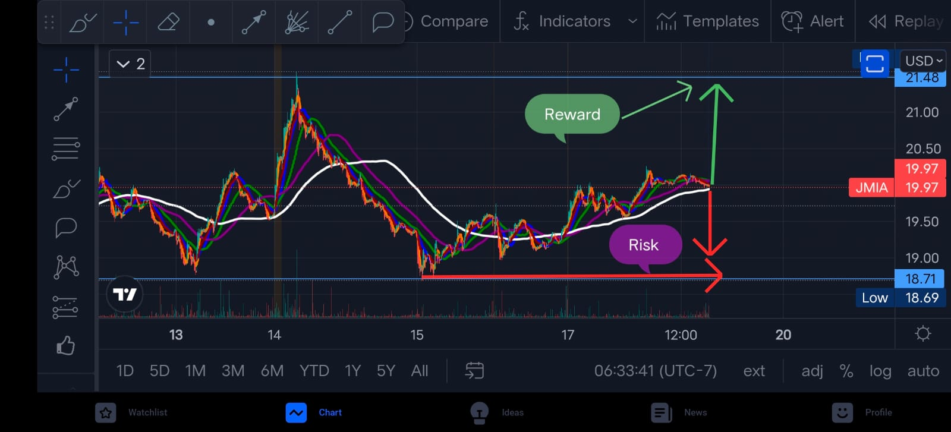

Our goal is to figure out what drives price movement. As traders, our job is to correlate price action and technical analysis with fundamentals to determine why this price action occurs. This will be discussed in greater detail later in the course.

**Lets break it down**

1. Price Action
   1. Breakdown opportunities
   2. Confirm good setups
   3. Find great execution points
2. Fundamentals
   1. Explain the price action

Using Candlestick charts

Candlestick charts, rather than line charts, provide more detailed information regarding price action that a conventional line chart cannot convey. Here is a explanation of green and red candlesticks taken.

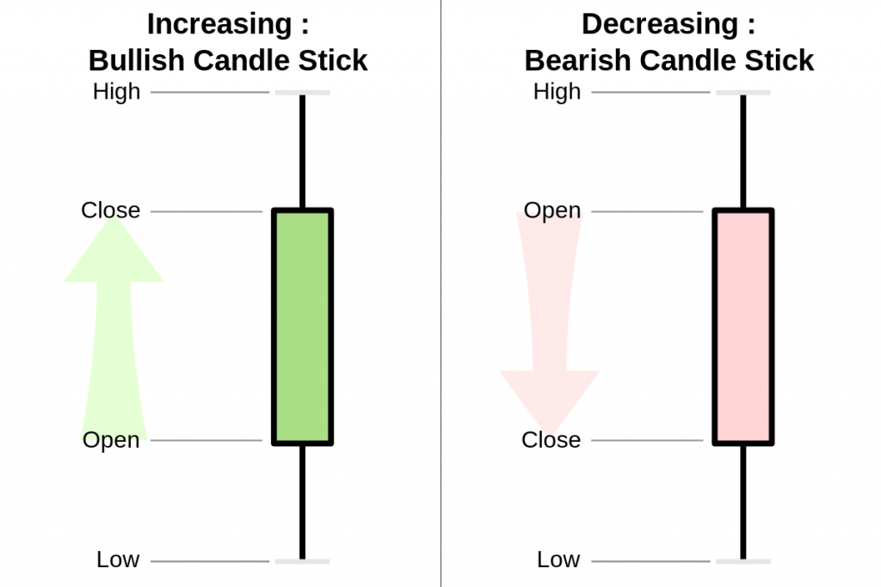

There are also wick candlesticks, which show the price opening and closing at the same price.

They are represented by a neutral candle

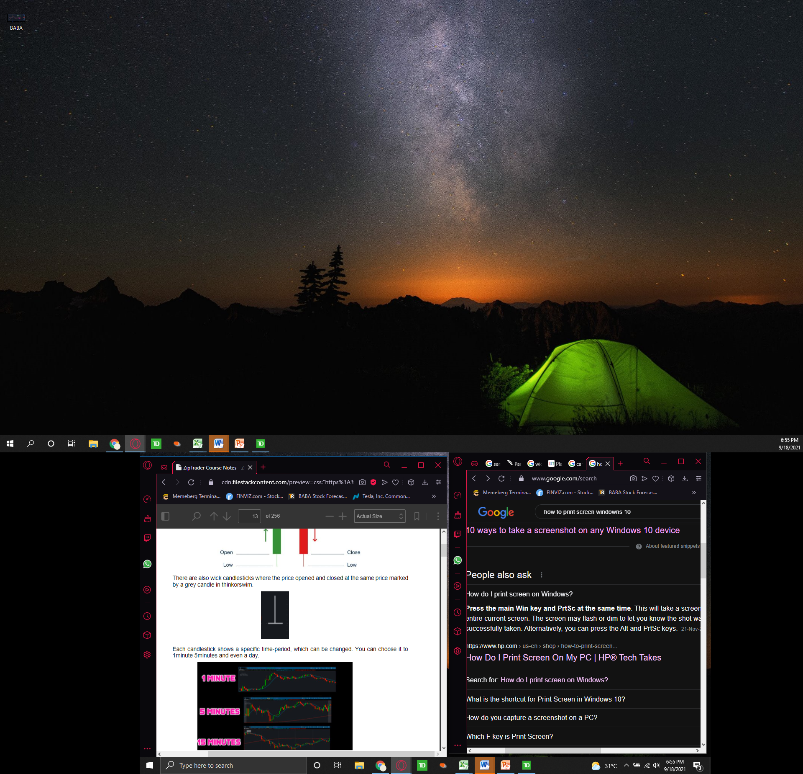

Each candlestick represents a different time period that can be modified. You may set it to 1 minute, 5 minutes, or even an entire day.

Lets take a look at ticker symbol $MSFT on the

1 minute chart

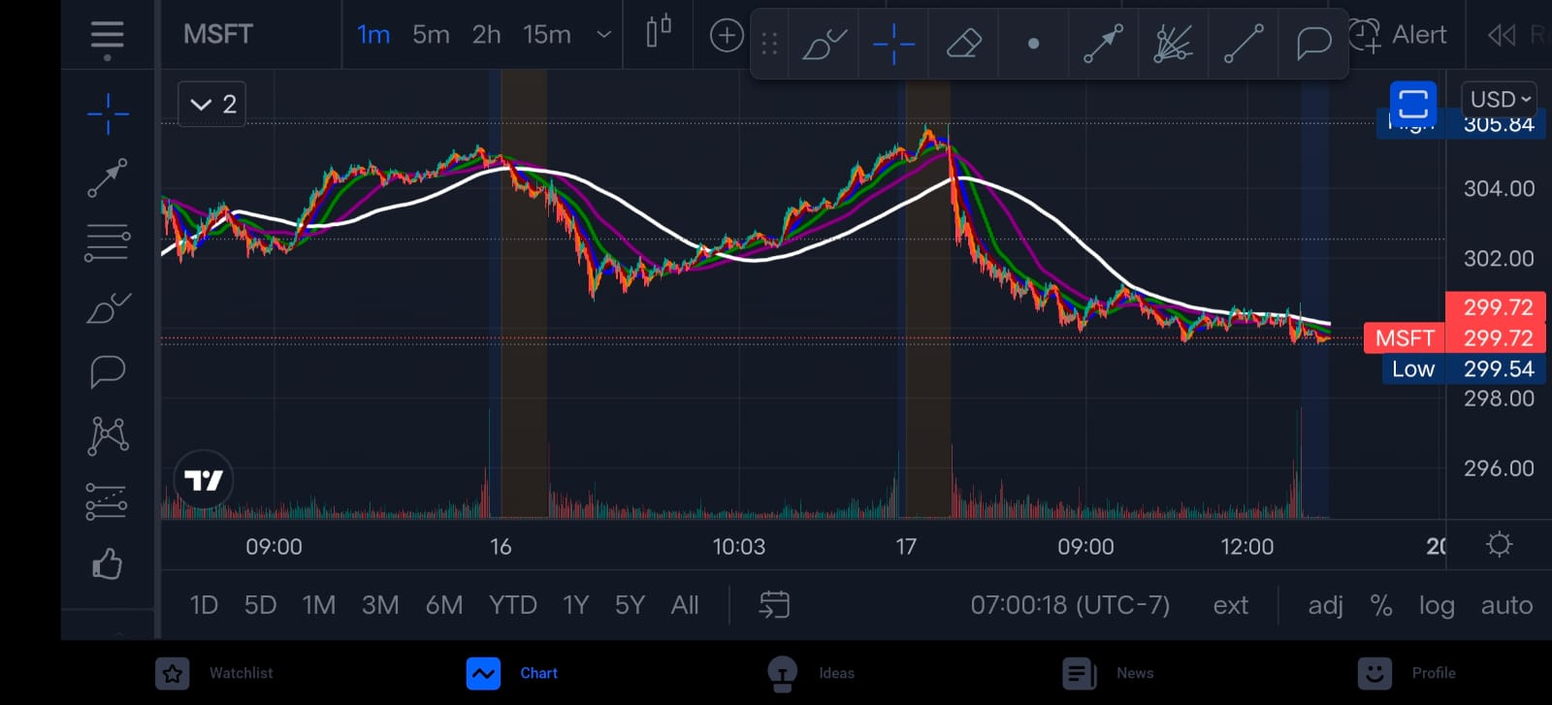

5 min chart

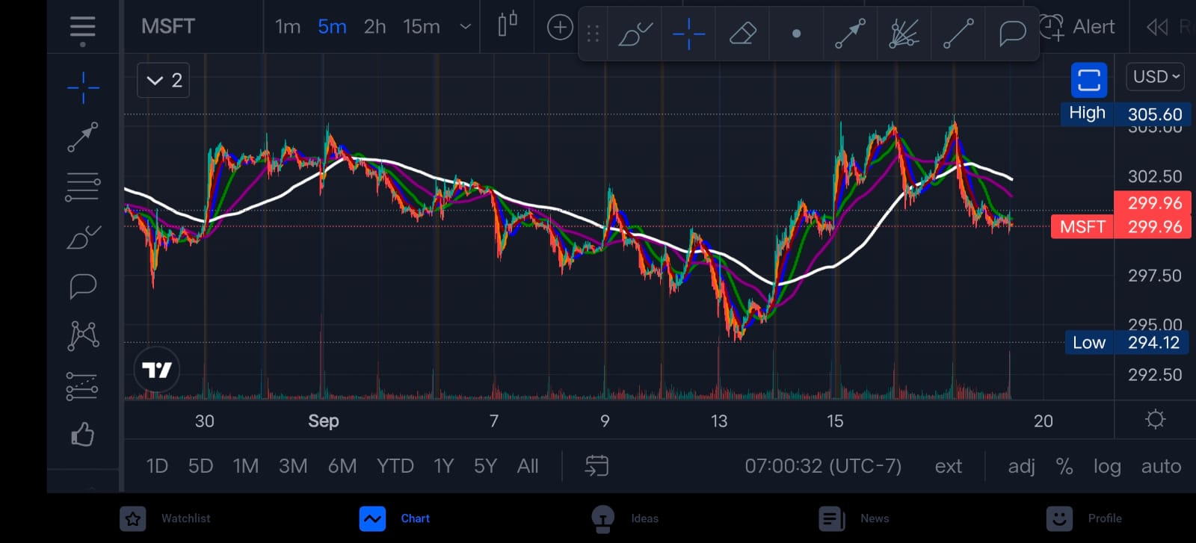

15 minute chart

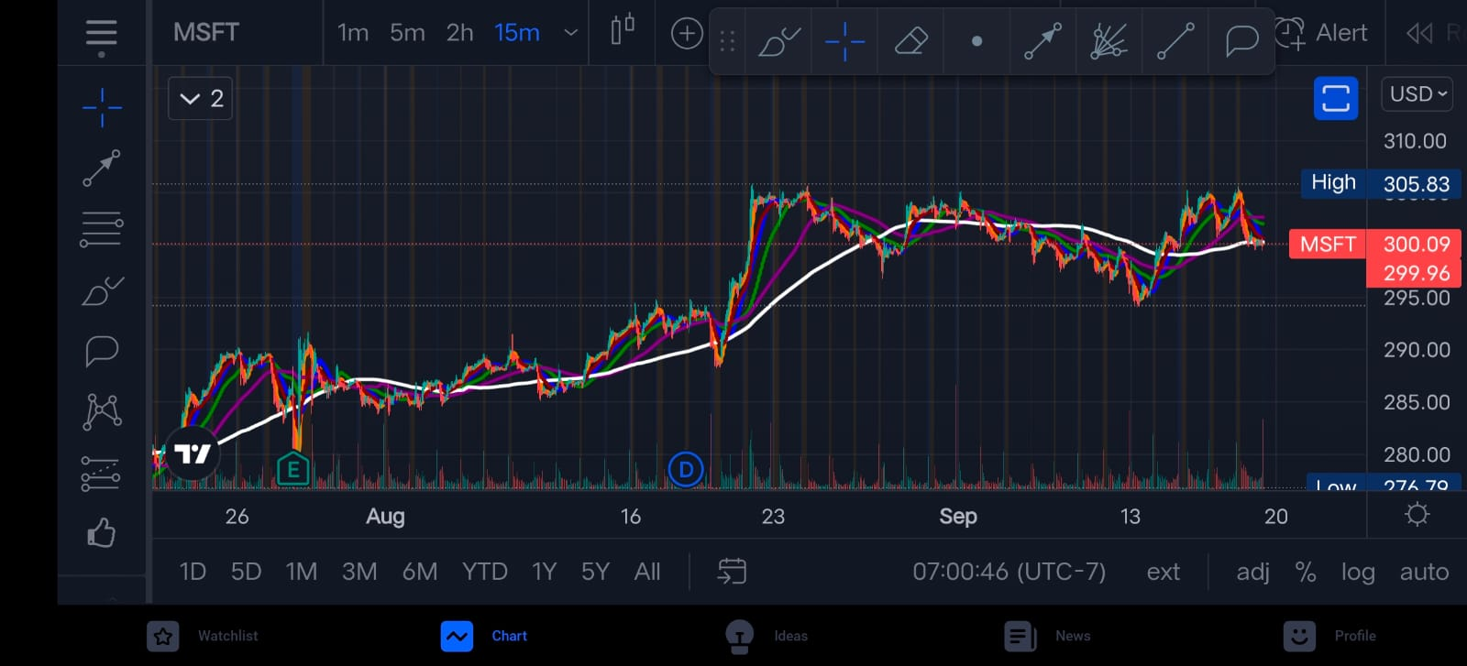

2 hour chart

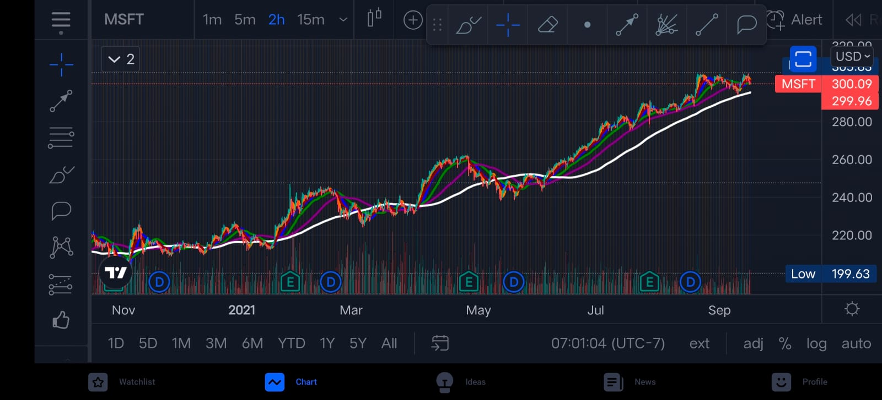

Each chart will give you different information to analyze. It is important to look at different variations of charts to get a fundamental analysis of short term and long term price action movement

**Identifying levels of support and resistance**

Lets take a look at ticker symbol $DIS

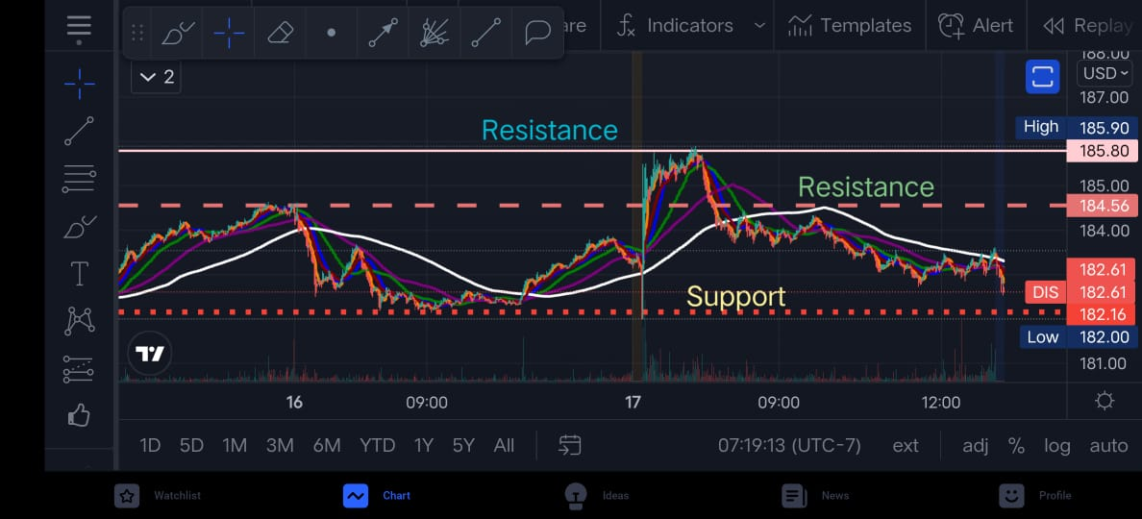

Price movements have varying degrees of strength and weakness. Support and resistance levels are what they're called. The price level at which the stock is unable to break below is known as support. The price level at which the stock is attempting to break above is known as resistance. These are depicted in the image.

* **As you can see a stock can have more than one resistance and support depending on the price action**

These levels can assist us in determining the possibility for upside vs. downside price action movement. When buying a stock, for example, it is preferable to be as close to the support level as feasible because this reduces our risk.

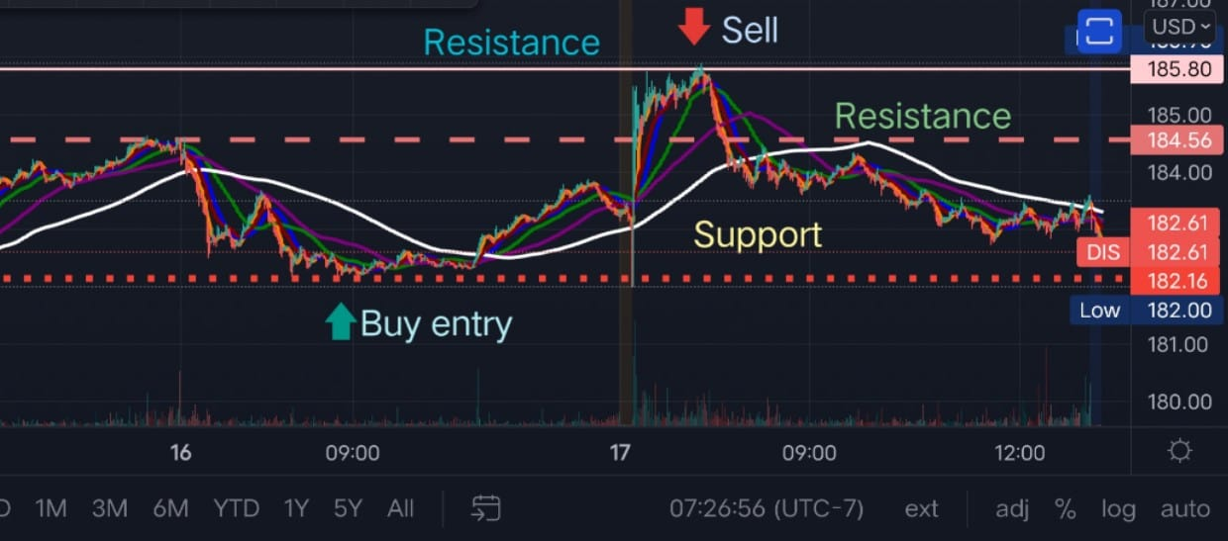

It doesn't imply we can't take a position near the resistance line; it's just one limiting aspect that reduces our chances of success. If a stock repeatedly hits a Support/Resistance level without breaking it, that level becomes more powerful.

Important: When a stock reaches a resistance level and breaks it, the new level becomes a support level, and vice versa. This can be seen in the chart below, where the stock broke the resistance level and became a support.

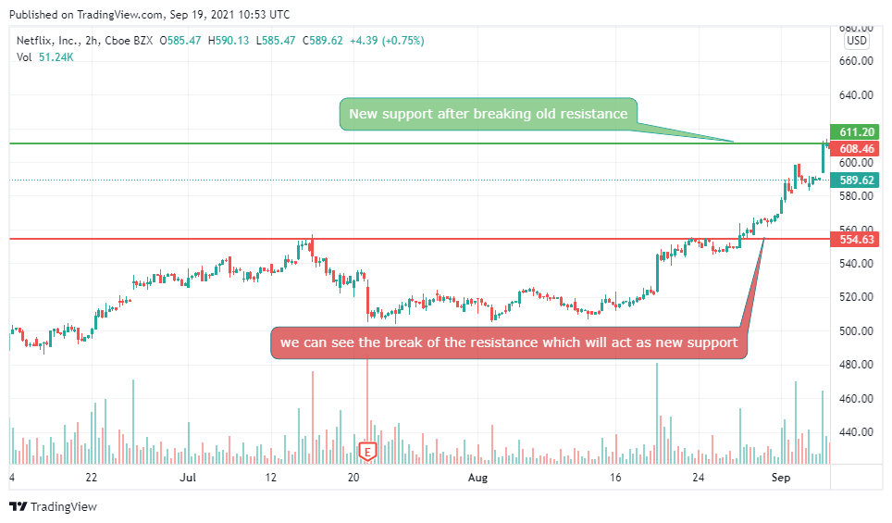

As indicated below, there are also down-trending and up-trending support and resistance levels (also known as channels). When a stock is continuously up-trending or down-trending, this occurs. The 75 percent rule is frequently used to these equities. In the case of equities that are down trending, this means that each high is 75 percent of the preceding one.

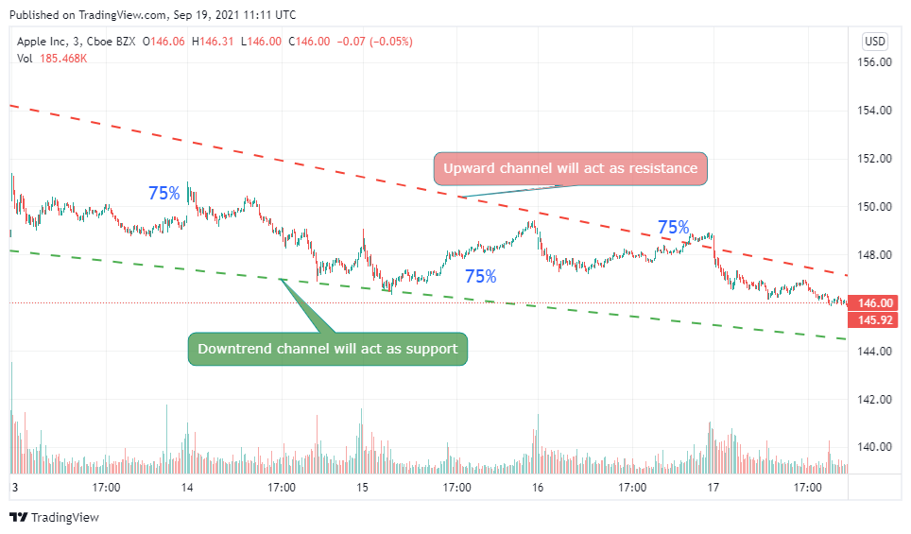

The task at hand is to determine which amount of Resistance/Support is appropriate for the position you intend to take. If you're a day trader, it's probably best to focus on intra-day support and resistance levels, but you should also consider the big picture to get a sense of how the stock is performing.

For example, if we wish to take an Intra-Day position, we can notice that we are trading near a short-term resistance level, which we can use to our advantage. However, when we look at the long-term chart, we can see that it is still a long way from its long-term support level, implying that the risk-to-reward ratio is high.

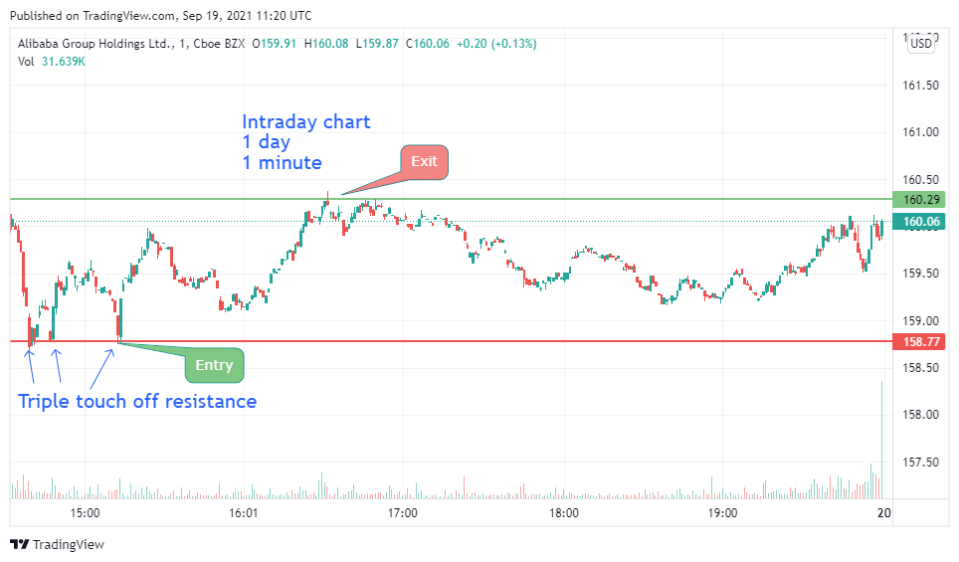

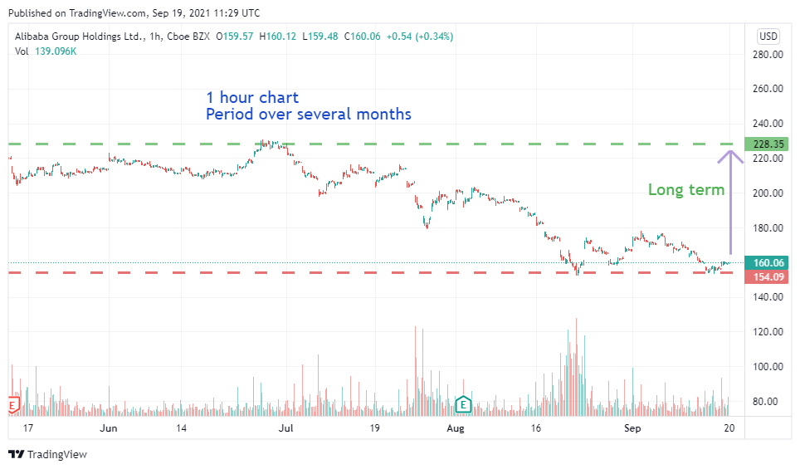

**Drawing effective support and resistance**

The most recent tested level for the time period relevant to your trade is considered as effective support and resistance level. This is the level of Support and Resistance that you are most concerned about.

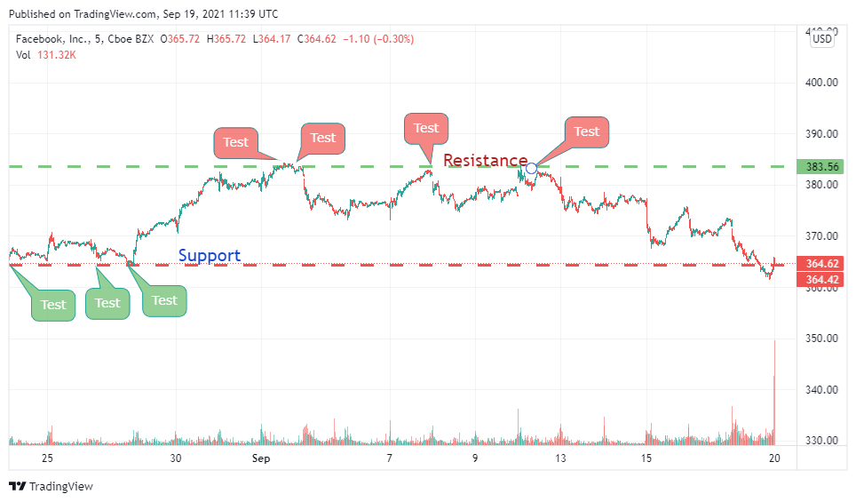

It makes more sense to define the short-term support and resistance levels as the Effective levels if you are adopting a short-term position. Long-term levels, on the other hand, are crucial for Context.

When a support or resistance level is struck several times, it only strengthens it.

**Let's look at a scenario where we wish to take a short-term stake at $SQ. The long-term and short-term levels are depicted in the diagrams below.**

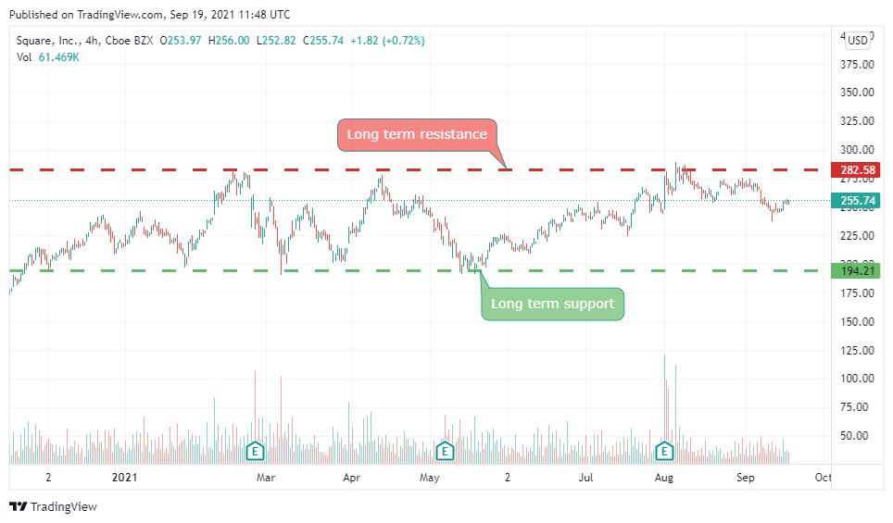

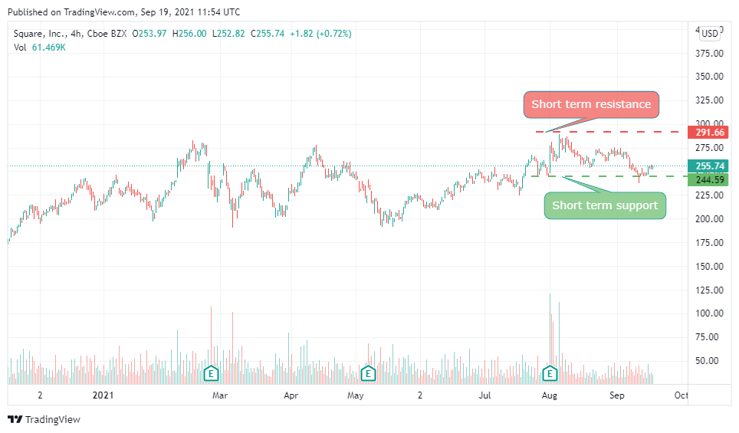

As you can see, the stock is near its short-term support level, which is the effective level in our situation; therefore it makes sense to take a position here. However, if you look at the long-term levels, you can see that we have a greater downward potential than an upward potential.

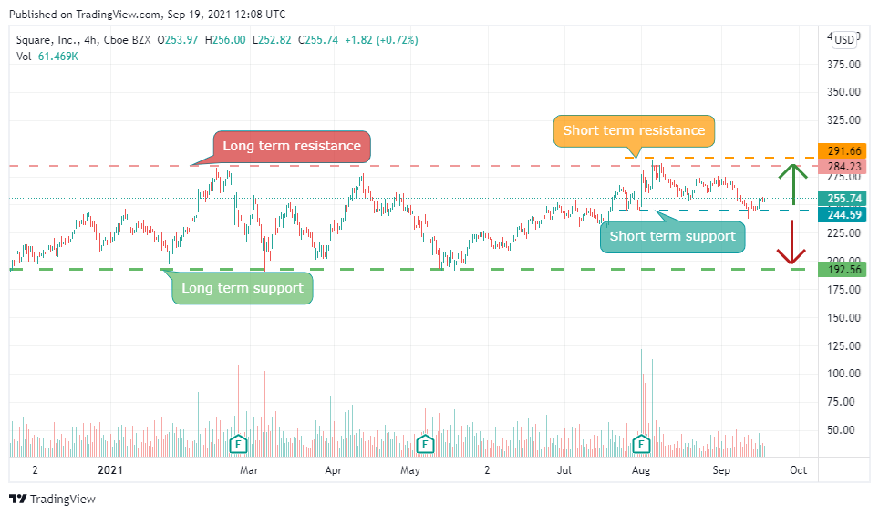

Despite the fact that these amounts of support are ineffective, they are crucial due to context. It's possible that this stock may continue to fall until it reaches its long-term support level. As a result, context is crucial.

**Let's look at an example where we want to take a short-term position in $LCID. The long-term and short-term levels are depicted in the diagrams below**.

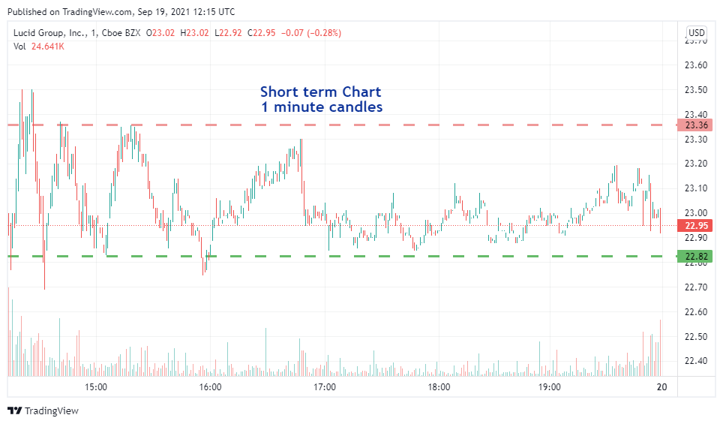

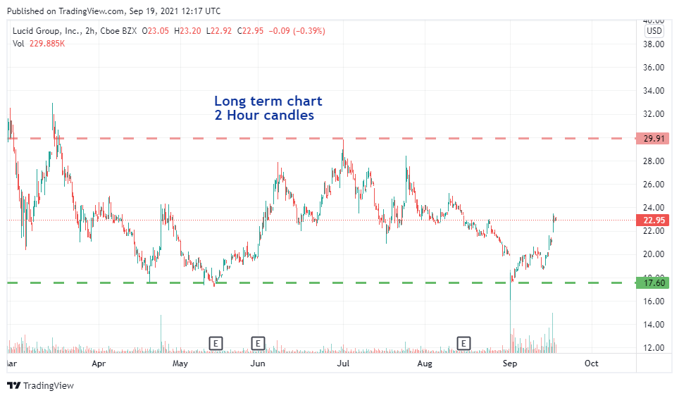

Pay close attention to the price bar to see the difference in context in both charts

We can see that, while there is less short-term potential because we are trading near the Resistance, there is more long-term potential. As a result, taking a position here only makes sense if we intend to maintain it for a long time. This is why it's crucial to understand the context.

**Let's look at $NIO as an example, where we want to see the long-term effective support and resistance levels.**

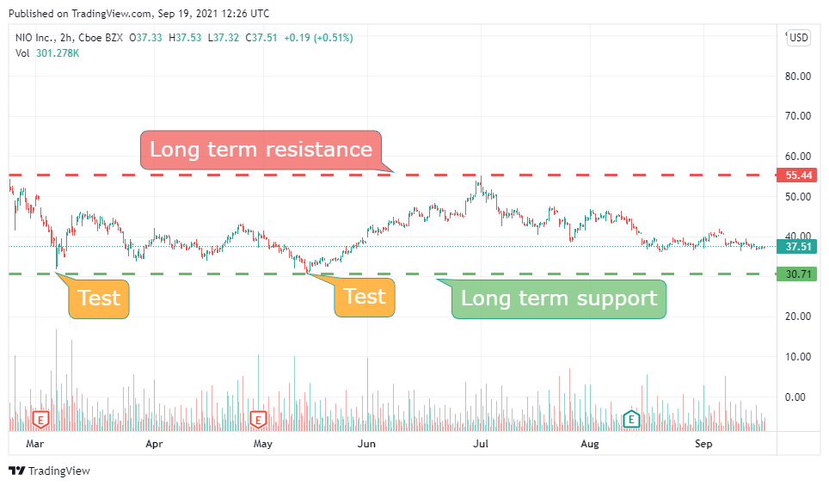

This support level was struck twice, as you can see in the chart above, making it a powerful support level. When we examine closely, though, we can see that there is another level that has been struck numerous times and is newer.

As a result, it becomes stronger, and we should concentrate on the Effective Support level. The illustration below depicts this.

Short term resistance, short term support, long term resistance, long term support.

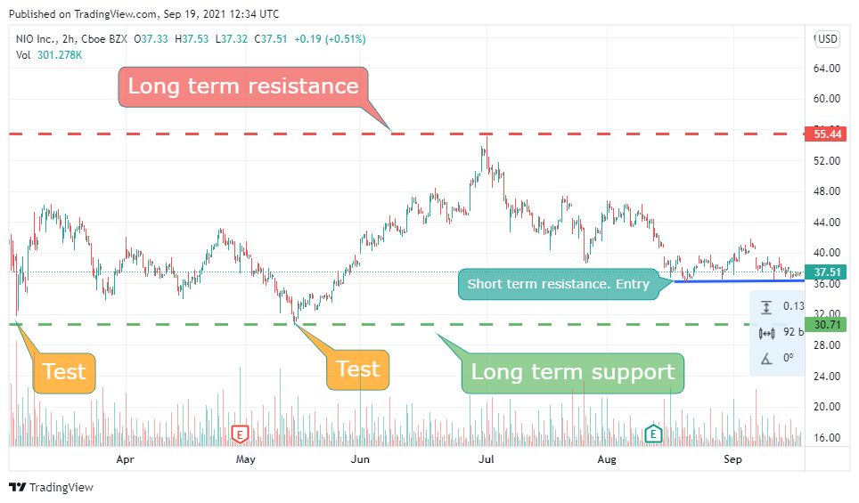

As a result, it is preferable to designate this as the Effective support level, although you may still choose the bottom level as a conservative level of support to reduce risk.

It makes more sense here to declare the more recently testing support line as the Effective support line.

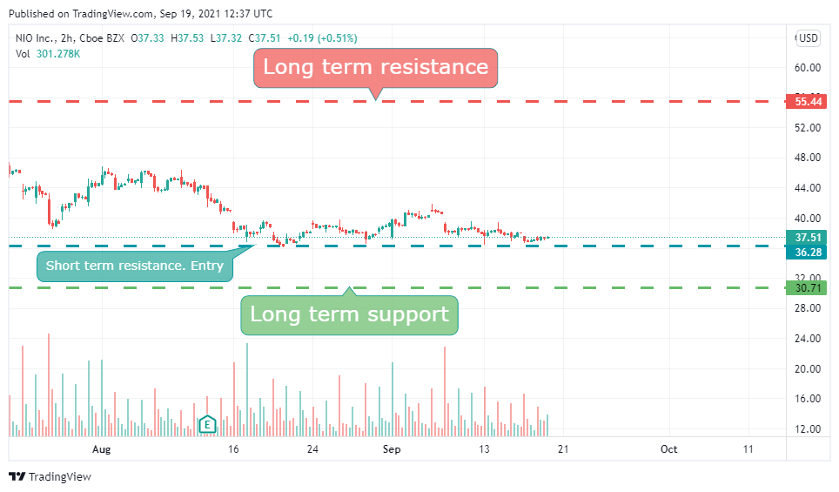

In general, newly measured values take precedence over previously tested ones.

**Additional rules**

When a support level is broken and the price falls below it, the level becomes a resistance level, as indicated in the diagram below. The stock fell below the Support level at this point. As a result, this Support level has now become a Resistance level.

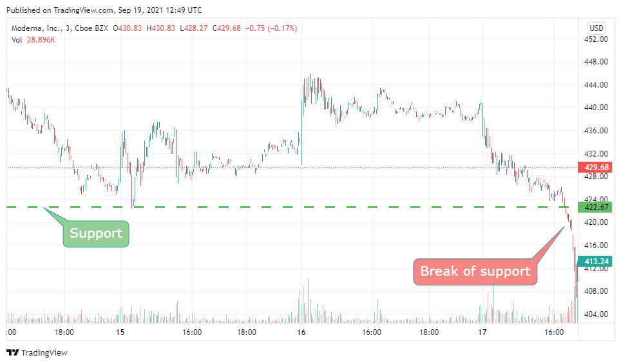

The opposite is also true like when a stock breaks a Resistance it becomes the new support as shown in the picture below

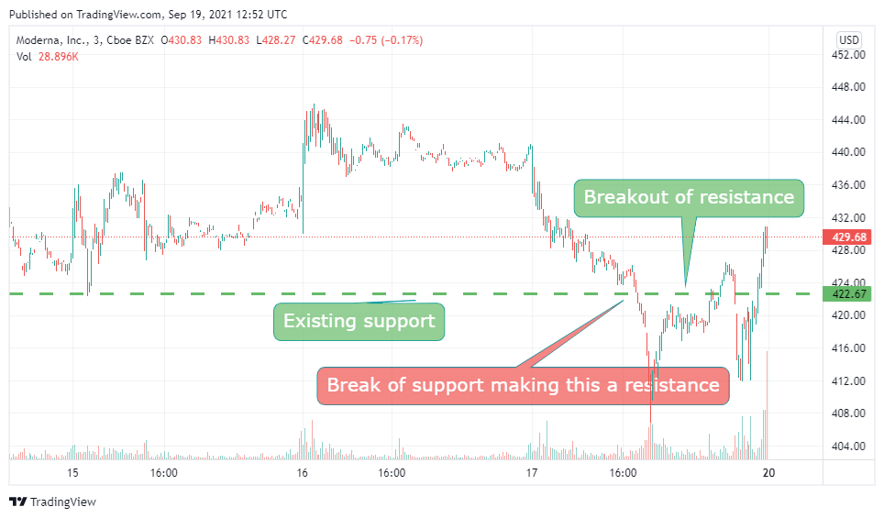

Because these new levels are so fresh in both cases, they can serve as effective support and resistance levels.

**Example 4: Using $NVDA as an example, we can now determine the Effective Support and Resistance levels. On the intra-day chart, we can see that $NVDA has broken through the prior resistance level, indicating that it has now become the new support level.**

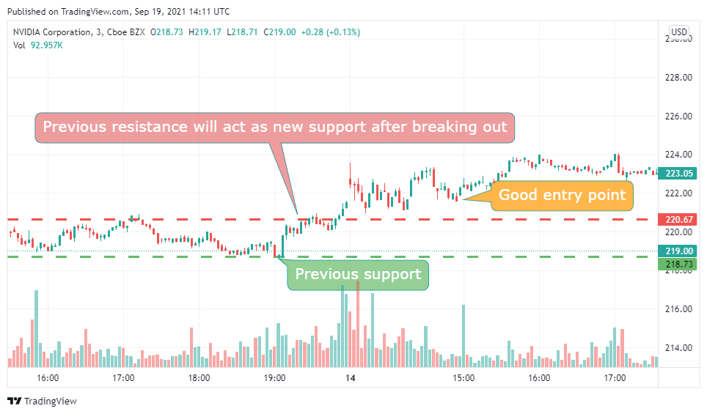

**As a result, the effective support and resistance levels are indicated in the diagram below.**

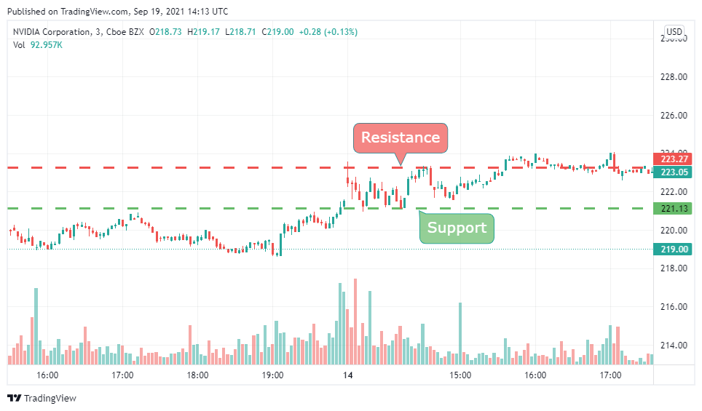

**However, you must observe the long-term levels for perspective, since they may impact the stock even in an intra-day position.**

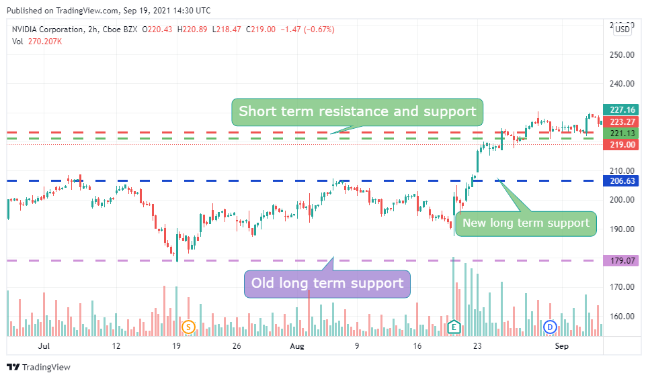

**Risk vs. Reward ratio**

The first thing to remember is that just because something has greater upward potential than downward potential does not imply it will move upwards. Likewise, the inverse is true. A stock's price fluctuation is influenced by a variety of variables. The route that a stock can drive on is simply the upward vs. downward potential. If it has more elevating elements than deprecating ones, the more road it has in the upward category, the more room it has to run upwards. If the ratio is larger, we are taking on more risk, and if it is lower, we are taking on more profit.

**Example1: Let’s take an example for $MSFT where we plan to take a Intra-day position at the entry point marked in the picture. We want to find the risk vs. reward ratio at that point.**

**We may compute the Risk vs. Reward ratio by marking the effective support and resistance levels, as illustrated below.**

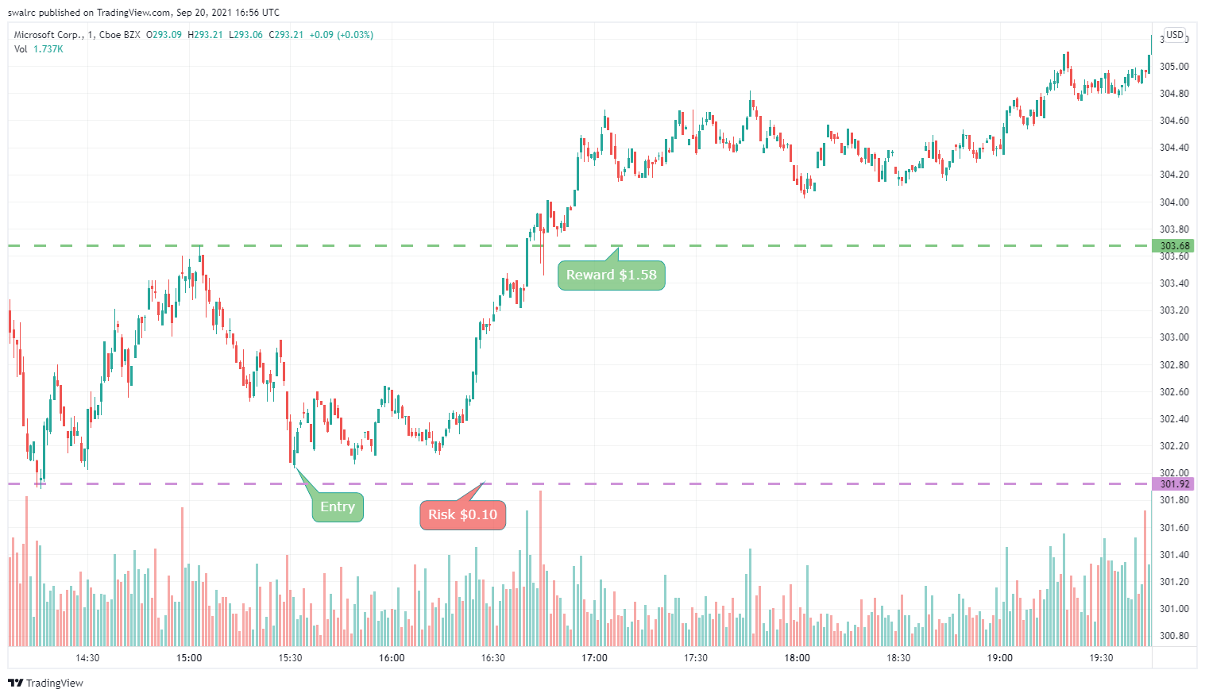

**Example 2: Let's have a look at another ticker symbol $AMZN case study. We are interested in working here for a few weeks. As a result, we must examine a chart that has data for longer than two weeks. This is when a 30-day chart is ideal.**

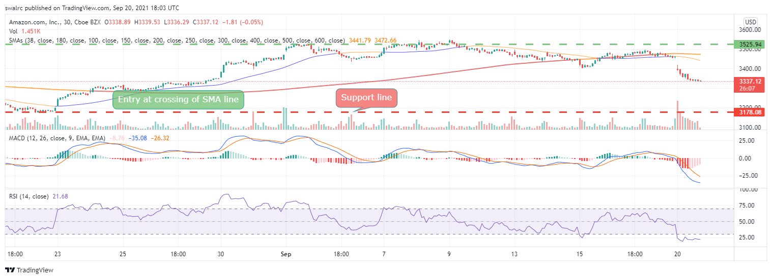

**We may compute the ratio as indicated above by drawing the effective support and resistance levels.**

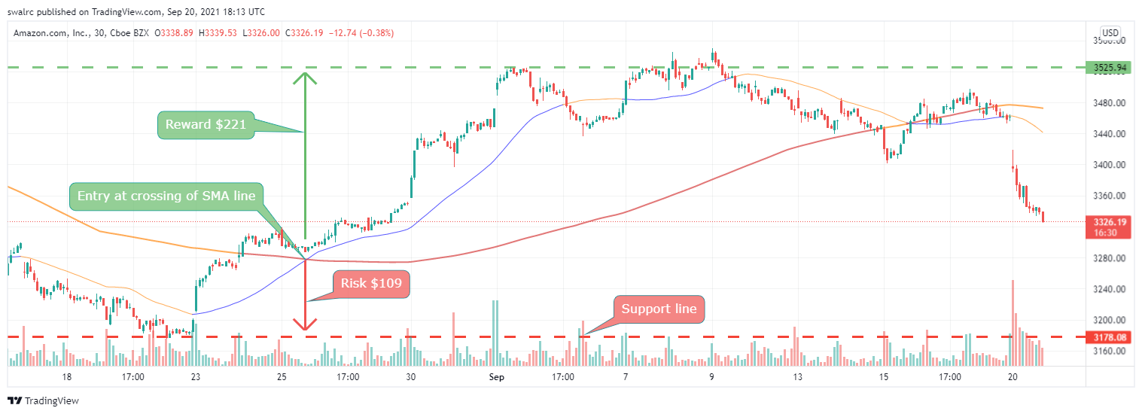

**As previously said, this is simply the path that price action can go if we receive any favorable news or trigger. This is something that will be explored later.**

**Example 3: Let's look at another example $LCID where we may apply for an intra-day position.**

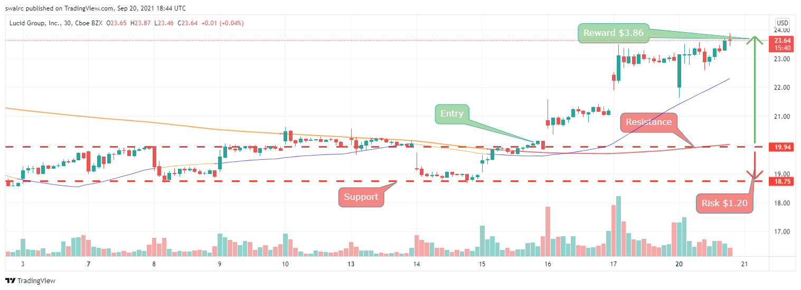

**We can see that the stock has upward potential of $3.86  This does not rule out the possibility of a loss if we take a position here, as the stock has since risen. It simply implies that the stock must break over the resistance level with momentum in order to be lucrative. As a result, taking a position here with this setup is a good idea.**

**Example 4: Let's look at another ticker $AMD. Where we can enter for a few months. That is why you should look at a long-term time chart, such as one that spans 180 days.**

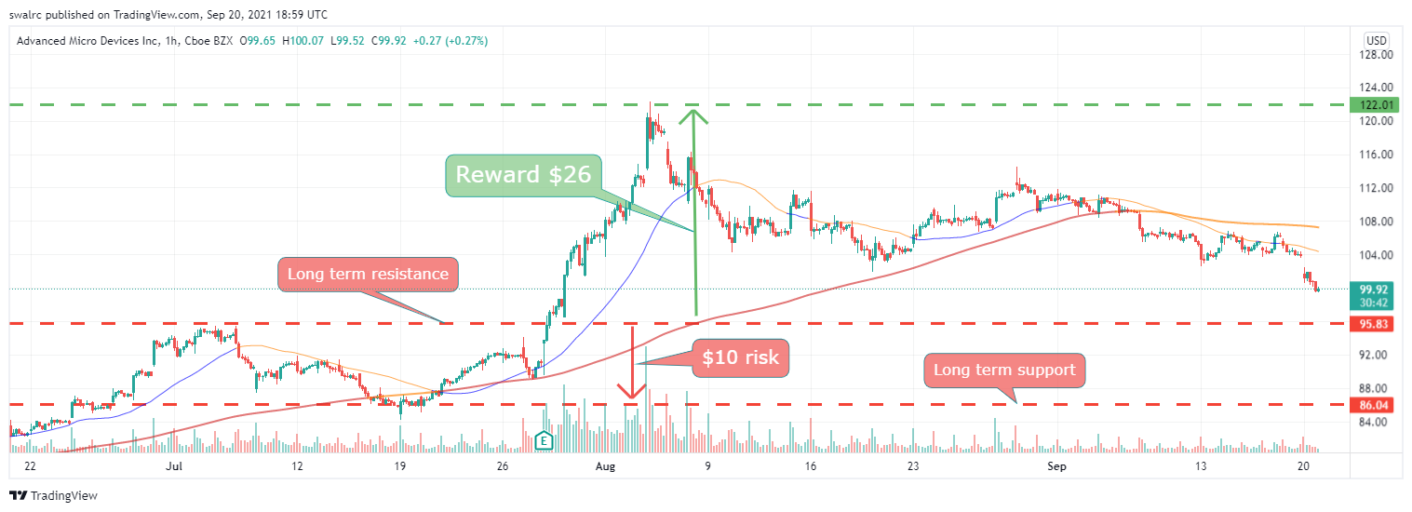

**This is what it looks like if we solely utilize long-term support and resistance levels. This demonstrates that we have some upward and downside possibilities.**

**However, if we look closely at the chart, we can see that the price has struck another support level twice. As a result, we should utilize this as our effective support level.**

**Important Points to remember:**

**The risk vs reward ratio, or the upward versus downward potential, is just the path that our price action can take. That indicates that if we have greater upward potential and the stock begins to go upward, there is more room for the stock to move higher. Please keep in mind that stocks frequently break these patterns, but in general, a pattern will likely to repeat itself over time. It's almost as if it's a self-fulfilling prophesy.**

**Important Points to Remember: Trend lines and channels tend to follow particular patterns; they can assist us in making trading decisions. Trend lines help us comprehend recurrent patterns by breaking them down into smaller chunks. When used in conjunction with other techniques, they can significantly improve our chances of success. Channels are only one component of a quality system.**

Volume and Float:

**A stock's volume “Total number of shares exchanged within any particular time period” is how volume is defined.**

You can see daily volume here as shown below for $FB

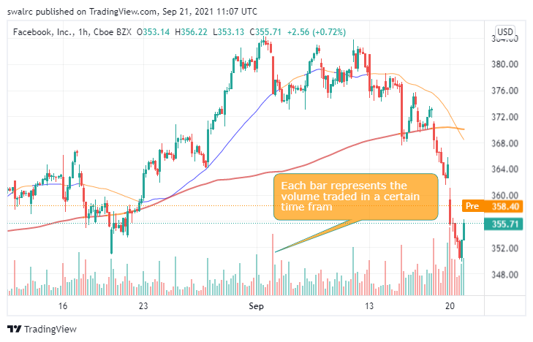

**Lets take a look at a stock where the volume is less $RKT**

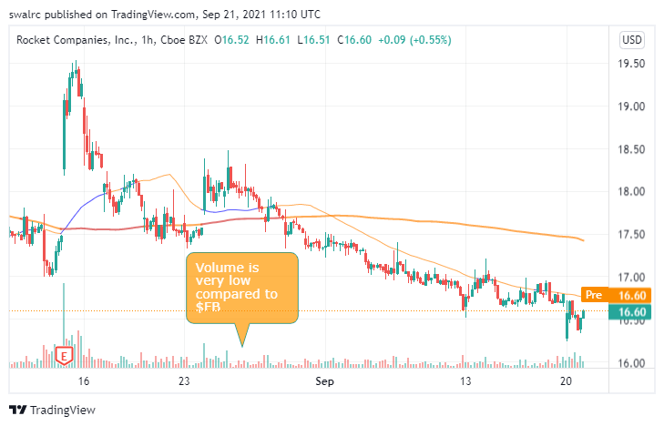

**The difficulty with low volume is that the stock hardly moves, and when it does, it moves randomly, as seen in the RKT example above. Furthermore, there is a danger that just purchasing or selling such stocks will alter the price. If you sell, it's possible that the stock price will drop and the execution would be sluggish since fewer people will be purchasing it.**

**A daily volume of 200,000 – 250,000 is suggested as a minimum.**

Take a look at $MRNA, for example. Even if the daily volume is over 200,000, the Intra-day chart shows that the majority of the trading takes place during the open and closure of the market hours.

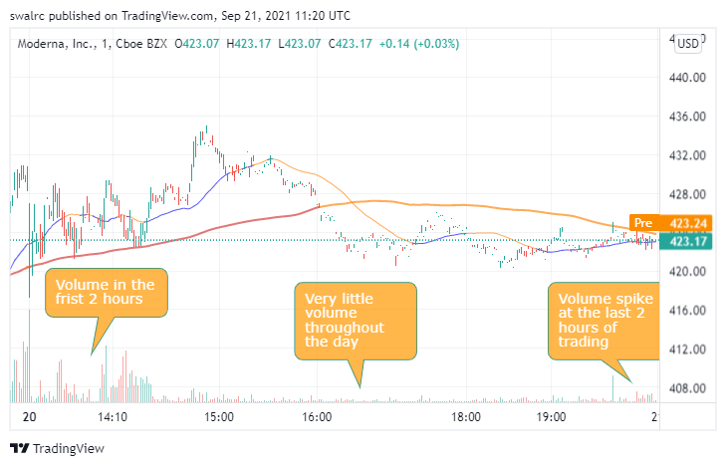

Depending on the position you want to take, this might be troublesome. The greater the volume, the less likely you are to run into this issue.

**Exceptions**

Stocks with low volume that see a jump in volume due to a news trigger such as FDA approval, earnings release, etc. During news catalyst days, stocks are more likely to see a spike in volume. This helps you to swiftly execute your positions.

Take a look at the data for $ACRX , which shows a jump in volume following FDA rejection.

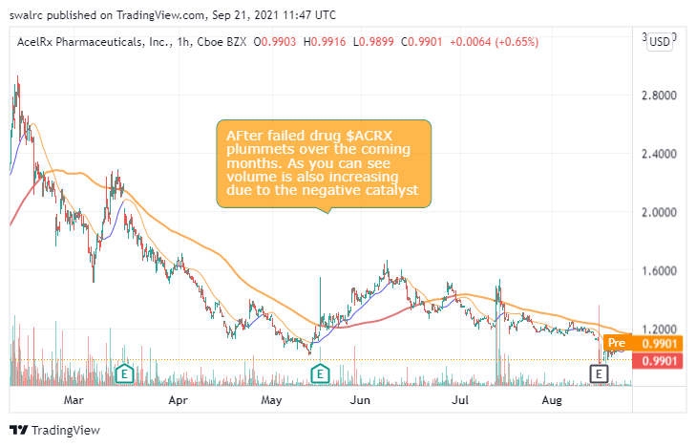

Volume is also used in other ways.

A stock with unusually high volume might be the result of a press release or some type of insider trading that we aren't aware of. You may take advantage of this by programming scanners to detect unexpected volume spikes. You may be able to uncover previously undiscovered prospects as a result of this.

An example of this is below with ticker symbol $GSKY where alleged insider trading was happening before the actual news catalyst

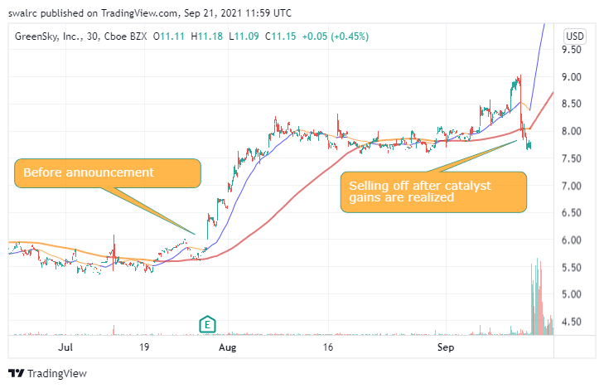

**Stocks Float**

**The “Total Number of Shares Tradable for Any Given Stock” is referred to as float. You can tell whether a chart has a low float by looking at it. Take a look at the graphs below, for example. There aren't any candlesticks to be seen.**

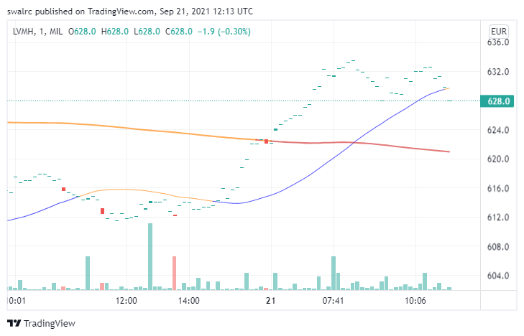

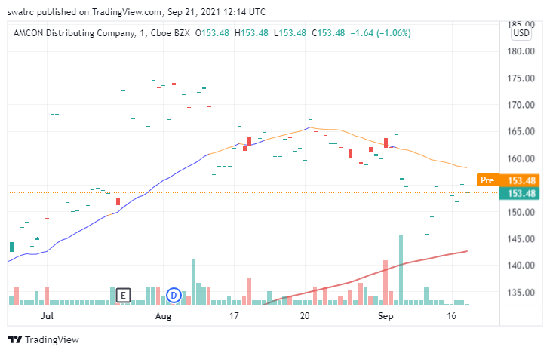

**If you're unsure about the float, you may also use Google to look for a stock's float.**

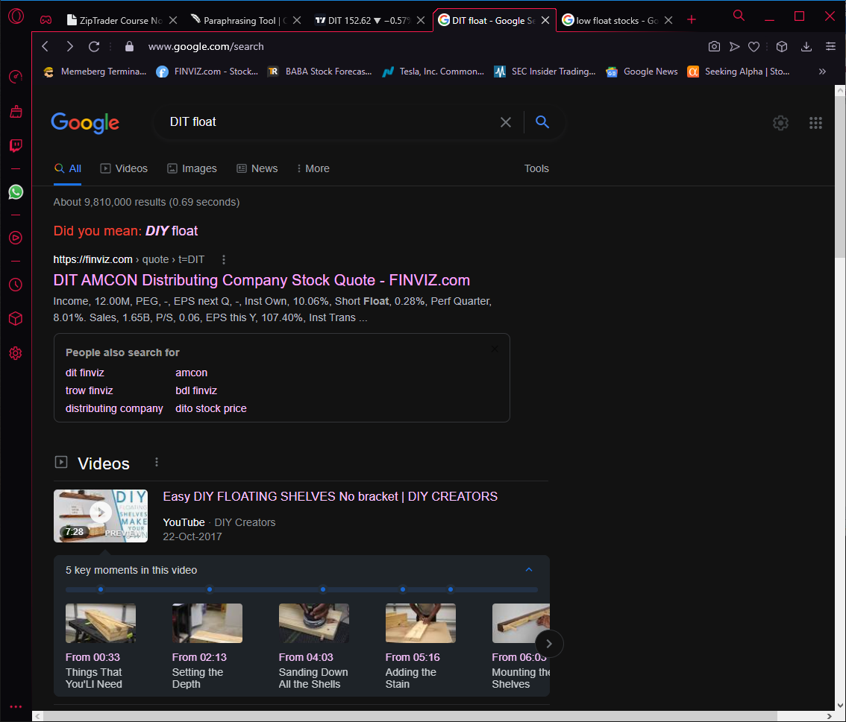

**Below is the data from finviz.com**

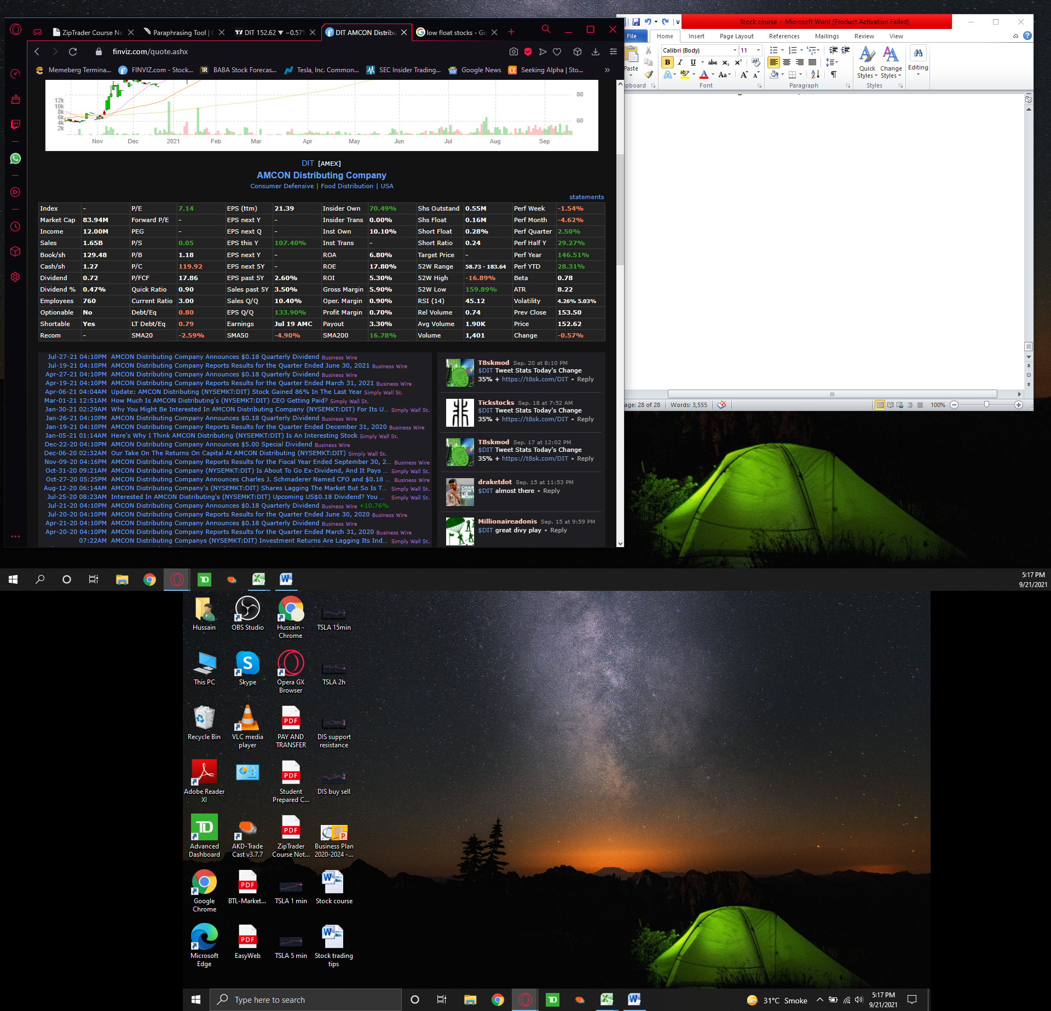

**Using the Pre-Market and After-Hours Markets**

**Pre-market and after-hours trading is where a lot of the big swings occurs. These are visible in your broker account. Some brokers will not show the premarket data on charts and some brokers will. If premarket chart data is not available you can also look at the bid & ask and monitor the fluctuations from there as shown below in the yellow box. During premarket hours the bid & ask will be changing every second.**

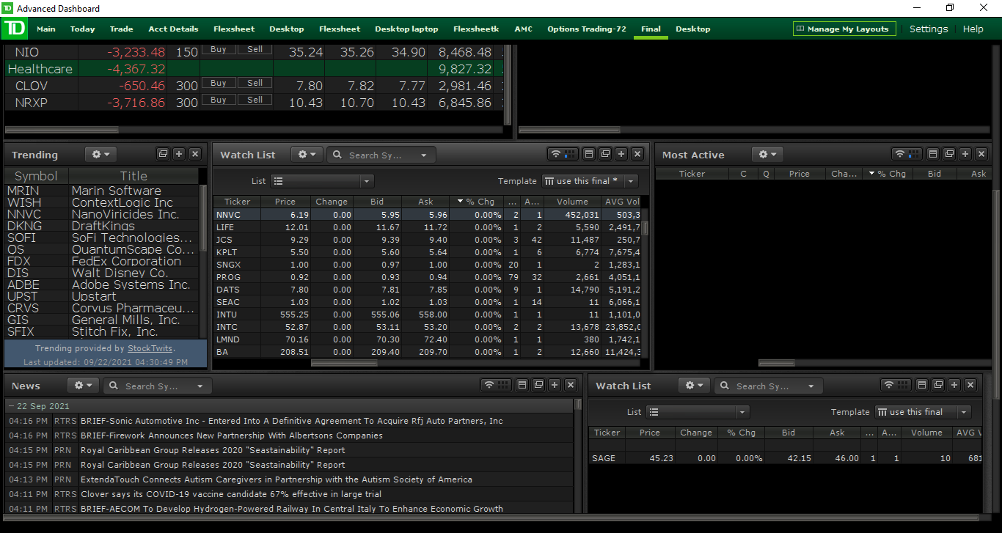

Pre-market hours are from 4 a.m. to 9:30 a.m. EST. After hours is from 4 p.m. to 8 p.m. Because many traders and institutions only trade during market hours, non-market hours are usually less liquid. We, as retail investors, have the option of trading during business hours. The only issue will be a lack of liquidity. That implies there isn't much movement in many stocks, and if there is, it's likely to be erratic.

That said, the last hour or two of Pre-market hours, i.e. 8 a.m. to 9:30 a.m., is more liquid. This period may also give us with price movement to trade-off. Because many firms post their stock news and announcements after business hours, this is a fantastic opportunity. They don't do it throughout the day since it may have an impact on the stock price. By watching the reaction in the after-hours/pre-market, we may see these expected results and take a position ahead of time. In the instance of $PATH, for example, an positive earnings report was released, which was seen as positive news, and the stock's price fell due to profit taking from the company.

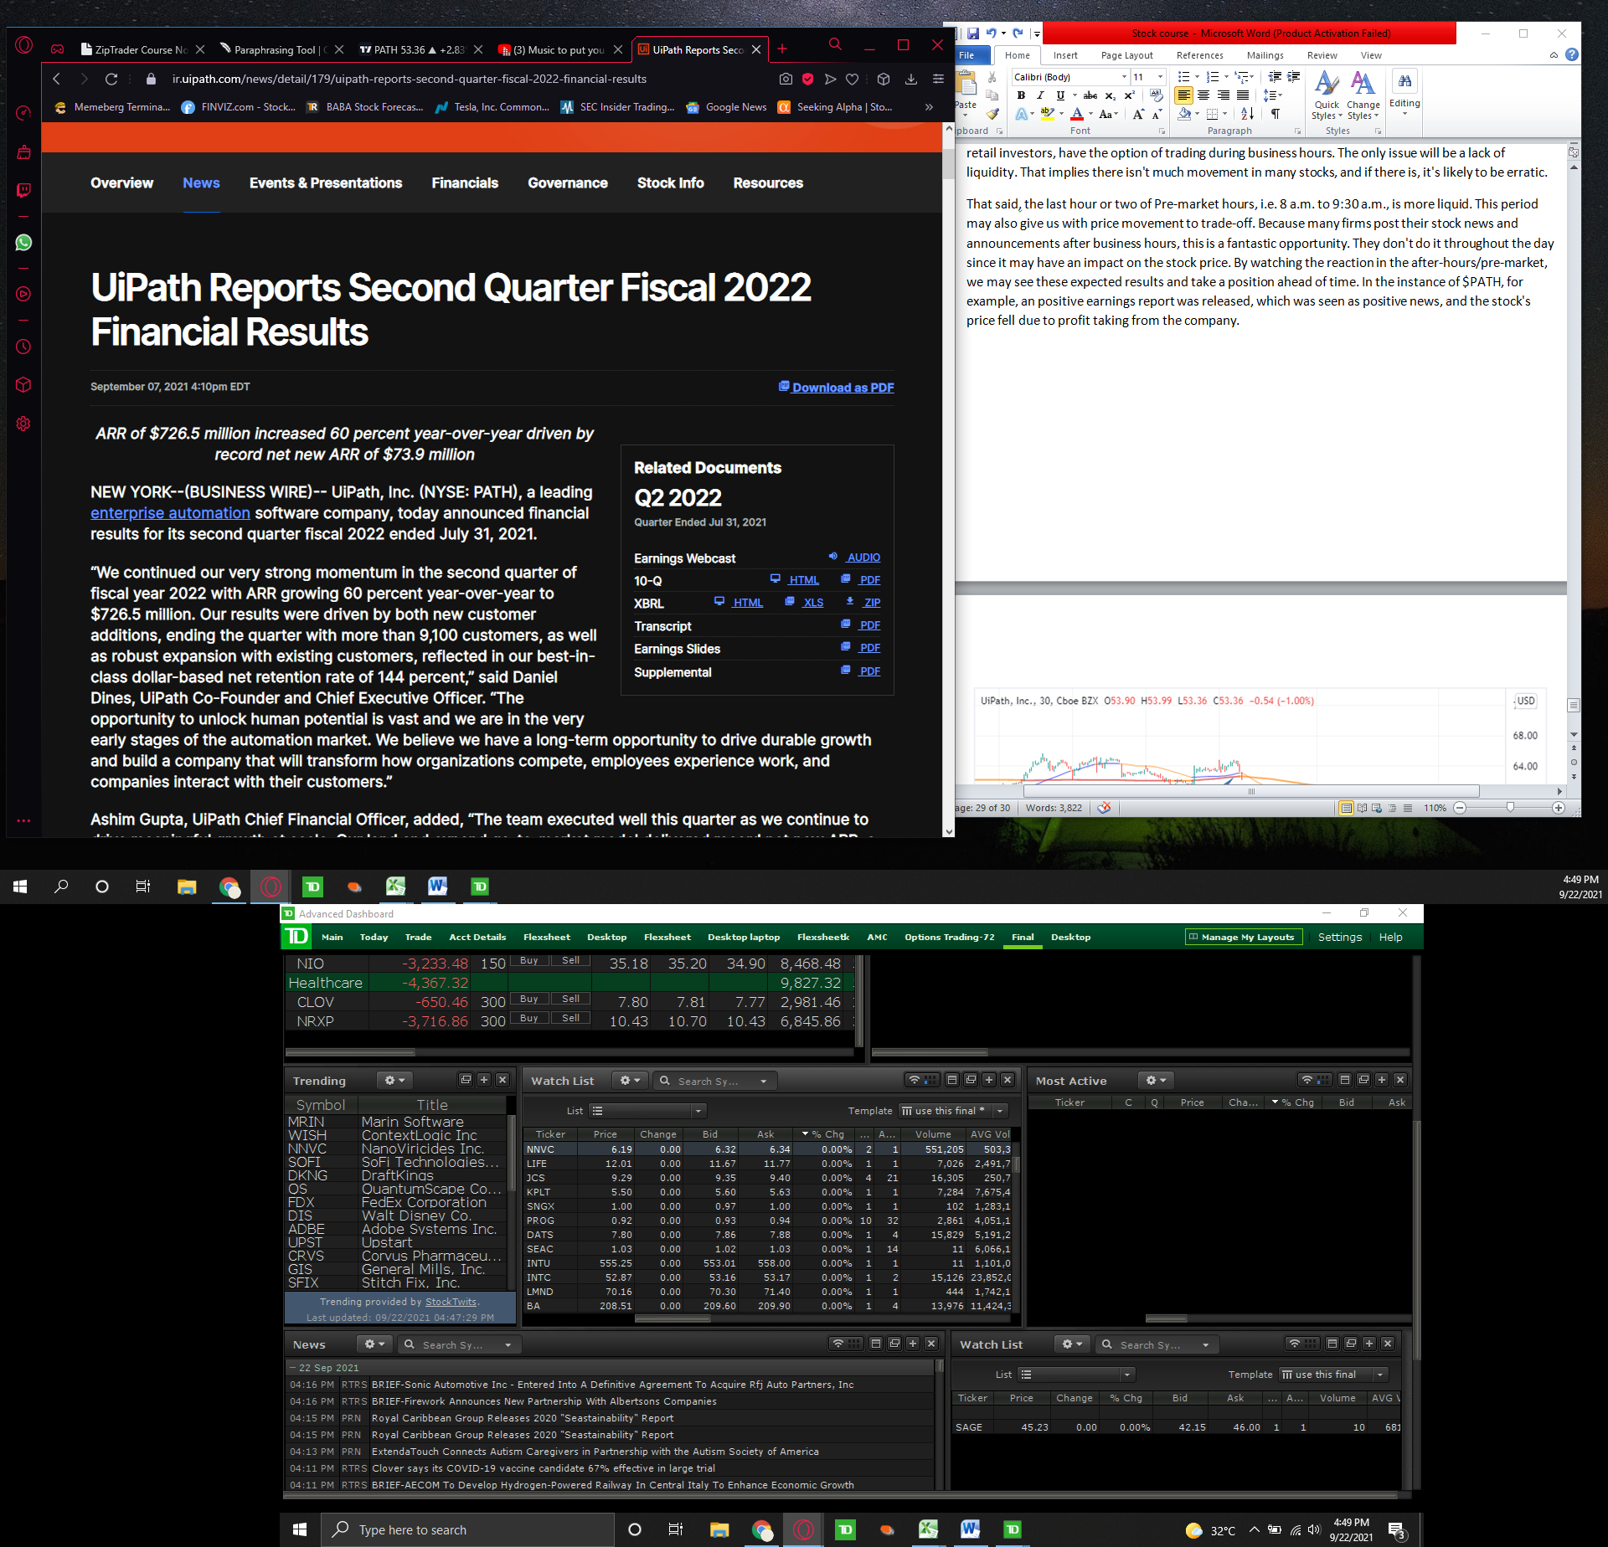

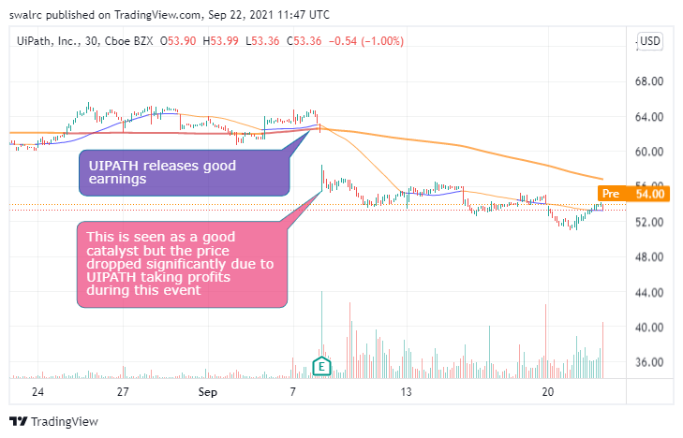

The pre-market phase is equally crucial. You may spot indicators of an uptrend before the market even starts if you keep an eye on it. Take, for example, $HLBZ

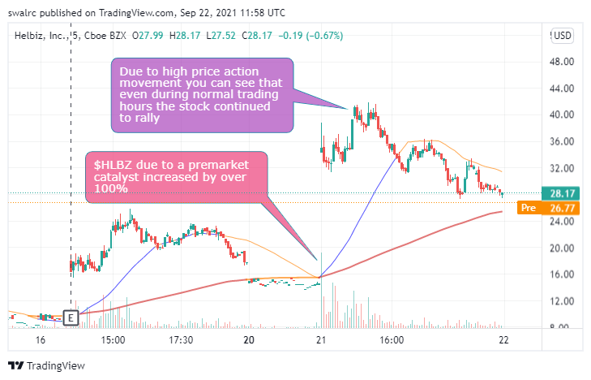

Below you can read the pre-market catalyst for HLBZ which caused it to rally.

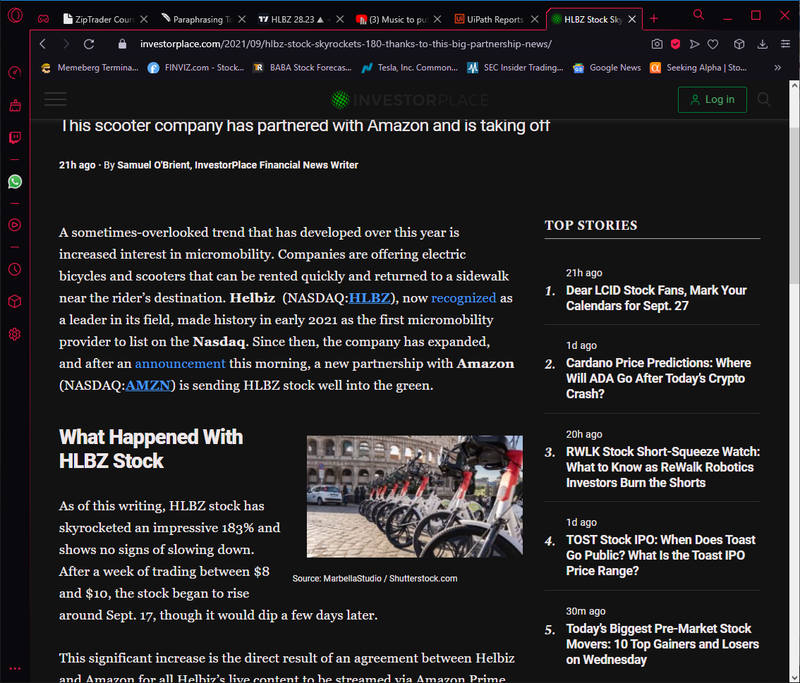

Pre-market has the advantage of allowing you to enter at a low price and then sell out during regular market hours. The disadvantage of after-hours/pre-market trading is that due to the low volume and float, you are considerably less likely to be executed into and out of positions. There are certain exceptions, such as a stock that attracts a high number of investors in after-hours/pre-market trading would have increased liquidity. This may be a fantastic chance for you to trade-off. You may check for equities with significant volumes in after-hours/pre-market using a scanner, which we shall cover later.

For example, in the instance of $NRXP, there was a significant buying in the pre-market, thus you can expect it to rise when the market opens. In this sense, after-hours/pre-market trading may be quite beneficial to us. This isn't always the case though. As we can see with $NRXP after the good news catalysts the premarket action was amazing. But during regular trading hours we did not see that same price action. We saw the price come down and not touch the pre-market highs.

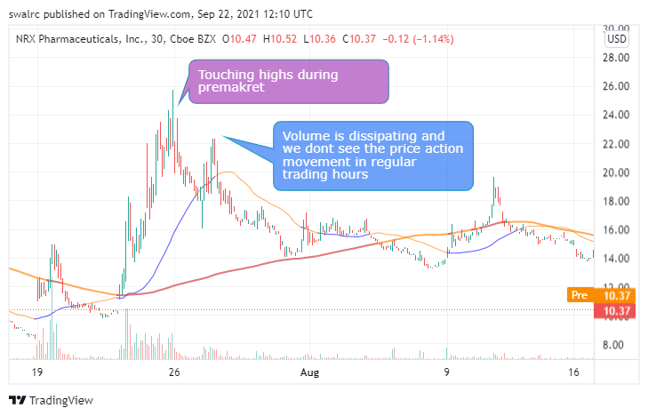

It's worth noting, however, that after-hours/pre-market prices only carry a little degree of future price significance. Due to low volume and floats, this after-hours/pre-market price movement is too erratic for our indicator setup to operate. As a result, don't utilize after-hours/pre-market trading to predict where a stock will go in the future. Use it just as a tool to observe how people react to news in the after-hours/pre-market. If you absolutely want to trade after-hours or before the market opens, make sure you utilize a limit order because prices might fluctuate erratically. Also, ensure that you enter at a favorable time according to the market hours.

**Important Points to Remember**

* After-hours trading is from 4 p.m. to 8 p.m. EST, while pre-market trading is from 4 a.m. to 9:30 a.m. EST.
* We have access to after-hours and pre-market trading as retail investors.
* These hours can help us understand how the market reacts to news that is issued outside of usual trading hours.
* Due to limited volume, stock movement during after-hours / pre-market is erratic.
* You may use specific scanners to see if there is a lot of trade going on in the pre-market hours and then take a position when the market opens.
* During these hours, only trade using limit orders; otherwise, you may end up with a very poor entry point.
* If you wish to trade during these hours, make sure you receive a favorable entry price in comparison to the price during regular trading hours.

**How to Choose the Right Size for Your Trade**

The amount of money you should utilize per trade is referred to as position size. There are three primary variables that influence this.

The amount of capital

The level of risk tolerance

The individual’s skill level

You shouldn't use real money if you're a newbie. Trade paper money for proofs rather than promises. Start small after that. You should start with a few of hundred dollar holdings until you can economically increase them. When you've completed this and have progressed to the Professional stage, you can take on more risk.

**Example**

Set a goal to grow your capital on a scale which is realistic. You can set a goal on a weekly or monthly basis. Always make sure to do your accounts to see if you are meeting your goals.

For instance, if you have a long-term trade that offers you 10% per month and a 10% potential each week utilizing day trades. You should invest your money in day trading. Take the most efficient position that will provide you the most profits without putting your money in a bank. You can distribute $50,000 in this way if you have $50,000 in capital.



Never trade your entire account in a single transaction. This is not a good situation. Your account will ultimately be blown up as a result of this. This is a really terrible habit to get into. Also, you should never trade with more money than you can afford to lose. Limit the amount of capital you utilize in a trade to no more than 20% of your total account value.  Even 20% is pushing it as a beginner trader.

If you intend to make a living from trading, you should develop the practice of not risking your whole account on a single deal. This is due to the fact that you will blow out your account and then have no money to return to the game. It's also a good idea to have some money in cash in your account. This manner, if any of your positions go bad, you may re-grow your account. You should also consider whether a stock is less liquid, such as a penny stock. This is because, due to limited volume, it is difficult to execute a position without impacting the price.

**Things to keep in mind**

Do not risk more money than you are willing to lose while trading.

Do not risk more than 20% of your account on any single setup.

Leave a portion of your trading account in cash.

The highest return positions were obtained through maximizing efficiency.

**Using Indicators and Patterns to Make Trades**

Indicator Focus: Putting the Odds in Your Favor

How well you control your probabilities of success in trading determines your trading profitability. Our indications and techniques will aid you in this endeavor. Even if the indications can't help us forecast the future, they can show us how likely we are to succeed. In this part, we'll go through each of the indicators.

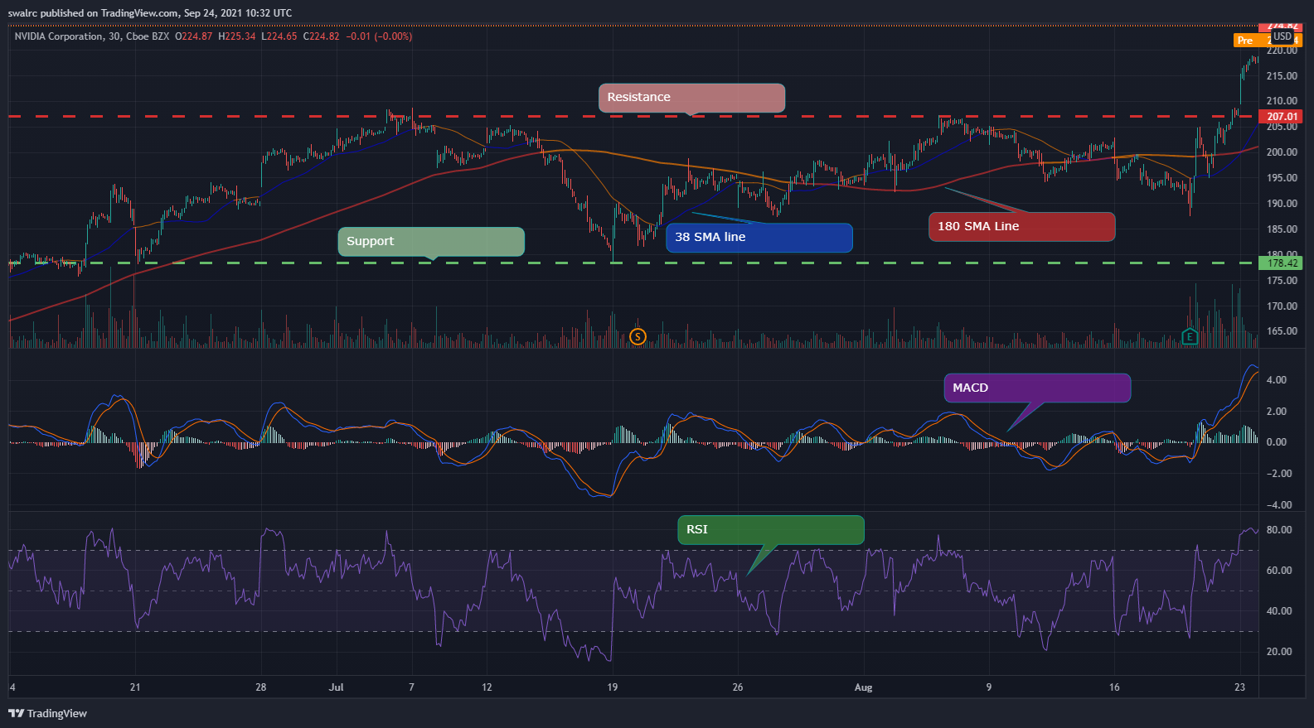

* The RSI (Relative Strength Index) is a tool that helps us determine if a stock is a good buy or not. We can buy a stock when it is oversold to increase our chances of success. Investing in oversold conditions does not guarantee success. It's only one aspect that increases the chances of success in our favorite game.
* Support and Resistance - We may use this to evaluate our risk vs. return ratio.
  + This isn't to say that we'll buy any stock that has a higher upside potential than a lower upside potential. First, we need to see indications of a recovery.
* SMA {Simple moving average} Lines-We use SMA lines to find entry points where we have higher odds of a continued increase as compared to decrease
* MACD (Moving Average Convergence Divergence) is a strength indicator. It will be explored in greater depth at a later time.

Finding Entry and Exit Points in SMA As indicators, we have two SMA lines. They function by taking a specified time period and averaging the results, which is reflected on our price action. The greater the time period, the less responsive to recent events it is, and vice versa. Our short-term SMA line is blue, while our long-term SMA line is red. The instructions for setting them up are listed below.

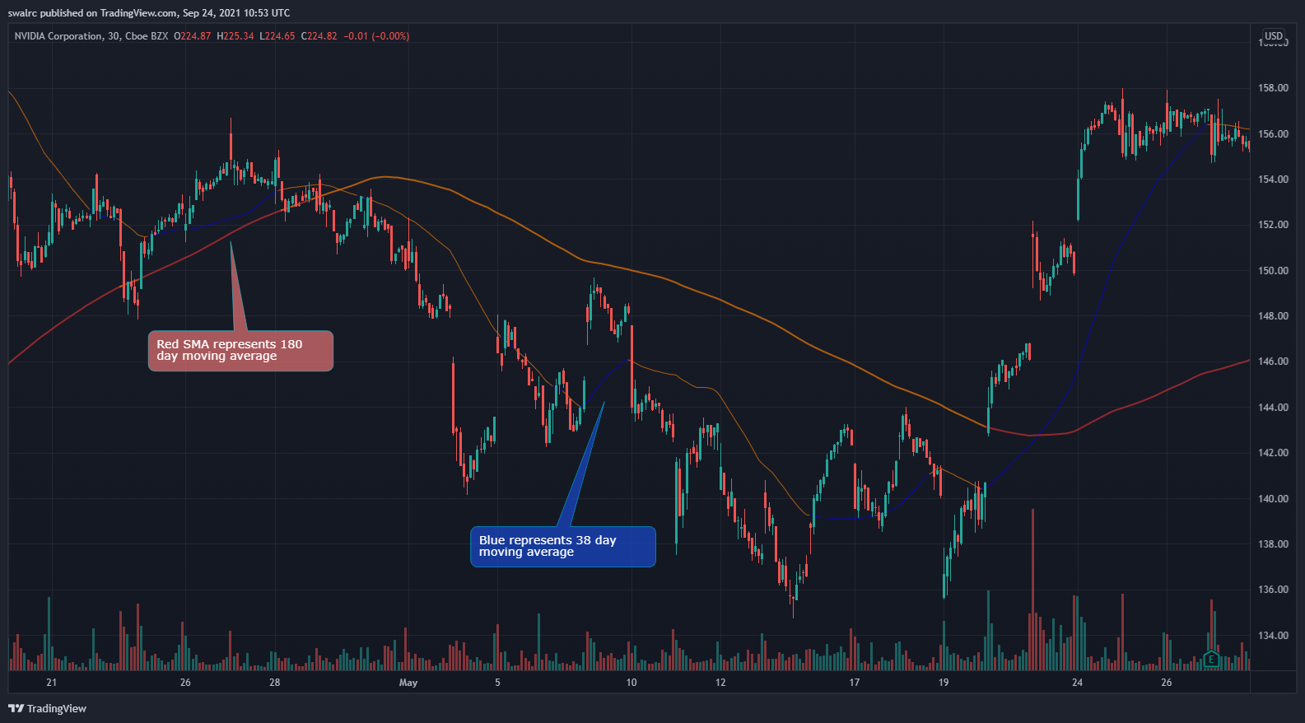

SMA Line (Long-Term) (RED) Our long-term SMA line is red, and it indicates directional strength. We are in an upward direction if we are above the red SMA line, and we are in a downward way if we are below the red SMA line. The following are two examples of this.

Upward

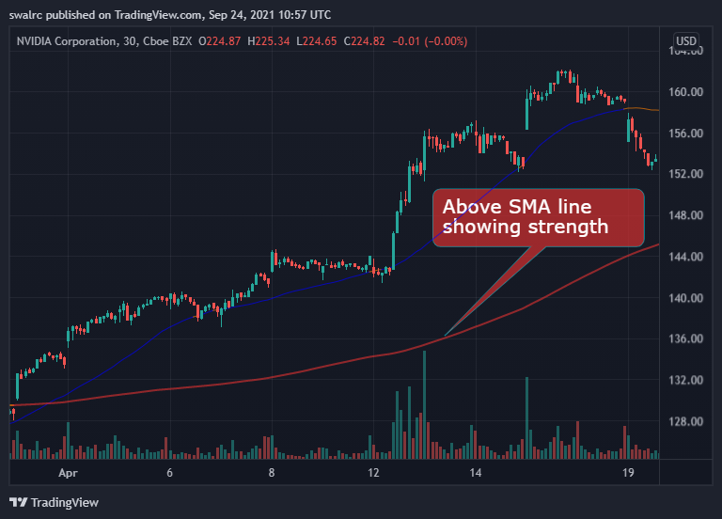

Downward

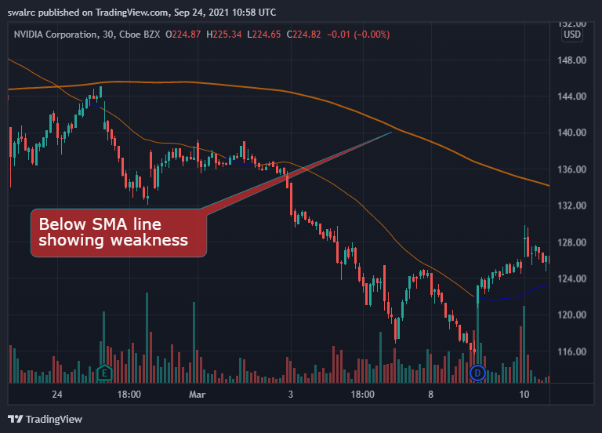

The greater the gap between price action and the Red SMA line, the more powerful the direction.

The importance of direction stems from the fact that you want to execute on the side of the direction. If you execute on the side of direction rather than against it, you will have an additional element working in your favour. That is, in essence, a motivating element. Every positive signal in your favour is a motivating element. A stock that is going upwards is more likely to continue rising upwards than a one that is trending downwards.

SMA Line (Short-term) (Blue) Price strength is shown by the blue line, which is our short-term SMA line. We utilise the short-term SMA line to evaluate minute-by-minute price strength rather than overall direction, as we do with the red line, because it is more reactive to current price activity.

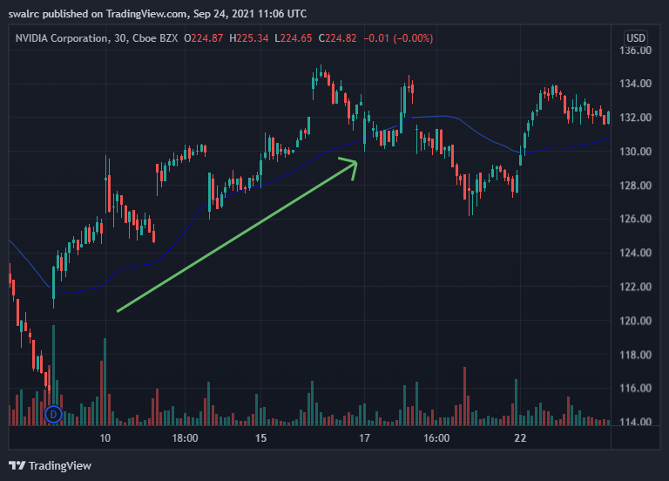

When price movement breaks above the short-term SMA line, it indicates that price strength is present.

The right time to enter a stock?

CONFIRMATION occurs when the first candlestick remains above the short-term SMA line.

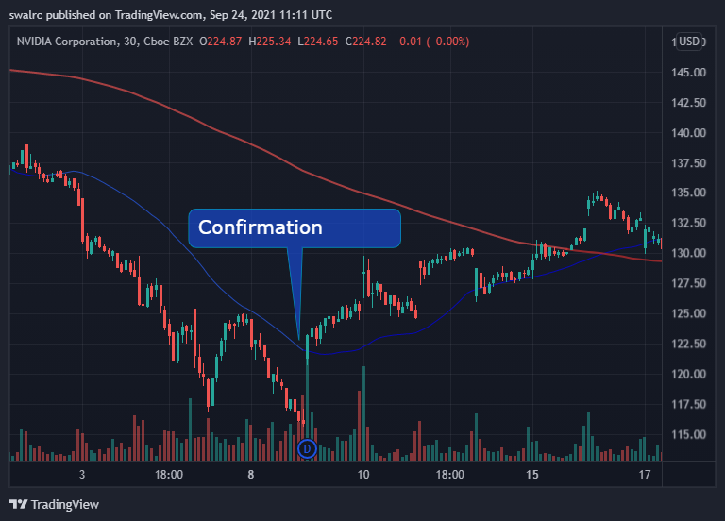

Yes, we are currently in an upswing, as confirmed by a confirmation. It may theoretically still fall down after that, but confirmation is critical since it lets us to enter when the chances of the uptrend continuing are strong.

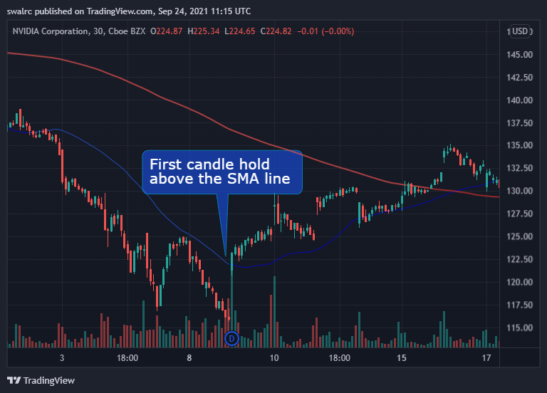

Price Action Intensity The gap between price movement and short-term SMA lines indicates the strength of the price action. The weaker the price action is in relation to the SMA line, and the stronger it is in relation to the SMA line.

We will be able to ride the price strength while also being able to quantify it in a real sense if we buy in at confirmation. We may then enter a position based on confirmation and maintain it until it loses its strength.

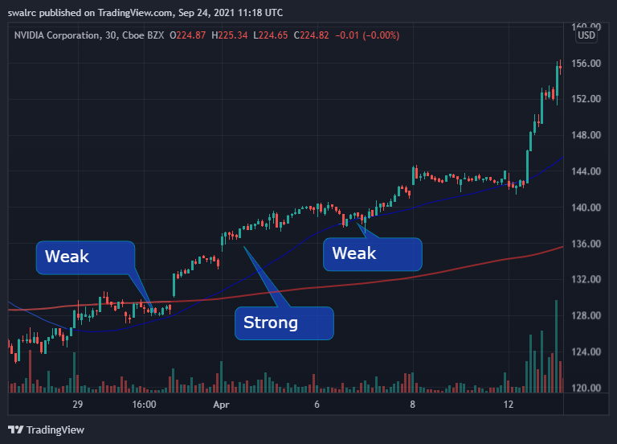

When should you leave a position? The moment at which you should leave is determined by how many uplifting variables you have in your favour. You may simply exit upon VALIDATION if you have a lot of upside potential, are above the long-term SMA line, and are still below fair value (RSI will be discussed later). The first candlestick that falls below the short-term SMA line is considered valid.

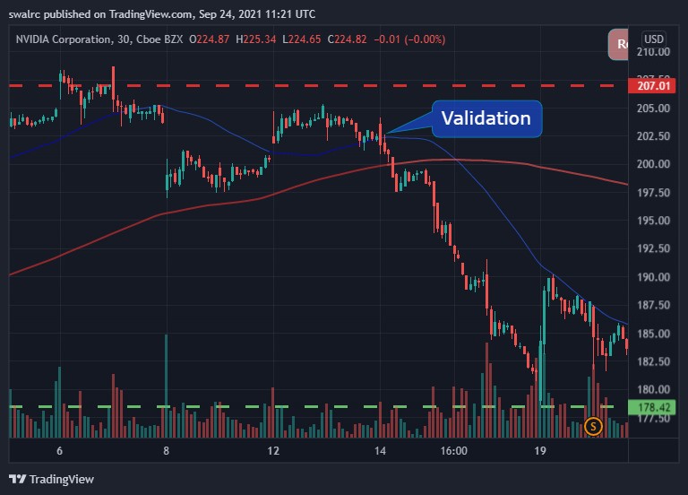

If you don't have all of these elements working in your favor, your position is much more vulnerable. In such scenario, it could be advisable to leave at an earlier warning sign, such as the first time the price action crosses the SMA line, or even sooner if the rising variables in your favor are favorable.

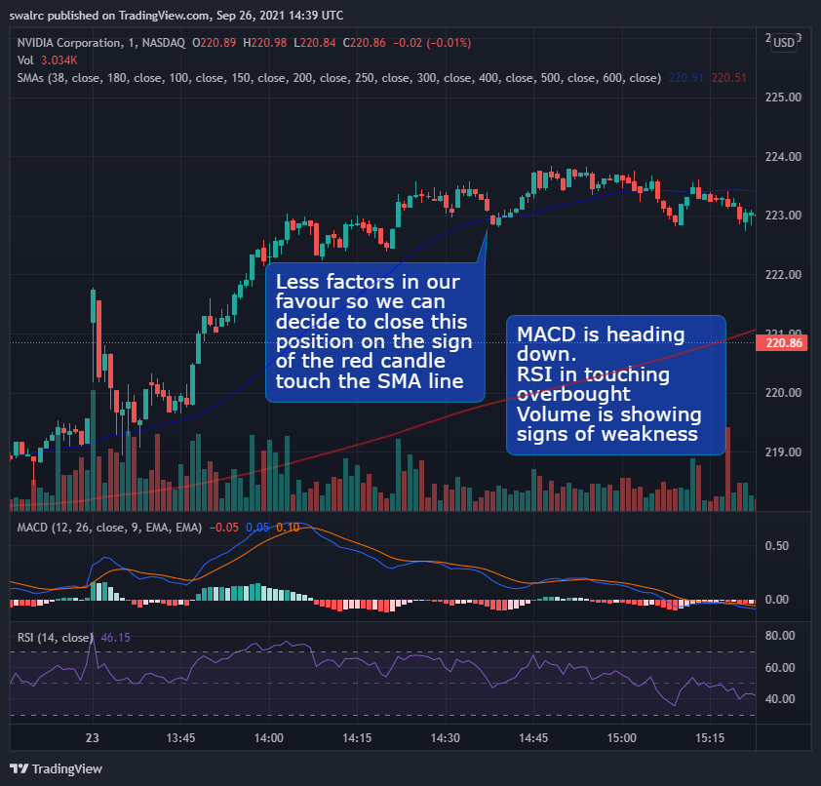

In this approach, you're attempting to tilt the chances as much as possible in your favor. This is done by contrasting the elevating and depreciating forces. It's critical to assess the sensitivity of your position by calculating how many factors are working in your favor. As a general rule, we should leave on a regular validation point if we have a moderate level of probability (Elevating factors) in our favor.

**Remarks in General**

The SMA lines are a basic trading technique that we may use to trade the stock market. They track two factors: price strength (blue line) and directional strength (red line) (Red line). As we progress through this course, we'll notice that SMA lines appear in virtually every case. We'll combine all of the signs later in the course to discover how to calculate our chances of success.

**Example**

We'll use a White Square to indicate the confirmation points and a Red Square to highlight the validation points in these examples.

$SNAP is the first example.

Here, we can observe how $SNAP plummeted after the market opened. Then it battled its way around the long-term SMA line until it broke through and generated some price movement, as shown below

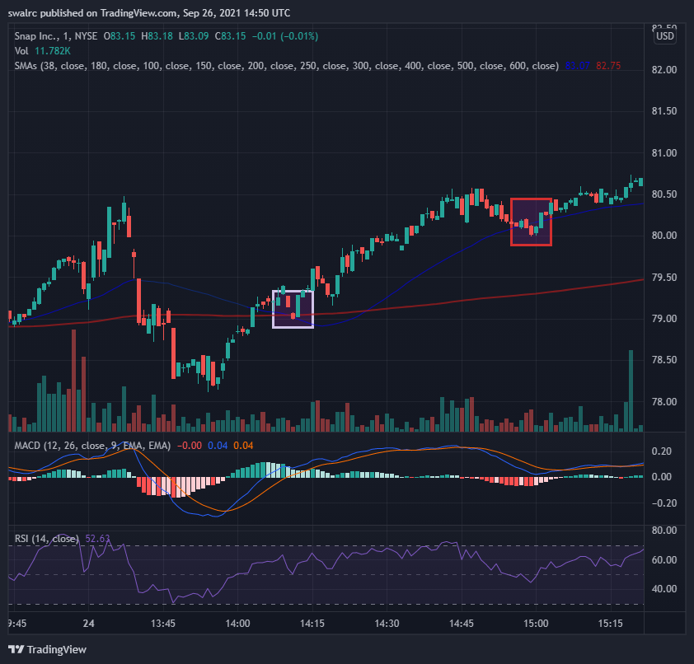

Important Points to Remember

Here are a few key points to remember.

To show the directional strength, we utilize the long-term (Red) SMA line.

To determine price strength, we utilize the short-term (blue) SMA line.

When we obtain confirmation on the short-term SMA line, we buy a stock (First candlestick holding above) Keeping in mind that there are additional variables in your favor.

We sell a stock when the short-term SMA line is validated (First candlestick holding below) Keeping in mind that there are additional variables in your favor.

Confirmations aren't meant to be used as a blind entrance point. They should be used in conjunction with existing excellent installations. Validations aren't only a way to get out of a situation. They'll be assessed on a variety of other things as well.

Validations aren't only a way to get out of a situation. They'll be assessed on a variety of other things as well. If your position is critical, you can leave sooner.

Finding a Good Deal with the RSI–Relative Strength Index We focus on buying on good deals as consumers, but for some reason, many take the opposite attitude when it comes to the stock market. People are more likely to purchase when a stock is rising in price, indicating that it is already overpriced. When buying a stock, we may utilize RSI to identify a good offer. When purchasing stocks, there is a risk of FOMO (Fear of Missing Out) if the stock is rising in value. You could believe that because of the stock's prior performance, it will continue to do well, but you can never be sure with stocks. People keep taking positions because they are afraid of missing out, and when this happens throughout the market, it produces a bubble that can collapse.

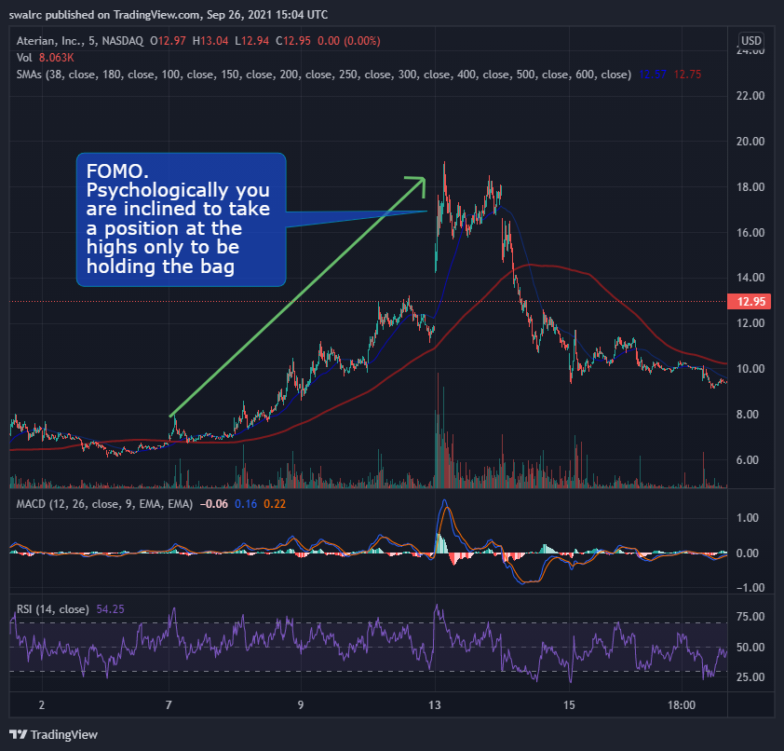

If you're investing because you believe it will continue to run because it has in the past. However, because this position is overpriced, as evidenced by the RSI, it is less likely to continue producing profits.

RSI is an acronym for Repetitive Strain Injury. On the chart, there are two RSI lines, one for Oversold and one for Overbought, as seen below.

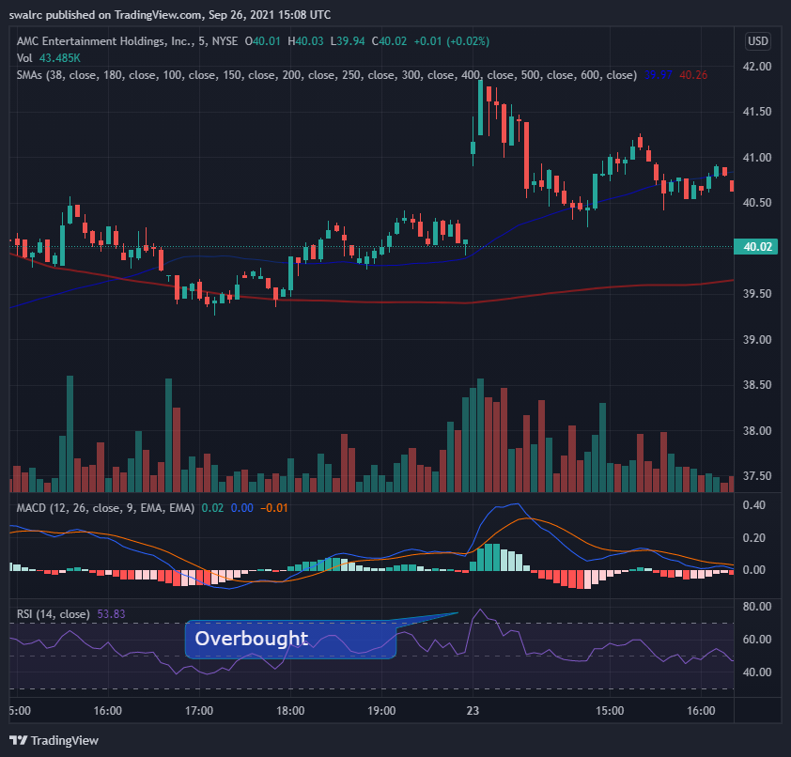

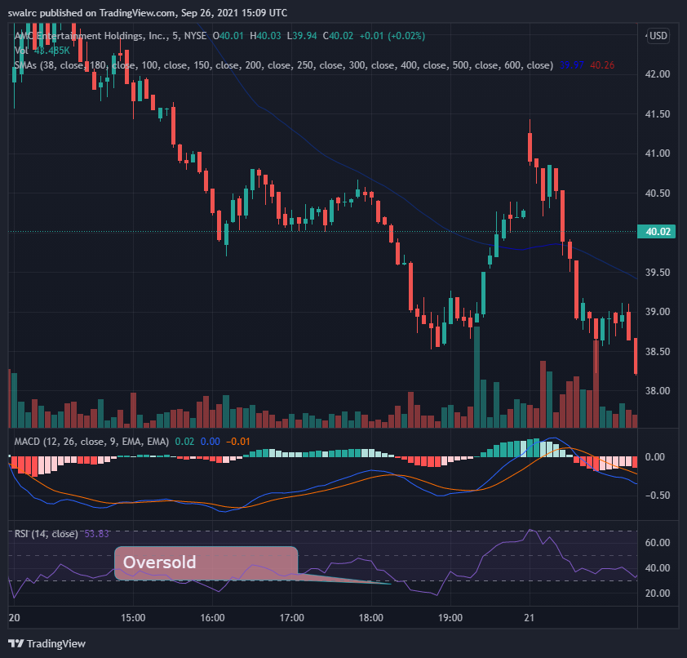

It is termed Oversold if the stock is trading below the oversold line.

The stock is deemed overbought if it is trading over the overbought line.

In the RSI, the exact center line denotes fair value. So anything below the center line is below fair value, and everything above it is over fair value.

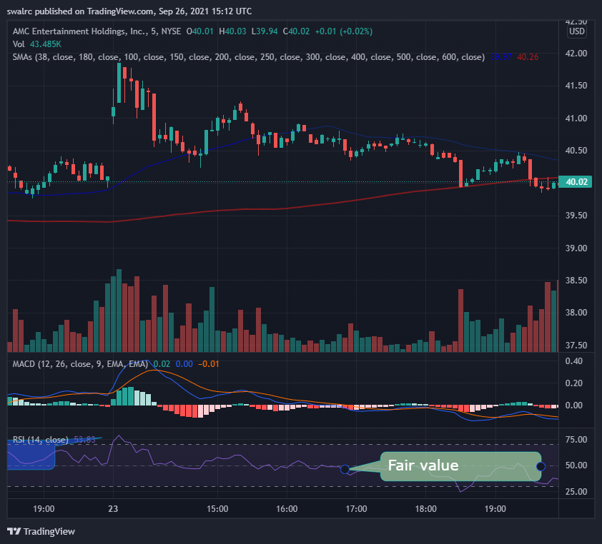

A stock's price swings a lot, as it should. The RSI algorithm crunches and puts all of that data together to determine if it's a good or terrible deal based on prior price movements. You can see in the image below that the RSI should be overpriced at position 1, but it wasn't in position 2 even though the price was higher. This is due to the fact that RSI rates it based on prior price points.

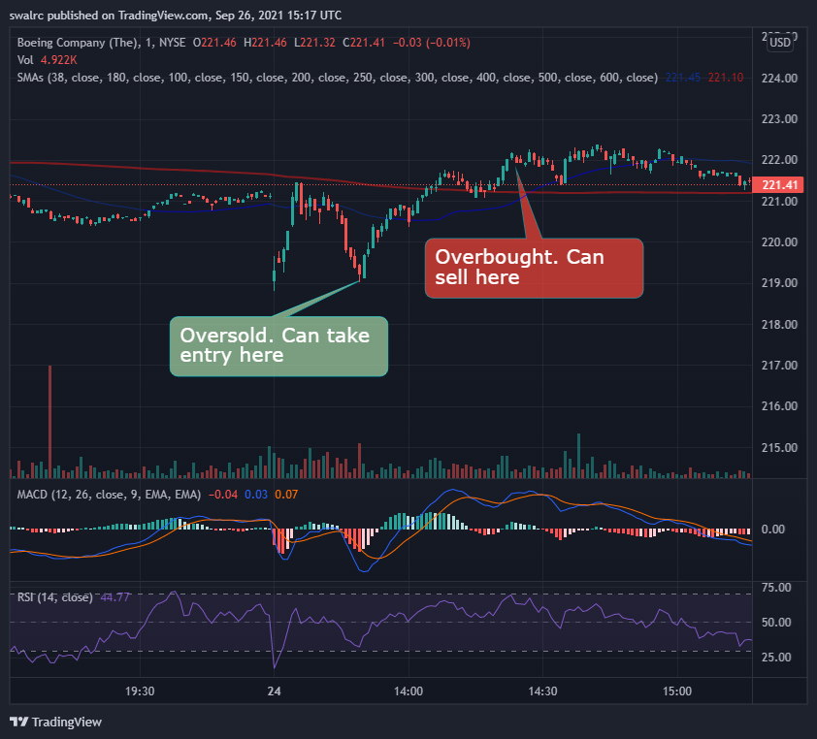

We may utilize the RSI to take trades when a price moves too much up and down.

$TSLA, for example. Even though we had several solid entry opportunities upon confirmation, purchasing on an entry point that was also oversold on the RSI would have enabled us to limit our downside because we were receiving a fantastic bargain, as seen in the $TSLA example below. We may also increase our profit margins in this way.

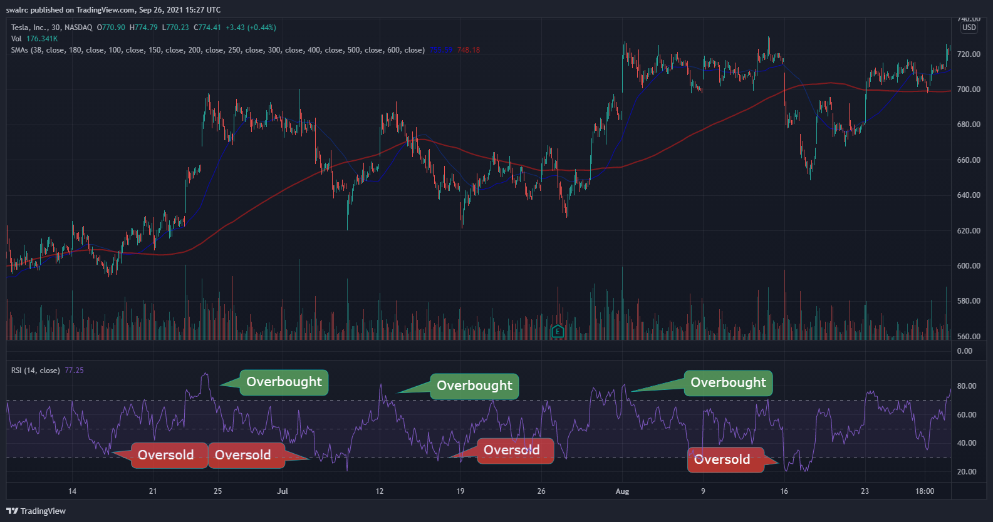

You might have just waited till we hit fair value because this stock has a history of overselling and then recovering to fair value. We'd also see that we'd returned to the opening resistance and had sold out at that time. If you had left certain moves on the table, you would have made approximately 10%. That is the power of elevating factors; when correctly employed and analyzed, a solid mix of elevating variables may help you increase your chances of success

After then, you can be on the lookout for the next oversold situation. As seen below, the next oversold position occurs here. However, there are just two uplifting elements pushing us in the correct path in this case. We've been oversold, and we still have upward potential till we hit the prior resistance. We also have depreciating factors because we are trading below our SMA lines on both sides. As a result, purchasing here would be difficult.

Instead, purchasing it now upon clean confirmation (see below) would have provided us with a comparable entry position to when we were oversold, as well as the ability to purchase at a period of price strength rather than weakness. This also provides us with an entrance point where we already have a history of recovering from.

You might be critical here because it did continue to run after that. The issue is that, while it did continue to run after that, it was an entirely new run-up with a completely different entry point. How did you manage to locate it previously? It has never been feasible to time this previously, and we are looking for long-term consistency.

When a stock is overbought and then continues to run, it becomes a momentum position. The problem is that it lost its price strength when it battled over the short-term SMA line. That implies we wouldn't have had enough enticing elements to entice us into a position until we had another confirmation.

That is the disadvantage of risk management. You won't be able to complete the journey. As a result, you must concentrate on making certain of the moves on a regular basis. This is the cost of maintaining consistency. Trading is a game that is won by a series of trades rather than a single trade. Don't become greedy and hold on even if your motivating reasons have shifted to demotivating considerations.

Important Points to Remember

Here are a few key points to remember.

We utilize the RSI to determine if a stock is a good buy or not.

Oversold (below) and overbought (above) are the two lines on the RSI (above)

When the stock is oversold, the RSI can assist us find suitable entry targets.

To properly assess the most lucrative entry moment, you should combine RSI with other indicators.

RSI is only a tool that, when paired with other elements, enhances our chances of success. This is accomplished by maximizing our gain while reducing our downside by obtaining a better deal.

**MACD (moving average convergence divergence)**:

Gauging Strength MACD is a new technique of measuring price strength and momentum. It may be found immediately below the chart, as seen below.

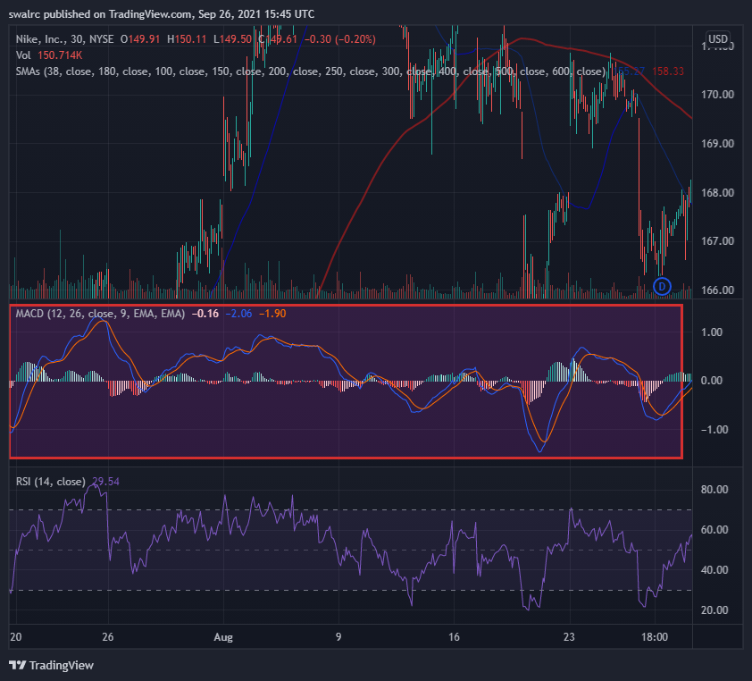

**What is the MACD and how does it work?**

Positive price strength is viewed through the MACD in a different light than negative price strength. We enter a phase of positive price strength when the MACD crosses over

, i.e. the blue line crosses the yellow line, and vice versa.

The greater the price action the wider the gap between the MACD lines & vice versa.

The MACD's histogram bars can also be used to determine the strength of the price action. The higher the activity, the higher these bars will be. In reality, it's quite similar to SMA lines, but from a different perspective.

When you're a newbie, looking at the MACD to assist you evaluate price strength is typically extremely beneficial. On the MACD, being in a positive price strength region is an elevating element, whilst being in a negative price strength territory is a depreciating component. It has a strong connection to the SMA lines, which aids us in assessing price strength.

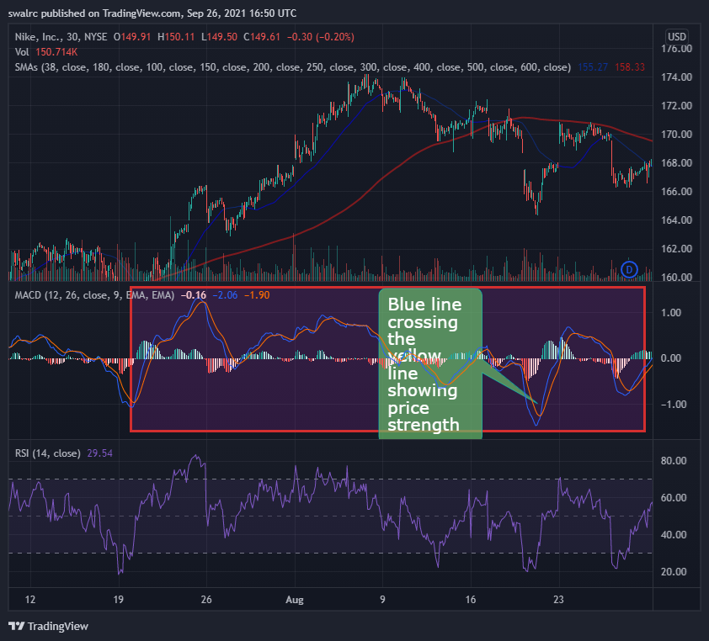

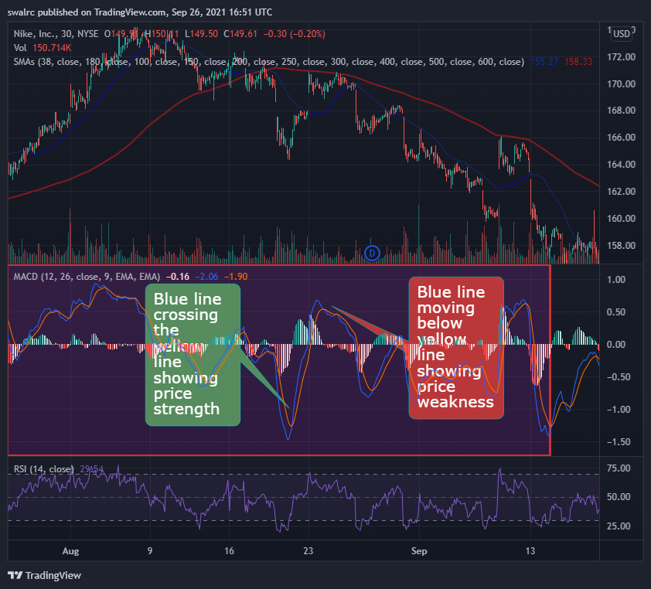

*Find 3 examples of this same movement in the MACD and use them as future references

**Important Points to Remember**

Here are a few key points to remember.

The MACD indicator is used to determine the strength of price movement.

It gives comparable information to the SMA lines but in a more lighted style.

When the blue line crosses the yellow line, it indicates a period of positive price action and vice versa.

Histograms depict the price action's strength.

The better the price movement, the larger the histogram.

It's Critical to Have Direction. We'll talk about the importance of directional strength in this lesson. Our long-term SMA line, as we all know, is the directional SMA line. Price activity above it is regarded rising direction, while price action below it is considered downward direction.

When a stock crosses the long-term SMA line downwards, it is deemed to have accepted a downward direction. As seen in the diagram below

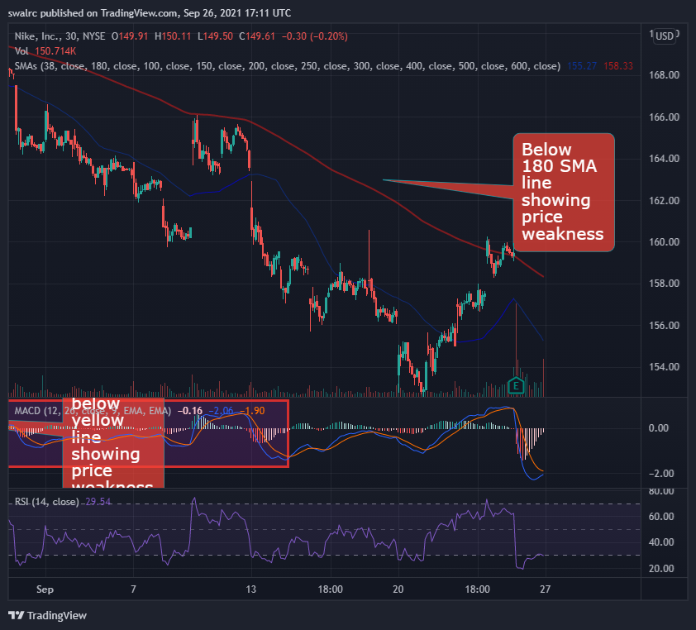

Upward Movement When a stock crosses the SMA line higher, it is deemed to have accepted an upward trend. As seen in the diagram below.

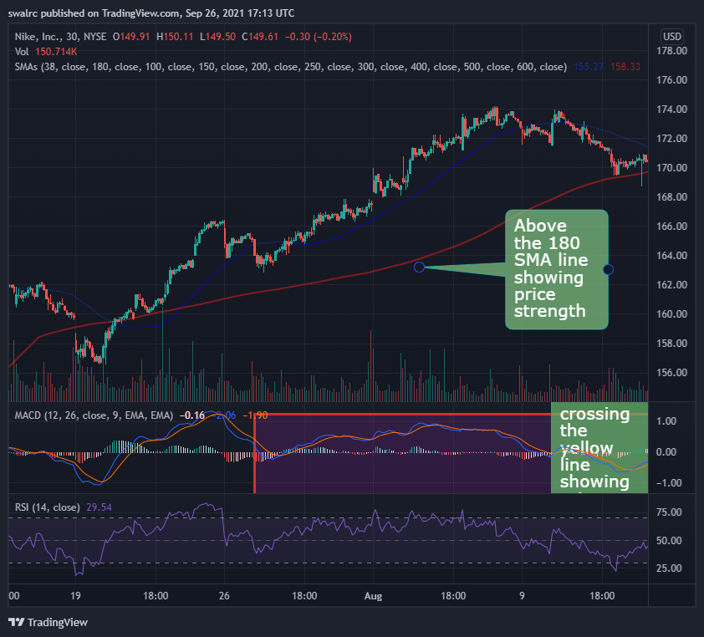

Rejection of Direction: A stock is said to have rejected a change of direction if it gets near to or crosses it for a short period of time before returning to its previous direction. If this occurs, the previous trend will become much stronger. This is due to the fact that investors now know the stock has tried the downside and failed. This indicates that it has strength in its previous direction (Positive).

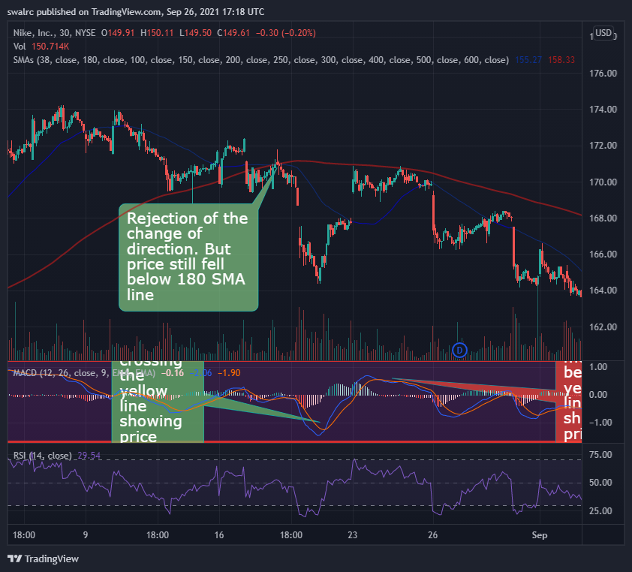

Price movement is uncertain. NETFLIX's direction was uncertain, as it tried the directional change many times during the INTRA day chart. We don't enjoy trading equities with a skewed trend. We do this because we want to trade in a direction that has a good chance of continuing.

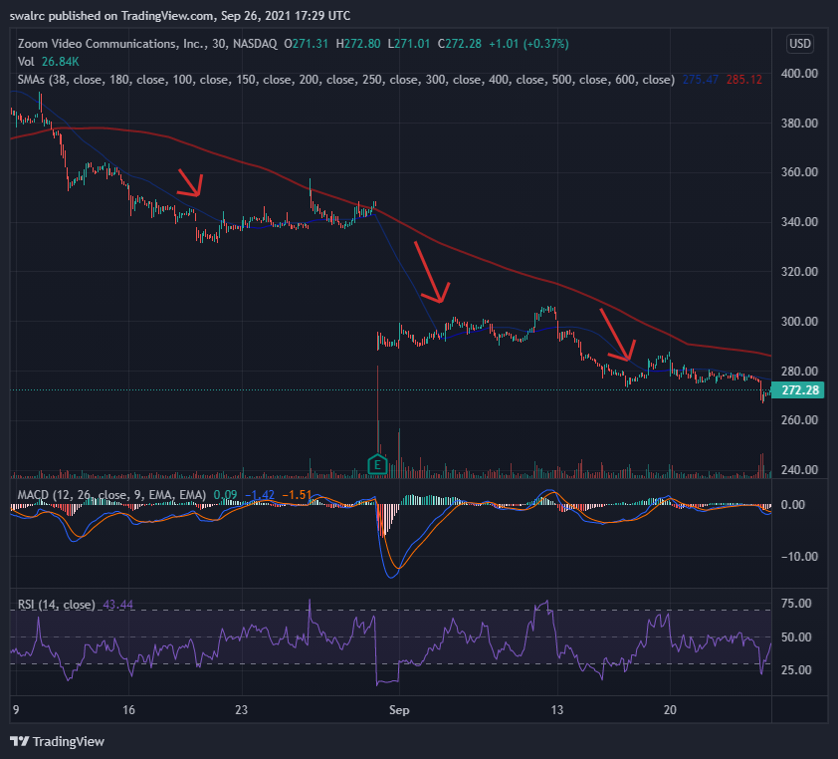

Price movement is uncertain.

$AMZN direction was uncertain, as it tried the directional change many times during the INTRA day chart. We don't enjoy trading equities with a skewed trend. We do this because we want to trade in a direction that has a good chance of continuing.

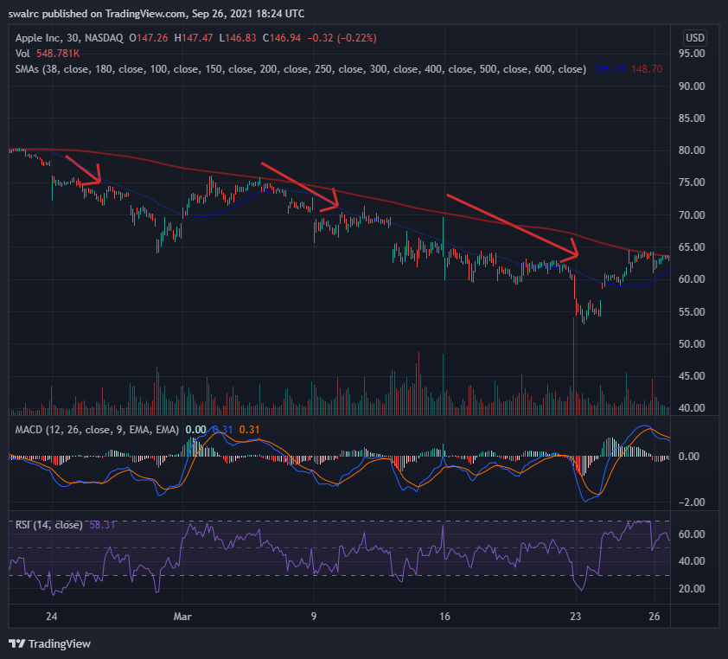

A Crucial Point Avoid trading against the trend because this is a significant depreciating factor. The following are some examples of this. Even if stock prices have plummeted, it makes little sense to acquire a stake if the stock is headed lower in the long run.

*find 3 scenarios similar to the above chart

**Important Points to Remember**

Here are some key takeaways:

Direction is extremely essential and a major uplifting element;

A stock is more likely to continue in an ongoing direction than the reverse;

It is preferable not to trade against the market;

Positive price direction is more forgiving if you make faulty entry positions;

Look for directions on both intraday and long-term charts. Uncertain price action may be tough to trade. You can trade a stock in the negative direction if you notice a lot more elevating causes, but you'll need extremely strong entry points to do so.

**Observing Previous Patterns**

We'll go over some prior patterns that seem to repeat themselves in this section. This can assist us improve our chances of success.

Example 1 AMD

Let's have a look at an AMD example. It has a trend of selling off at market open, as you can see. This trend has the potential to repeat itself.

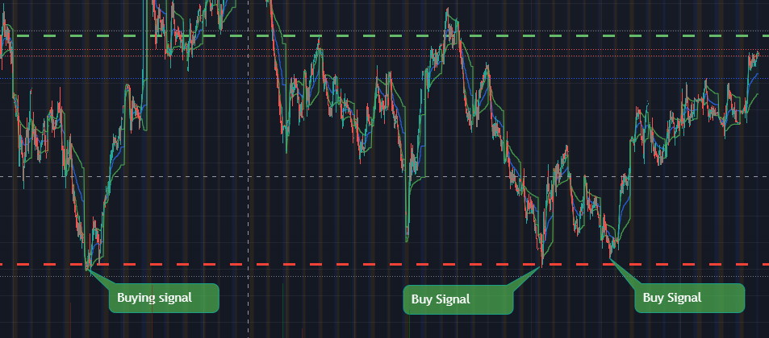

This may allow us to enter at a reduced rate. That is why you should not enter the market just as it opens, since it is more likely to sell off.

**Key Notes**

Over time, patterns tend to replicate themselves. A recurring pattern may be a powerful motivator. On charts, examine at different time periods to determine if there are any past trends. If a pattern has repeated itself previously, it is more likely to do so again. It's also worth noting that, while prior patterns have a tendency to repeat themselves, they don't have to. A pattern might break at any time, thus we should constantly wait for previous pattern confirmation. Even then, a pattern does not have to repeat itself, but it is more likely to do so. In this approach, we improve our chances of success. The more a pattern repeats, the more powerful it becomes, and vice versa.

**Finding the Best Breakouts Has Never Been Easier**

We'll go through how to spot good breakouts in this part. Some individuals advise purchasing equities with higher highs, indicating that they are breaching barriers. However, this isn't always the case. As you can see in the image below, On three instances, this stock has broken through to new highs. There was a lot of upside potential in the first one; we were oversold on RSI in the second one; and if you purchased it at a greater high, you would lose a lot of money in the third one. That is why it is critical to distinguish between a poor and a good breakout

**Exmaple 1** NVDA

Let's look at another example of a good breakthrough. There are multiple breakouts here. We may have purchased at confirmation and ridden the price action until the next confirmation. We might have also purchased it at the breakout.

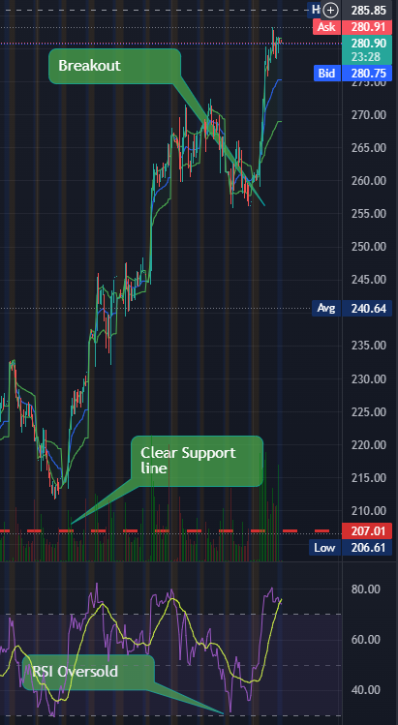

**What distinguishes a high-quality breakout?**

You must first determine whether the breakout is part of a health uptrend, as seen in the example below. We experienced two little breakouts, then pushbacks, and then a major breakout. On the RSI, a robust and long-term uptrend may now be oversold. However, you can benefit from it as long as it provides price action confirmations. The trick is to ride the breakout before it loses momentum at the conclusion, rather than buying in merely because they broke out.

There's nothing wrong with the RSI being oversold. It enables us to get in on a pullback and sell out when the market becomes oversold. Any upward trend in health will be met by a slew of little setbacks.

We've just spoken about support and resistance breakouts thus far. We'll start to see some directional breakouts now. For example, we saw a directional breakthrough and then fantastic price activity in the chart below. We had a breakaway here, and then we put the change of direction to the test. When it was able to hold it and go higher. You should constantly be aware that when there is a change of course, we normally conduct a test. This gives them confidence that they can stop the breakout. This guarantee is crucial.

**$DWAC Below with a clear breakout after being exponentially oversold**

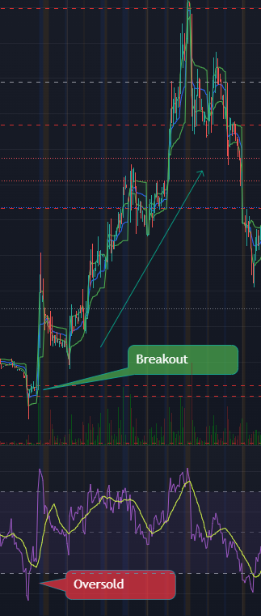

Important Points to Remember Here are a few key points to remember. To determine whether a breakout is robust, check to see whether it is being reinforced, such as by testing a reversal, accepting a reversal, and rejecting it, as well as the health of the uptrend (Over selling on RSI) When it comes to testing the breakup, reassurance is crucial to observe.

**Pattern of Return**

Because of its simplicity, this is one of the most well-known trading patterns. This is the overselling and overbuying trend. This pattern has the potential to significantly improve our chances of success. This pattern can appear on a variety of time period charts, including 1-Day, 2-Day, 5-Day, and even 180-Day charts.

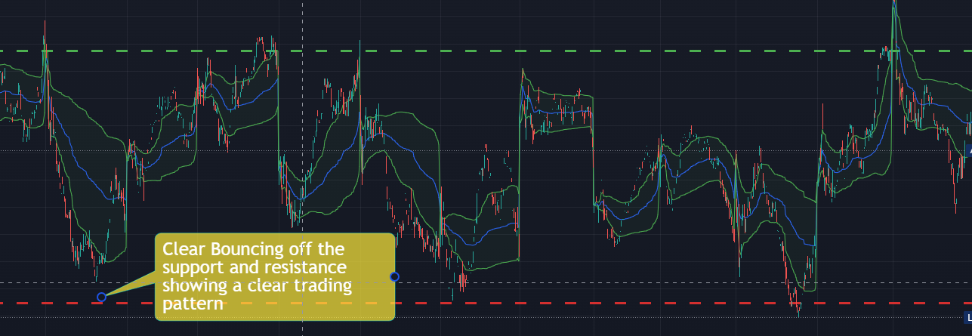

This is the most basic type of design. If you look at the chart below, you can see that we could have simply purchased at an oversold level and sold at an overbought level on the RSI and earned a profit. This is a significant motivator. When used alone, this pattern has a lot of promise, but when paired with the other technical tools, it greatly increases our chances of success.

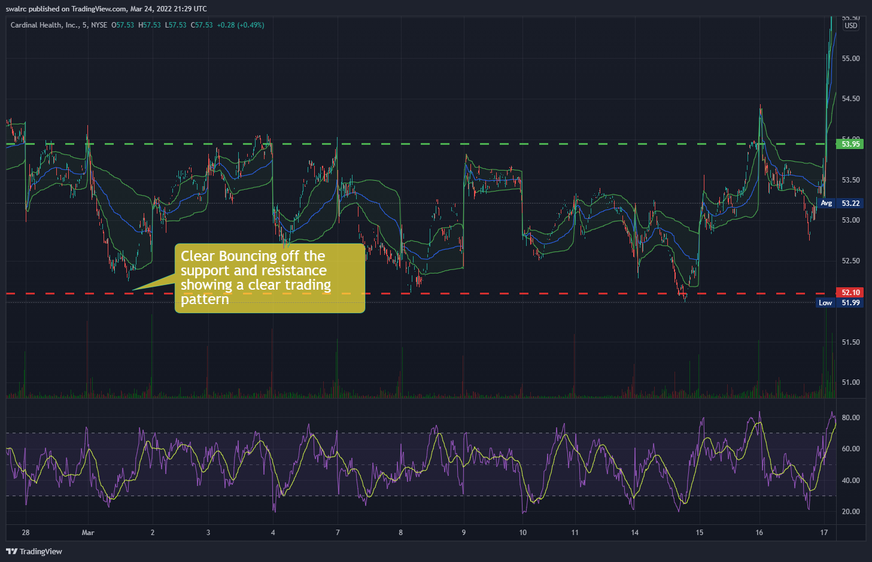

Make sure to keep an eye on the RSI. As you can see by observing the direction of the RSI you can plan your entry and exit for the following trade.

**Important Note**

It's vital to remember that if you have a stock that is continually heading downhill, you'll have a hard time trading it, even with the Comeback King pattern. This is a bad indicator if you have a negative direction.

**Important Points to Remember**

Here are a few key points to remember. The goal is to use the RSI to determine common levels of support and resistance. Oversold-overbought, oversold-fair value, fair value-overbought, and so on are all possibilities. Also, remember that trends tend to repeat until they don't. As a result, you must combine these patterns with additional technical indications to increase your chances of success. Take them as merely motivating factors rather than precise entrance and departure locations. We don't buy stocks just because they're on sale.

**DoubleBottom**

The Double Bottom will be discussed here. As we previously established, the more times a price tests a level, the more powerful it becomes. That is exactly what the double bottom is for. Let's look at an example FB to see how this works.

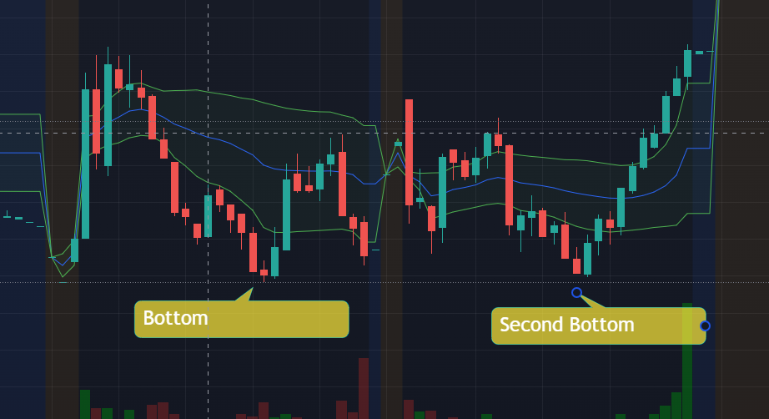

When a stock reaches a double bottom, it's more likely to rise to its prior high, and if it does, it becomes a momentum play, as it did in this case. This is not by coincidence, as we must emphasize. This is because we have a support here, which we have now double-checked. It can only move up or stay flat once it has been established that it has the power to hold on to this level. If it rises, we have upward potential up to prior resistance, and if it breaks that, this becomes fresh support. Remember that old opposition can become fresh support. As a result, we have a huge upward potential following that.

**Important Points to Remember**

Here are a few key points to remember. Double bottoms happen when you hit a support level twice, making it stronger. After that, the stock will most likely only go up or flat. They can then go into momentum positions if they break the obstacle. These are only raising aspects, which is why you must combine them with other technical indications to increase your chances of success.

Choosing the Most Appropriate TimeFrame It's critical to choose the right time period. There is no universal timescale that applies to all circumstances. It all depends on whose side you're on. Fortunately, when choosing a time range, there is one fundamental guideline to follow. The guideline indicates that you should choose a Timeframe that corresponds to the length of your location. In other words, you should choose a time period that corresponds to the length of time you will be in your position.

**What is the support and resistance time frame?**

In such scenario, the situation is exactly the reverse. In these cases, long-term support and resistance levels matter more than short-term support and resistance levels, regardless of the time period. This is because long-term decisions are regarded as more significant than short-term decisions. When a stock falls below its 52-week low, there is a lot of hoopla in the media. It's the same with encouragement and opposition. A company like Tesla, for example, would reach its 3-Year support after several months of decline, and sustaining this support is a major thing. This is due to the fact that you can now get it for the lowest price in the previous three years.

**Example $LCID**

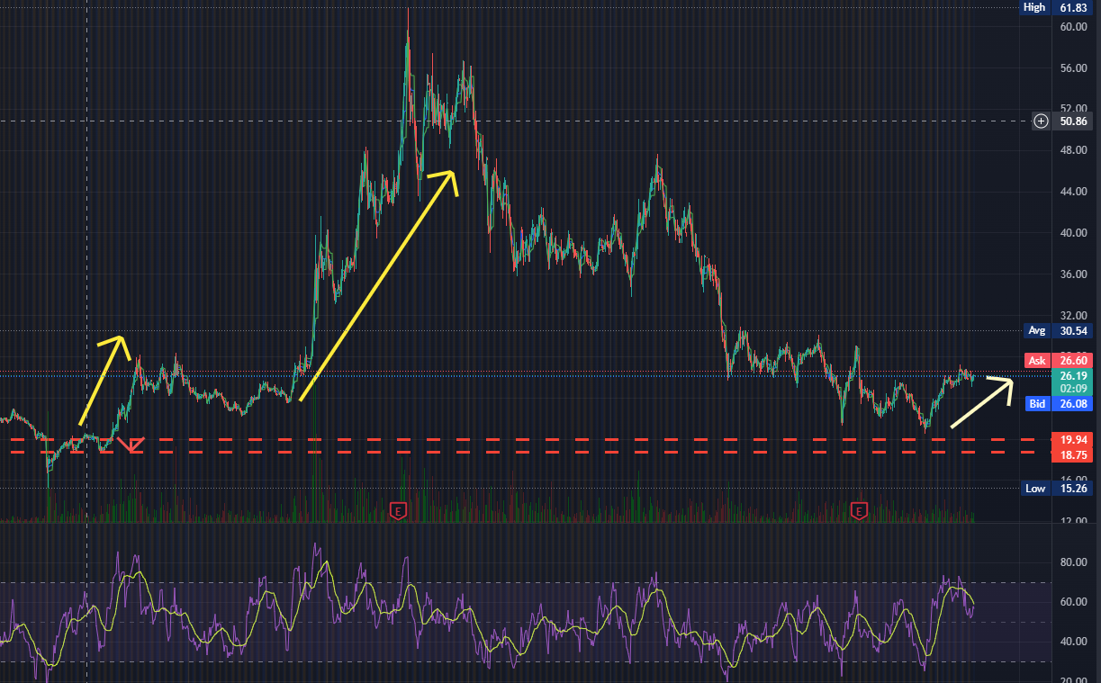

This is also a significant upward indicator since it indicates that we have now reached a discounted price, held it, and are now beginning to run-up. However, if it falls below this three-year support level, it will be a significant depreciating factor.

What are the advantages of looking at the context of this build-up?

Because we want to take a day position, it makes sense to concentrate on the day chart. By taking a look at the larger picture, we can see how strong this move is and how strong the upward momentum is.

After being knocked down for a long time, we can see that this is part of a bigger breakthrough into the upward direction. As a result, we know that any price increase in this environment would be quite strong.

**Important Points to Remember**

Here are a few key points to remember. Focus on the time frame that corresponds to the duration of the position you are going to take. Also watch the longer time charts to see the context of the move. When utilizing several time charts, you can get entirely different signals on the same indicator.

**Squeezing and Measuring Volatility**

We'll talk about volatility and volatility squeezes in this section. Volatility is critical since it is similar to the gasoline that our automobile runs on. There are no transactions if there is no volatility. Volatility is defined as the difference between the bottom and top of the price movement, plus the difference between the bottom and top of the price action. How frequently does it go there?

**$GME short squeeze**

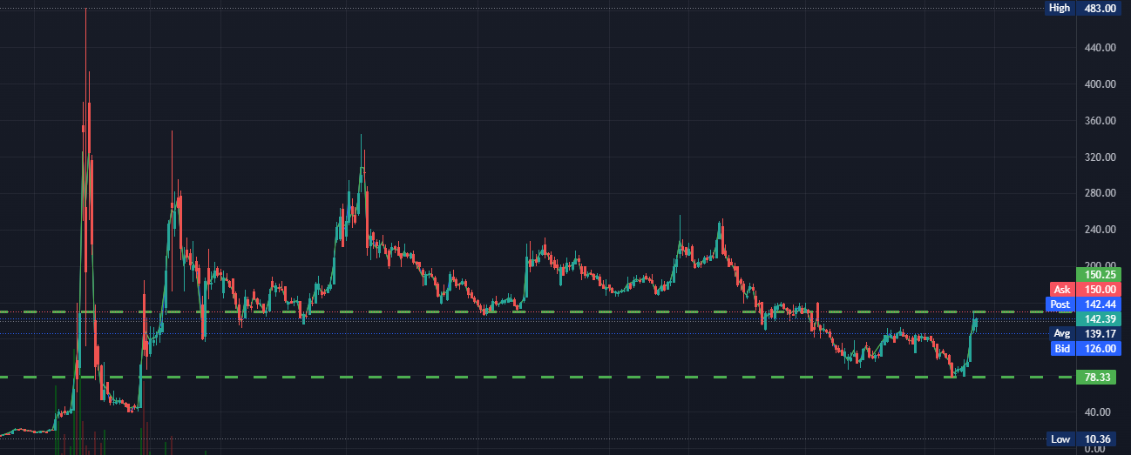

**$MSFT**

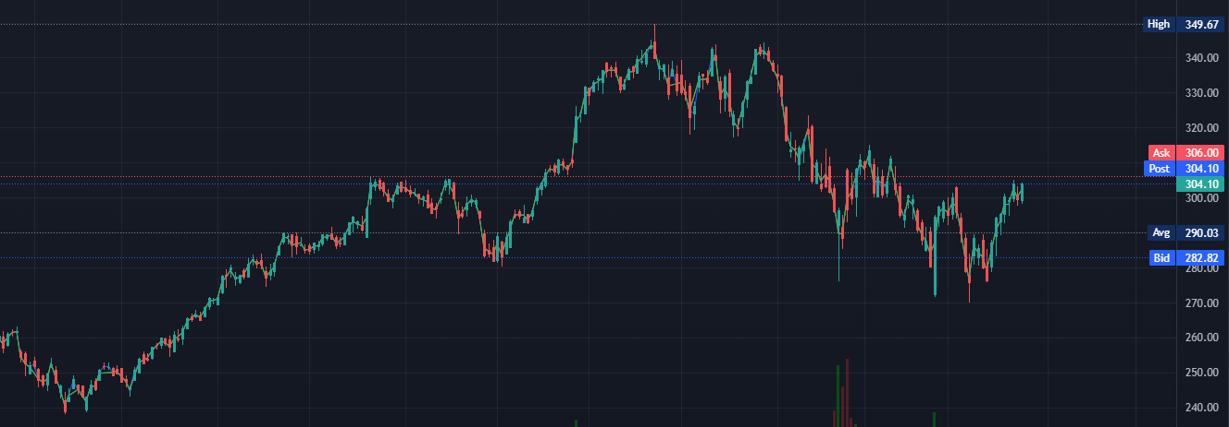

What is the distinction between these two graphs? When comparing $GME to $MSFT, it is evident that $GME has higher volatility. As a result, it has a larger volatility, which means there are more possibilities to purchase it at a low price and sell it at a higher price. There are also more points that are overbought than there are places that are oversold. MSFT On the other side, because it is so flat, there are fewer clear run-ups and hence less possibilities. As a result, you might deduce that greater volatility equals greater opportunity. Now we'll look at how to calculate volatility and how it varies over time.

**Bollinger Bands**

Are a type of band that is used to describe As a newbie, you can utilise a tool to better understand stock volatility. Bollinger bands are added to the research, as seen below. Because these Bollinger bands make the chart a little cluttered. As a beginner, though, you may add them to the chart to get a feel of volatility. Once you get more experience, you will be able to view it without these bands.

**$PTON**

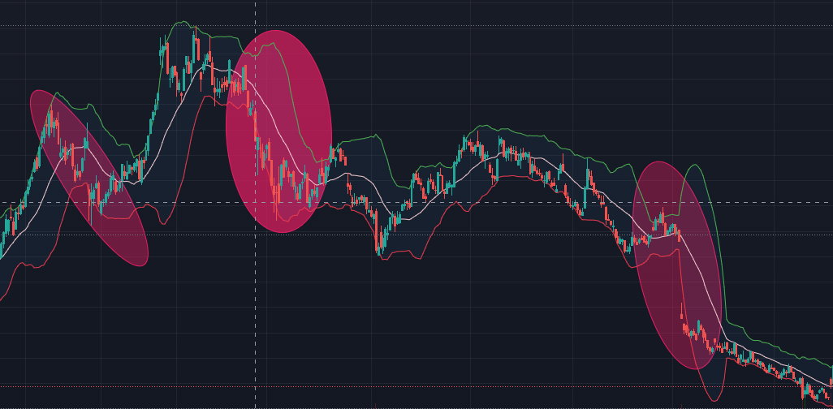

You may also deduce that this stock is more volatile during market open from this information. As a result, it may be a better time to trade this stochastic.

**Some Crucial Points**

When you have a stock that is tightening, that is, the volatility is becoming really tight. This suggests you've got a volatile squeeze on your hands. If it is opening, on the other hand, we are seeing a volatility growth. It's an elevating element to have extremely low volatility on a stock with a historical price trend of constricting and then expanding.

This occurs because it has a tendency of doing so in the past, and price action can only go to a particular tight limit. As a result, knowing when something like this is happening may be really beneficial to us.

The inverse is likewise true, in that it can only extend to a certain extent. The more Volatility is spread out, the more likely we are to see a drop in Volatility. This may be a derogatory factor.

**Important Points to Remember**

Here are a few key points to remember. More volatility is an elevating element since it might generate price action to trade. If volatility tightens/expands too much, it is more likely to shift the other direction, i.e. expand/tighten. You may use Bollinger bands to observe regions of high volatility in the beginning. You can utilise Volatility to your advantage by finding areas/time periods of high volatility. A volatility squeeze is most likely to occur just before a Breakout.

**Aggression: Finding Aggregation Periods**

Now we'll talk about aggregation periods, including what they are and how to find the right one for your aggression or conservation level. Simply explained, the aggregate period is the amount of time represented by a single candlestick. For example, you may utilise 1-minute, 2-minute, 4-hour, and a variety of other time intervals. The more forceful you are, the smaller the Time utilised for a candlestick. When trading, you should avoid being excessively aggressive or conservative. This is always dependent on the nature and duration of the employment. It's like there's a sweet spot for each position. It is only through further practise that you will be able to master it.

Example $QCOM

Let's look at $QCOM. As you can see in the image below, we have a 1-minute aggregation period, and the price movement is highly filthy, making trading difficult. This is due to the fact that we frequently discuss buying in at confirmation and selling at validation. However, because we are trading really aggressively (1 minute), we have a lot of movement on the SMA. It's not easy to swap this.

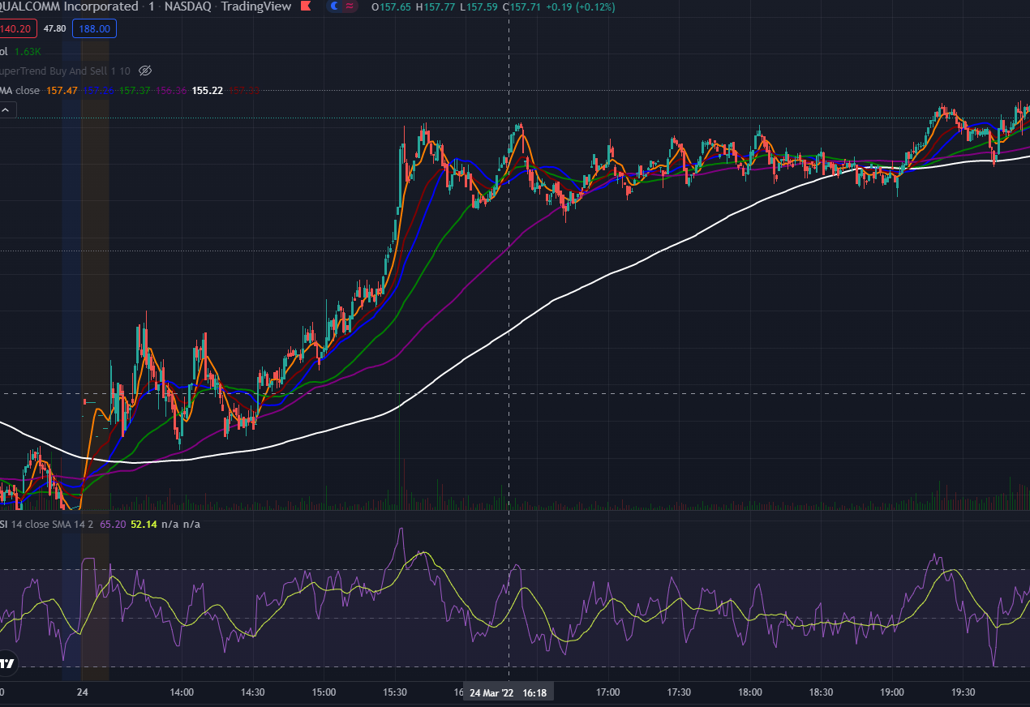

We may raise our aggregation period from 1-minute to 3-minute if we want to tidy it up a little bit. The end result may be seen below. Now that we have a clear confirmation and validation, this price movement is more tradeable.

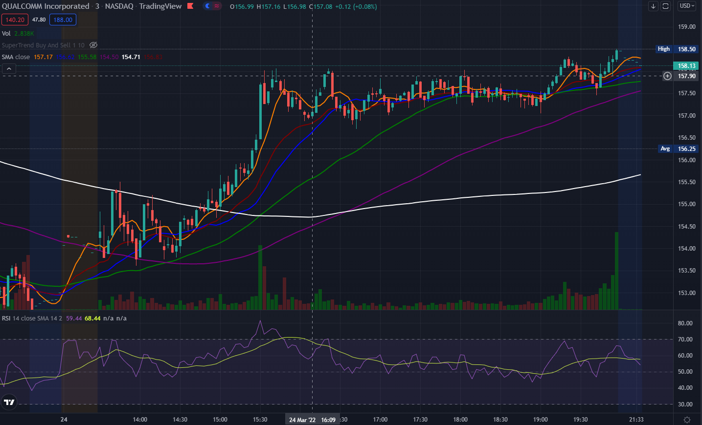

How do I know which Aggregation period I should use?

It all depends on the sort of position you're taking and the type of opportunity you're looking for. As a result, trading 3-minutes or even larger aggregate periods makes more logical. It's possible that if we increase the period too much, it'll become excessively cautious. It's still OK when we attempt 5-minutes here. It would, however, have caused you to adopt a stance a little too late. As a result, if you're too cautious, you won't be able to catch some of the moves.

**Important Points to Remember**

Here are a few key points to remember. The time depicted by 1-Candlestick on the chart represents the aggressiveness period. The shorter the aggression period, the more aggressive it is, and vice versa. A messed-up chart can be cleaned up by increasing the aggressiveness period. Your degree of aggression determines the confirmation and validation points, depending on the type and length of position you will take. It is advisable to utilise the more aggressive period for fast moving intra-day charts. If you make it too conservative, you may miss part of the price movement. You must find the sweet spot between being too aggressive and being too cautious.

**When to Exit:**

Minimize Losses and Maximize Profits We'll talk about cutting losses and taking profits in this part. We need a strategy that is both conservative and aggressive enough to safeguard our wealth while also allowing us to take winning positions. Trading, as we all know, is a probabilistic game, thus some losses are unavoidable. That is why it is critical to have a plan in place for when to accept a loss and leave a trade.

**STOP THE LOSSES**

Setting a STOP LOSS is the primary and most usual approach to limit losses.

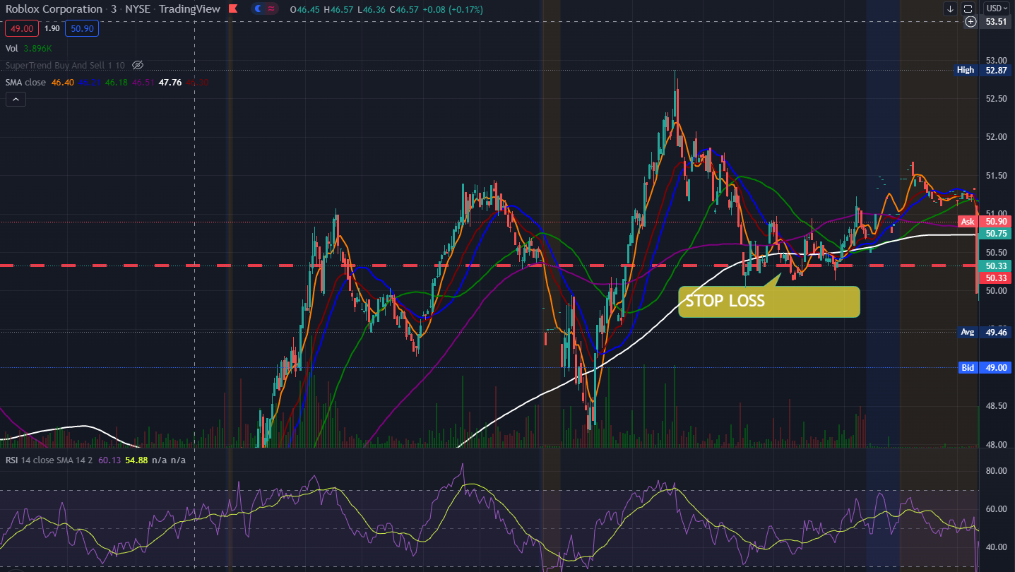

I'm not a huge supporter of utilising STOP LOSS as a catch-all technique since it's too rigid, but it's beneficial for preparing for worst-case circumstances. You shouldn't totally rely on a mechanical stop loss since it removes your intellect from the equation. If you are a newbie, it is recommended that you establish a STOP LOSS that is high enough to safeguard your money in the event of a worst-case scenario while still being low enough to be unrelated to current market movement. This is due to the fact that an overly high STOP LOSS might force you out of a trade with a minor price change.

For example, if there is a significant decline from current price action to this level, the stop loss will come in handy. The Bad Stop loss illustrated above might force you to depart a position you didn't want to leave.

**VALIDATION**

VALIDATION is the moment at which you should consider exiting a position. This has previously been mentioned in the section about SMA lines. However, this is not the entire tale. The VALIDATION POINT is not a specific departure point. It's just a moment at which you compare your elevating and depreciating aspects and make a selection.

$TTD

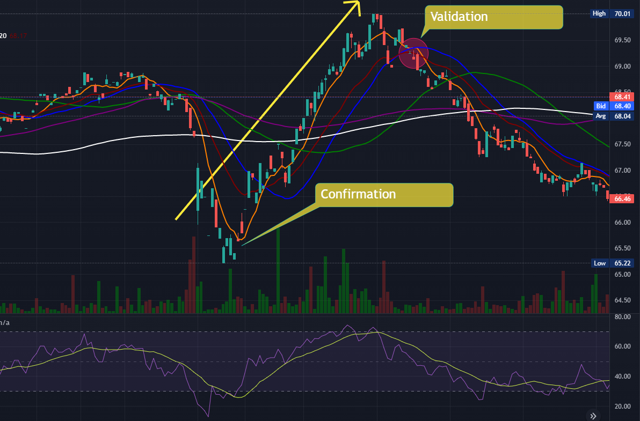

As you may be aware, we place a premium on buying a stock at CONFIRMATION. We consider VALIDATION while deciding whether to exit a trade at a profit or a loss. The first candlestick below the short-term SMA line is called VALIDATION. Simply following the CONFIRMATION and VALIDATION guidelines would have worked well in the aforementioned scenario. However, in this section, we'll talk about how to cut losses. Assume we take a position on a stock as illustrated below on CONFIRMATION, despite the fact that the RSI is overbought.

Why would you continue in it if you wouldn't contemplate taking a position at the validation point? In the example above, we can see that the RSI is now at fair value, and we are still hitting the price strength of our short-term SMA line. These are two variables that help to raise the bar. However, we are still on a downward trajectory, with an equal amount of upside and downside possibilities. As a result, it could be reasonable at this moment to limit our losses owing to these depreciating variables. This means you could lose out on the upside on the subsequent run-up, but that's alright because we can't focus on taking the entire move every time. Trading does not function like that.

If you take a loss here, you're protecting yourself against all the possible downturns. If you followed the Confirmation guidelines, you may enter a new position here and ride the price strength upward till validation. You would have been able to benefit as a result of this.

**Important Points to Remember**

Here are a few key points to remember. When deciding to quit, ask yourself, "Would I be likely to accept this job again if I wasn't currently in this position?" Because trading is a probability game, cutting losses is a necessary element of the process. If used correctly, stop losses may be beneficial. Poor stop losses might force you out of situations where you wish to stay. Charlie despises mechanical stop losses. Another option is to depart at the Validation stage. Validation refers to the moment at which there are more deprecating factors than raising factors. It is not a foreclosed exit. You must also assess the issue and take appropriate action.

**Must Perform the 7-Step Test for Profitability**

1.Find a time frame to FOCUS on.

Which time frame will you be concentrating on? Choose the one that will maintain your position for the period of your trade as well as the pattern/movement you want to trade.

2.Assess Your Risk vs. Reward Situation

Do you have a higher upward potential than you do a downward potential? Is there a sufficient "road" of reward to propel the price action higher?

3.Make a list of your elevating and depreciating factors.

Are you getting a good price on your purchases? Do you have pricing power? Are you heading in the right direction? Do you have any proof that the market is strong?

4.How does the situation appear in the long run? What are the long-term raising and depreciating factors? If you have any major long-term depreciating elements, make sure you mention them when you take a position.

5.Can you think of any news catalysts? Why am I buying and selling stocks? Is there a connection to a news catalyst? Make sure you understand that every stock market reaction is an overreaction, and that prices may reverse VERY fast.

6.What is the analyst's price target for the stock? It'll be useful to know where the analyst price target is if you're trading an investor speculative play (large run-up, news catalyst, earnings release, etc.). If it is far higher than your current trading price, this is a great motivator for sheep investors. They'll assist in raising the price.

7.Is the job VALUE FOR MONEY? Do not trade a setup that does not make sense in light of your elevating and depreciating aspects. Overtrading is a sickness that will devour your bank account like a jack rabbit devouring jack cheese.

**Smart Trading Techniques**

Developing a Plan:

A Step-by-Step Guide When trading stocks, you must have a strategy. Never get in at arbitrary entry points and then sell out when it feels like the moment is appropriate. When trading stocks, you should always have a strategy in mind. Don't make a decision based just on your feelings. You can take the emotions out of the game if you have a precise plan with entrance and exit points. What does it mean to have a strategy?

Questions to ponder

1.What must occur in order for me to be considered for a position?

a)Do I Have To Wait For Confirmation?

b)Waiting For What Elevating Factors? Is it a VALUE FOR MONEY? Is there any confirmation of the PATTERN? How strong is our price position? Is this a high-probability scenario?

Remarks

Always, always, always, always, always, always, always, always, always, always, always

1.We wait for the positive aspects to outnumber the negative factors. For that, look at price strength, fundamentals, analyst price targets, and so on.

2.How will I know when or if the stock is appropriate for my strategy?

a)Have I Activated My Alert?

b)Am I Paying Attention To The Chart?

c)Did I Make A Limit Purchase?

3.What must occur in order for me to EXIT a position?

a)Do I Have To Wait For Validation?

b)What Negative Factors Am I Anticipating? Is it now considered OVERBOUGHT? Is there a BREAK in the pattern? Is our pricing power eroding?

4.How will IFIND OUT whether or if a stock is appropriate for an exit strategy?

a)Have I Activated My Alert?

b)Am I Paying Attention To The Chart? c)Did I Make A Limit Purchase?

**Good ENTRY Plans include:**

1. "I'm noting that we're oversold, therefore I'll buy in if we have confirmation of price strength."

2."I'm observing a trend of moving from $55 to $65 on a regular basis, so if we go back to $55 and receive confirmation, I'll take a position."

3. If you're looking for a "I want to take advantage of this stock's pullback from an uptrend. But I'll hold off till I have confirmation."

**Bad ENTRYPlans Examples:**

1. "I've seen that this stock is oversold, therefore I'm going to buy because it's on sale."

2."I'm noting that we've had a tendency of moving from $55 to $65, so I'll buy in blindly when it gets close to $55"

3."This stock has had a pullback from an uptrend; I want to profit RIGHT NOW!" Because we're in a pushback, I'll simply buy in."

4.Examples of Effective Exit Strategies:

1."I'm noting that we're overbought, and we're losing price strength, so if we hit validation, I'll leave."

2."I'm going to go out since there are a lot of depreciating variables."

**EXIT Plans that dont work:**

1 "I'm going to hold and hope till the price activity improves! I'm not going to lose any money."

What are the characteristics of good plans?

a)Each one has a distinct entrance (confirmation) and exit (validation) point.

b)At each confirmation and validation step, they all require analysing various elevating and deprecating\elements. You don't purchase or sell just on the basis of confirmation and validation points.

c)They are simple and easy to understand.

**Position Timing:**

How to Calculate Position Length When it comes to how long they like to maintain employment, many people have differing perspectives (or what length positions they like to focus on). However, because the length of your position may only be predicted, you must plan ahead of time. Because the market may alter at any time, we recommend sticking to basic common sense criteria while looking for long-term holdings. Day Investing: (Buying & Selling Intraday) Rule No. 1 If the pattern, rising factors, or confirmation that you are trading-off of is on the 1day -5-day chart, your position is a DAY TRADE.

**Swing Investing:** (Buying & Selling Over Multiple Days -Weeks)

Rule #1: If the pattern, elevating variables, or confirmation that you are trading off of is on the 5-day -180 day chart, your position is an ASWING TRADE.

Trading in Positions:

(Buying & SellingOver Multiple Months -1 Year)

Rule #1: Your trade is a POSITION TRADE if the pattern, elevating elements, or confirmation you're trading off of is on the 180-day chart or above.

**Example**

**$AMZN**

On the 180-day chart, you can see that AMZN takes three weeks to shift from oversold to overbought, based on prior patterns. You're considering placing a trade after witnessing price strength confirmation on the 180-day chart. What kind of job do you think this is going to be?

Answer: If it takes three weeks on average to get from oversold to overbought, your anticipated position will take three weeks to complete. That example, you are utilising the 180-day chart but want to execute a swing trade since your forecast is three weeks.

**$MRNA**

On the same 1 minute 1 day chart, you can see that MRNA has significant intraday rising forces and is giving confirmation. What kind of job do you think this is going to be?

Answer: If these motivating variables are present on the intraday (1 minute, 1 day chart), then this is a day trade.

**How to Decide on Order Type**s

You must select an order type when making a transaction.

Here are your choices.

CURRENT Price -> Market Order -> Buy Or Sell at Buy Or Sell at SPECIFIC Price

Limit Order-> Buy Or Sell at Stop Order->Buy Or Sell at CURRENT Price

After A Specific Period Is Reached (Note: In popular culture, a "stop" order is commonly referred to as a "stop loss" order.

Order of the Market.

Examples of Market Orders 1st scenario:

If you opt to sell your shares via a market order, your shares will be sold at the next available market price. That implies that if the price is fast falling, you may be taken out at a much lower price than you desired (or at a much higher price if the price is rising).

Market orders have the best chance of being completed (and the quickest) since your shares will be executed at whatever price the market desires. The most basic type of order Market Orders have the disadvantage of being executed at a price that is drastically different from what you wanted. For example, if you wish to sell your shares for $50 at market, but the stock is rapidly declining, you can be sold out for $35. It's also true in the other direction.

Scenario 1: If you pick a limit order to sell your shares at $50, it indicates that it will only sell your shares if it is able to do so at $50. (or higher).

Scenario 2: if you set a limit and order to purchase shares at $50, it will only buy shares at $50 or less.

Limit Orders Have Advantages:

You Get What You Want.

Your execution point will not be a surprise; it will only run if it meets your order's requirements. Limit Orders Have a Few Drawbacks: Because you've provided particular criteria, if shares at your price point aren't accessible, you may never be executed. If you're trying to cut your losses in a stock that's falling fast, this may be disastrous. It might also mean missing out on opportunities to be executed into advantageous positions.

Stop Order Scenario 1: If you pick a stop order to sell your shares if it falls below $50, it will automatically create a market order to sell shares whenever it falls below that amount.

Scenario 2: if you pick a stop order to buy your shares only if it breaks over $50, it will immediately place a market order to acquire shares once it breaks above that level.

Advantages of a Stop Order:

When compared to a Limit Order, you are far more likely to be executed. This is fantastic since it means you'll be far less likely to be stuck maintaining a position if anything lowers quickly. By only executing if it passes below or over a specified threshold, this is an excellent strategy to help "guard" your money and capture breakouts.

The disadvantages of a stop order are as follows: Because a Stop Order becomes a market order once it is triggered, it is possible that you may be executed at a different price point than you intended. The notion that a "stop" order ensures downside protection is false; it just implies that it will execute you as a market order at the given level.

**The Easiest Method to Locate SWING Stocks**

In this section, we'll go through how to use the think or swim scanner to uncover some of the finest swing trade possibilities. For that, you'll need to install filters. You may accomplish this by heading to the scan tab and selecting add filter, then stock from the drop-down menu. You may add as many filters as you wish this way.

LAST, Volume, and Beta are the three filter categories most frequently employed.

Last is the most recent price at which the stock traded.

We set it to $15 instead of $1 or low since you don't want to go too low in pricing while swing trading. The motions become more irregular as you descend.

These positions are good for day trading, but they can be quite hazardous if held for more than one day (as in swing trading).

So $15 is the absolute minimum; there are possibilities lower that, but when we scan, we are searching for the finest possible setups.

We want a greater volume because we are swing trading. Values of 100,000 and above are allowed. Less volume is fine for a catalyst play where there are spikes in volume on some news, but for swing trades when you may be pulling out of a position in a week, less volume might be troublesome.

**BETA:**

Beta is the number that indicates how far a stock deviates from the market. When compared to the market, the greater the Beta, the more volatile the stock is. We like volatility for swing trades, hence a high Beta value is required.

A value of 2 is recommended as a minimum. If you want to, you can go much higher.

**Section 7:**

**Basics: What They Tell Us & How to Apply Them**

**How Do I Make ANALYST Price Targets Work For Me?**

We'll go through how to leverage analyst price targets to your advantage in this part. Many investors buy stocks solely based on the advice of their favourite analysts. We, on the other hand, do not condone such conduct. This is because relying solely on analyst price forecasts is absurd, as they are not a credible source. Many of them, in reality, are biassed and have competing interests. They do, however, serve a function for us in that they provide us a sense of how the typical individual feels about a stock's future (bearish/bullish) based on the underlying facts.

We also enjoy these analyst targets since they save us a lot of time when it comes to basic analysis. We can create a suitable target price for the future by combining the averages of numerous analysts. When you average the performance of several analyst firms, you can predict whether the firm will rise or fall in the future. This is significant because, in comparison to large analyst firms, we just do not have enough resources to look through these basics as individual traders. They engage professionals who can look into various data sets, thus they will most likely uncover more trustworthy and relevant data than we do.

**Example $MRNA**

We recently received some bad news, and as a result of the overreaction, the stock has dropped down. As a result, we are optimistic that if price strength is confirmed, we will be able to take a position and maintain it for a few weeks. So, in this instance, why should we utilise analyst price target? This is due to the fact that we have no idea if $MRNA is healthy or not. The longer you keep a position, the greater the impact it has on our fundamentals. Furthermore, we want to enter a long-term position that the typical investor is optimistic on. To do so, we may go to an analyst website and check. The website http://www.tipranks.com is fantastic. To check for price objectives, enter a ticker as shown below.

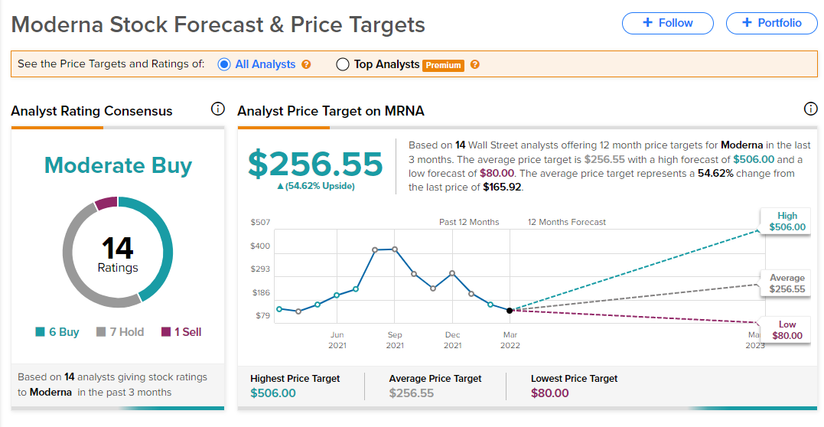

Other materials are also available, which you may find by searching on Google. The trick is to locate one, which requires averaging many analyst companies. Whatever you pick, be certain it is unrestricted. As you can see, the average price objective for this stock is $256.55, representing an increase of 62 percent from its current price. This indicates that our average analyst firm is optimistic on the stock.

One thing to bear in mind is that analyst opinions are often biassed. They are skewed to the right. With that in mind, if your position trades over the price goal, you should be aware that something is awry. This is because analysts would often respond higher if there is even the slightest hint of a favourable outlook for the firm, and will assign it a high price target on average. So, if you're trading over your price objective, it's possible that you've missed something fundamental, and you'll need to conduct some further research to figure out why.

**Example $NIO**

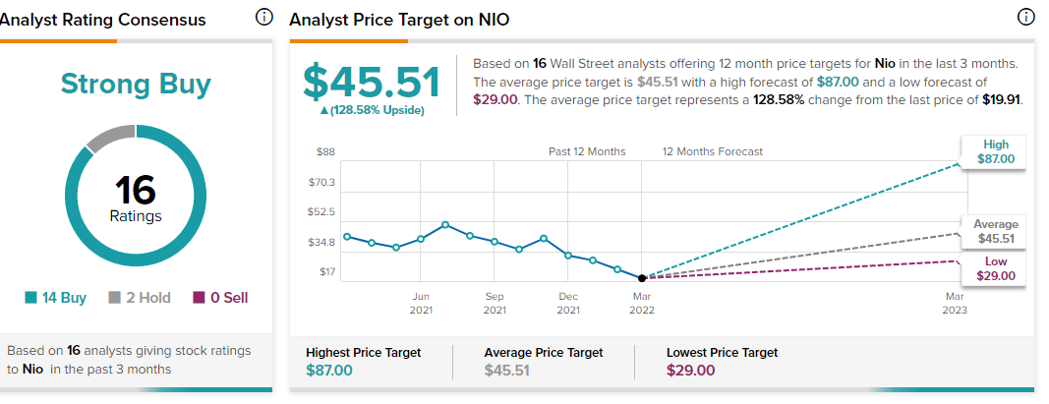

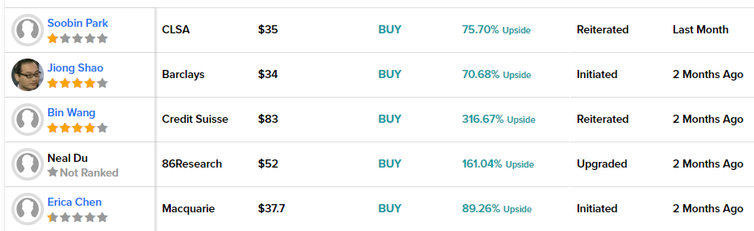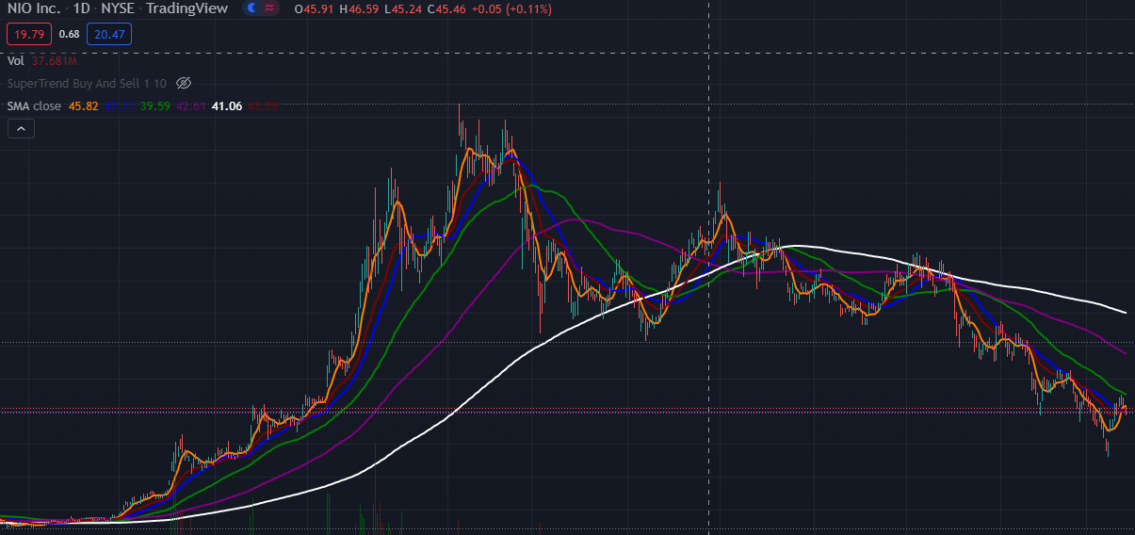

They are quite positive because they expect a 50% upside. It's also vital to note when these targets were announced. As you can see, there have been a slew of new price targets released in the previous six days, all of which are trading below the current trade price. This lowers the recent average, indicating that experts are having a negative reaction to the current news. As a result, the price action has been dropping. As a result, if you take a position here, you can see that ordinary investors are pessimistic, which is a depreciating element.

**Takeaways to Remember**

Here are a few key points to remember.

Many experts are biassed, thus it is best to take an average. Analyst price projections let us evaluate if the average investor is optimistic or bearish on a company.

Analyst price targets can save us time by removing the need for extensive fundamental examination.

The longer you hold a stock, the more important fundamentals become.

For us, this is merely a motivating/demotivating aspect. Do not acquire stocks just on the basis of price experts' recommendations. If the stock is trading below the average price target, this is an elevating factor for us. The longer you keep a position, the more important fundamentals will become.

**Trading Earnings is a game.**

Where can I discover Earning Plays?

We'll go through how to locate the greatest Earning plays in this part. To accomplish so, you'll need to visit a scanner that scans for basic earning plays. The most straightforward approach to do so is to go to www.finviz.com and then to screeners. You may choose a suitable earnings date screener there, such as The following five days were shown to her.

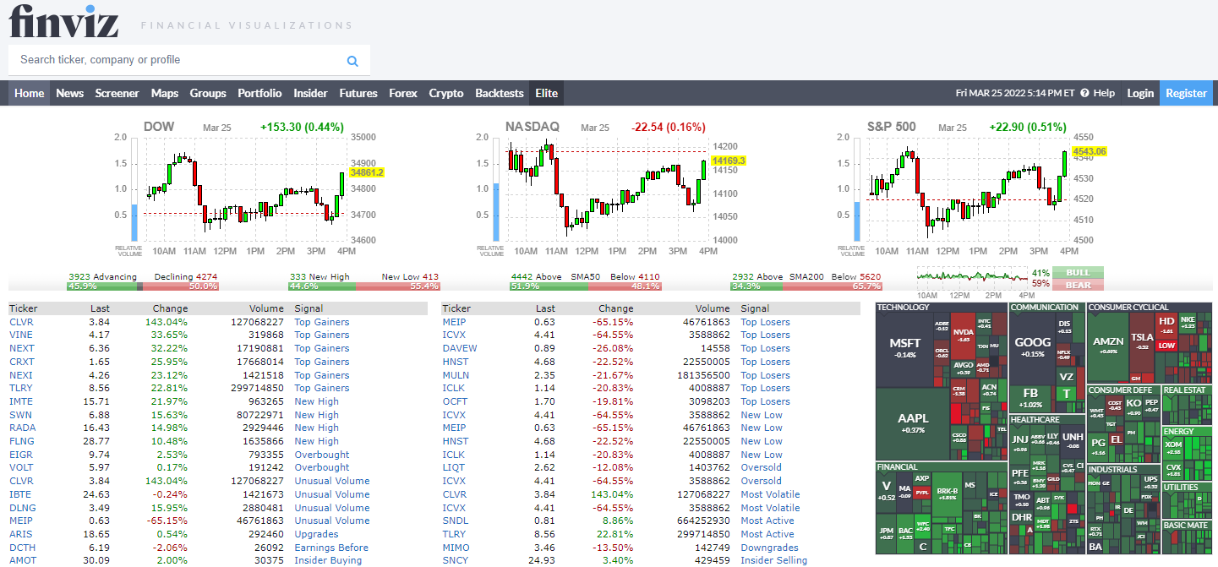

After that, you'll get a list of all the firms with earnings days coming up in the following five days. You may go through them all, apply them to your brokerage platform, and then assess them depending on what you think is important. In the following part, we'll talk about certain plays are more important than others. You don't have to pay for it because it's a free scanner.

What is the best way to trade Earnings games? We will talk about earnings overreaction in this part. Earnings are a fantastic moment for overreaction since people might experience a variety of emotions during this time. That is because, regardless of how wonderful or horrible an income is, individuals have no notion how to react. Because every stock market reaction is an overreaction, we have a wonderful chance when trading earning plays.

**Example $FB**

What exactly do we mean when we say "overreaction"? Let's take a look at $FB as an example.

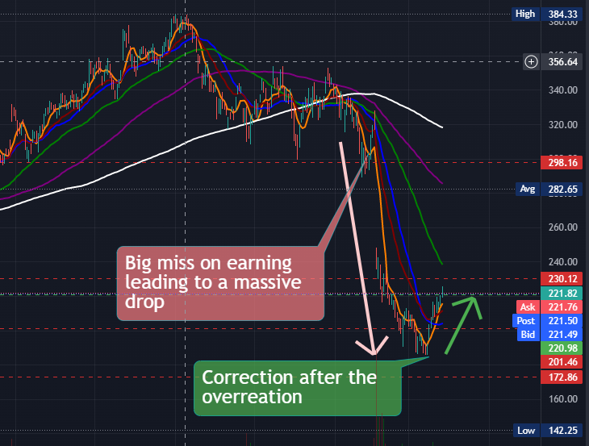

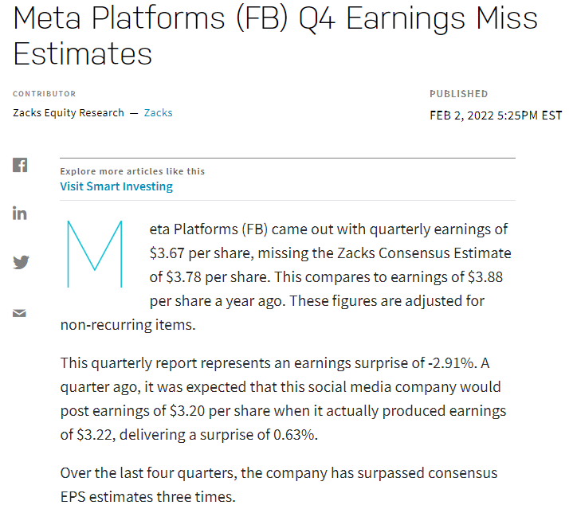

What is the rationale for this? Investors, on the other hand, had anticipated the rise and had included it in. As a result, when the official announcement was made, they sold out and profited. This triggered an overreaction, and as investors sold out, more individuals misinterpreted the information as unfavourable, resulting in a massive overreaction. Take a look at the price activity to see what I mean. We took a beating and then over-reaction lows, but people saw it was an over-reaction and bought in, and the stock price rose.

**Here are a few key points to remember.**

Using www.finviz.comscanner, you can keep track of anticipated earning dates.

Earnings frequently induce an overreaction owing to the emotional nature of the stock market. This overreaction may be in both directions, and it can occur regardless of the earnings report.

If a play is heavily discounted due to an overreaction, it might give us a strong trading opportunity. Wait for price strength confirmation before buying in if you see a play that has been beaten down. Trading with your emotions is a terrible idea. That is why it is critical to develop and apply a sound trading strategy.

**Insider Trading**

Like Insiders, Trade It's critical to understand what insiders are doing when it comes to spotting possible catalysts, analysing transactions, and forecasting future changes. Insiders are generally the first to know what's going on in a corporation. We'll talk about how to figure out what insiders are up to here.

A great website to track insider trading is [www.nasdaq.com](http://www.nasdaq.com)

**Example $GOOG**

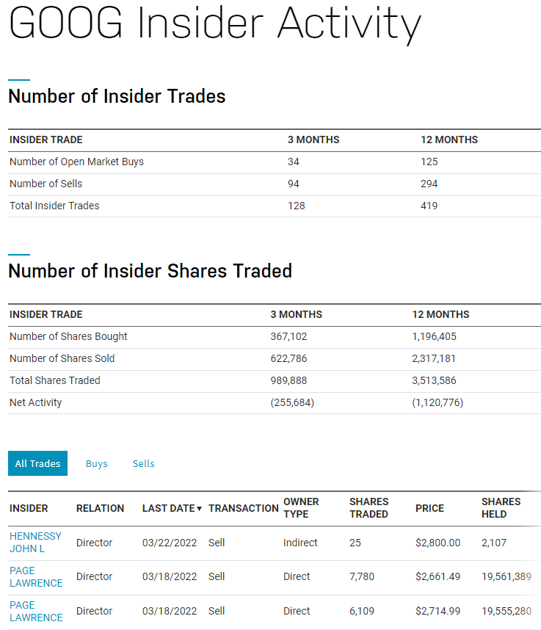

You may get a detailed picture of Inflow and Outflow by visiting the NASDAQ website. This provides you a sense of the amount of traffic on the internet.

There is a significant outflow of shares exchanged in this situation. A negative number is denoted by brackets. As illustrated below, we can also observe which insiders are buying and selling.

You may also look up who has the most shares, such as Elon Musk in this case. What is the CEO's next move? He is buying shares in the company indirectly. When a CEO buys stock, it is often regarded as a positive sign. This is how you learn what people on the inside are thinking.

What does this mean for us?

Now, these are large corporations; but, when it comes to smaller corporations, it becomes more intriguing since the same names appear throughout all biotech industries. You may sort of detect a trend this way, since some people tend to sell when the stock price rises and purchase when the stock price falls. We don't purchase or sell stocks depending on what insiders are doing these days, but it is a motivating element for us.

**This is an excellent resource.**

If you don't want to use Google, try these alternatives. This address's ticker should be changed.

https://www.nasdaq.com/symbol/tsla/insider-trades (The format was just modified.)

There's also this:

https://www.marketbeat.com/insider-trades/7.3.5

**Important Points to Remember**

Here are a few key points to remember. By looking at what insiders are doing, we may get a sense of what insiders believe about the company's future prospects. We can also get a sense of whether the present stock price is over/under priced. When it comes to biotech, you may get a head start on predicting the outcome of phase trials by looking into insider trading.

**HYPE SECTIONS TO WATCH FOR:**

Marijuana, Natural Gas, Penny Stocks, 5G, and EV, so on.

In this part, we'll study how to spot overvalued industries and how to profit from them. As you may be aware, the stock market as a whole experiences bubbles. This is true for many different aspects of the stock market. As traders, our first goal is to discover areas with price activity that we can trade. This is why the ability to spot overvalued industries is crucial. That is why, in this course, we will examine many industries so that you may trade in other areas if one becomes unavailable. You should diversify your trading to ensure that you can trade regardless of market conditions.

So, how can one recognise an overhyped industry? Electric Vehicles industry in the fall of 2020 was one of the most current ones.

**Example $TSLA**

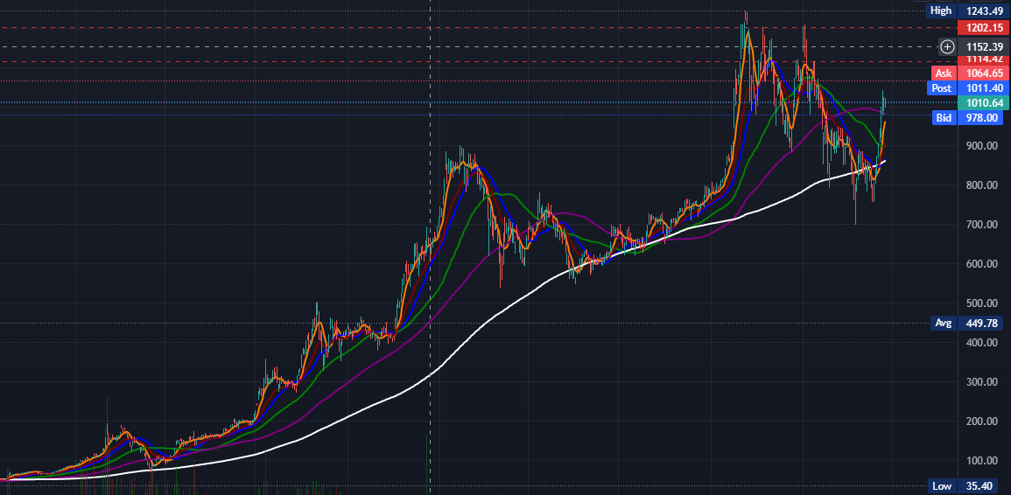

During the Corona stock market crash one of the over hyped plays was $TSLA

**How to Spot Overhyped Markets**

I recommend going over the list of top gainers every day and looking for commonalities. For example, if all oil and gas-related stocks are rising, this might indicate that the rise is due to a fad in the oil and gas industry. If this happens on a regular basis, you may be sure that this industry is overvalued. Since the beginning of the stock market, overhyped industries have been a huge issue. Overhyped sectors absorb pretty much anything that comes into contact with them. For example, the dot-com bubble wiped out the entire IT industry. The same thing happened with the housing bubble. The same thing happens with tiny industries, as we've seen with marijuana and other similar ticker symbols.

**Important Points to Remember**

**Here are a few key points to remember.**

Overhyped sectors might give strong price activity as a trade-off for the fact that these sectors are similar to bubbles in that they don't persist forever.

It is critical for us as traders to discover such overhyped sectors since they generate attractive price movement.

One approach to do so is to look at the top gainers each day and see what they have in common.

How to Profit from Both Positive and Negative News Every reaction in the stock market is a sloppy, sloppy overreaction. If you grasp this concept, you will be able to explore new possibilities. Two types of overreactions exist. A positive catalyst overreaction is number one, while a negative catalyst overreaction is number two. Examples of Negative Catalysts Let's look at some unfavorable catalysts in action.

**Example $BABA**

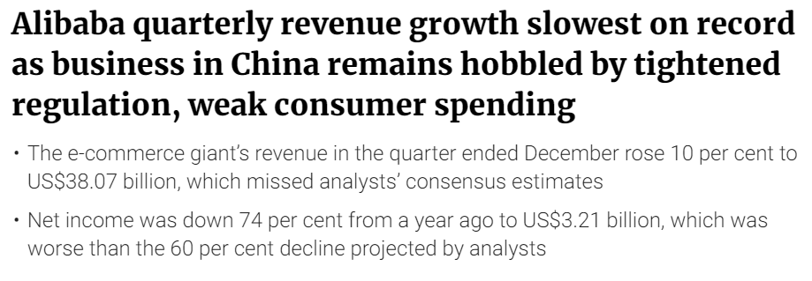

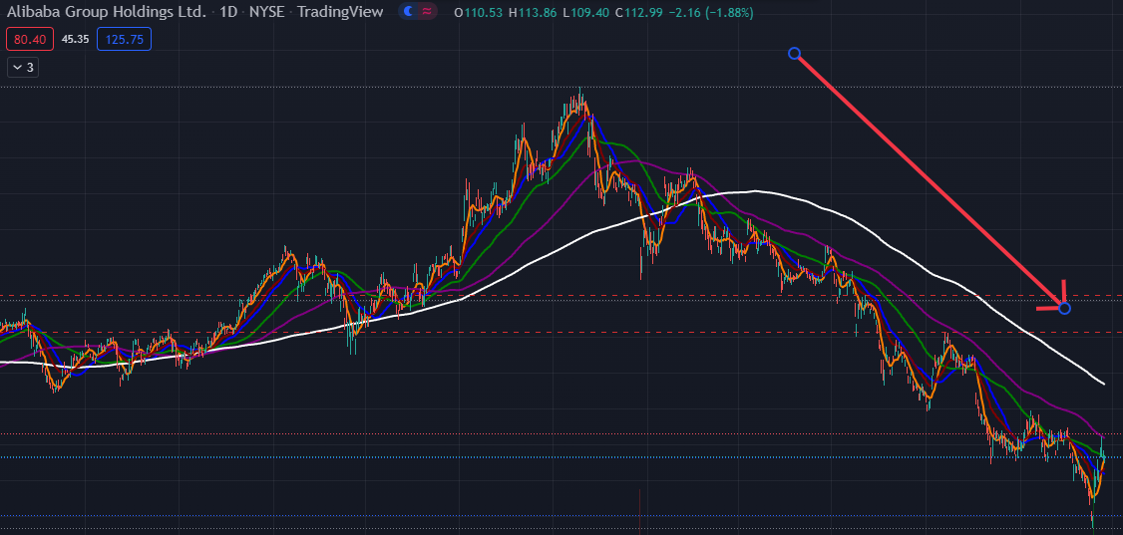

Important Points to Remember

Here are a few key points to remember.

In the stock market, every movement is an overreaction.

This is true for both good and terrible news.

We can spot such overreactions and enter trades when our technical analysis reveals signals of price strength.

The longer the overreaction took, the longer the position will be, as the correction will take the same length of time.

**The Most Efficient Methods of Obtaining News**

In this section, we'll talk about how I like to find new things quickly

Google News (https://news.google.com/) is a service provided by Google. One of the simplest methods is to go to Google News and type in the ticker.



We discover a few things here, such as the fact that $AMC is taking a stake in Gold. This is a encouraging element. Google News is useful since it aggregates information from a variety of sources. We can discover additional information if we keep scrolling down.

**Example $TSLA**



As you can read you can see that there are encouragin factors and news articles to consider taking a position in $TSLA. You can see that the articles are positive which should be a positive catalyst for $TSLA.

**Seeking Alpha**

(https://seekingalpha.com/) is a website that helps people find answers to their questions. Let's pretend we don't know what ticker to look at and we're hunting for possibilities in the general market. You may get this information at Seeking Alpha. On a company-level basis, there are many chances and a lot of pertinent news. As an example, as seen below, you may see many types of news.

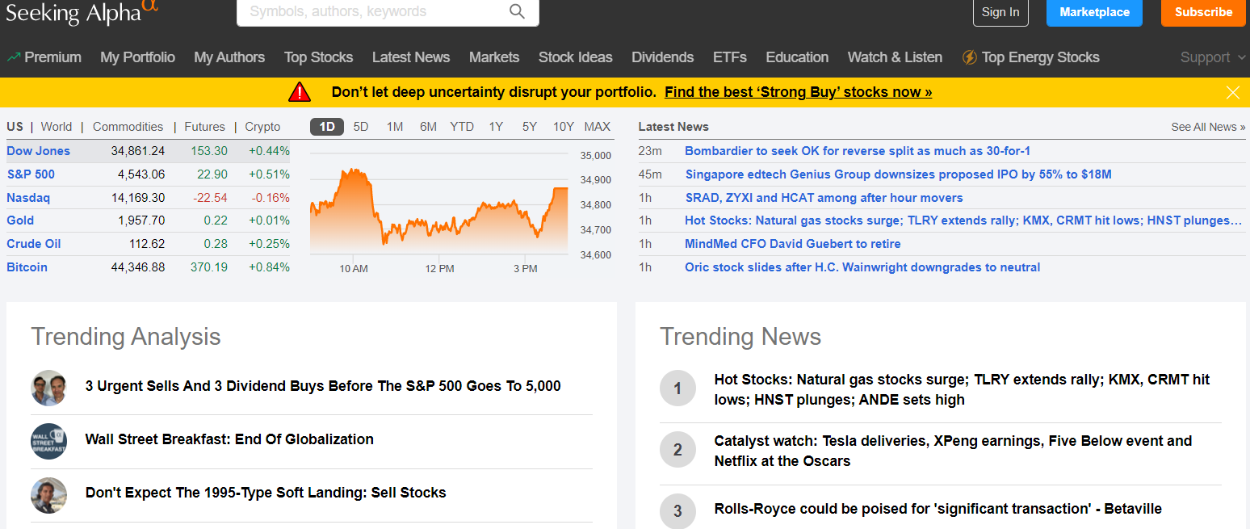

**You may navigate to the Trending news section to look at tickers that are important in the current market situation.**

CNBC

(https://www.cnbc.com/) is a news organisation based in New York City. Check CNBC first thing in the morning and last thing at night. They show you some very fascinating stuff that can be quite useful. Every morning, you can visit this page for very broad general news. The Federal Reserve, for example, is issuing a new statement, as indicated below. You may also look at some of the most recent company news. This is an excellent spot to obtain a quick overview of what's going on in the market and economy as a whole.

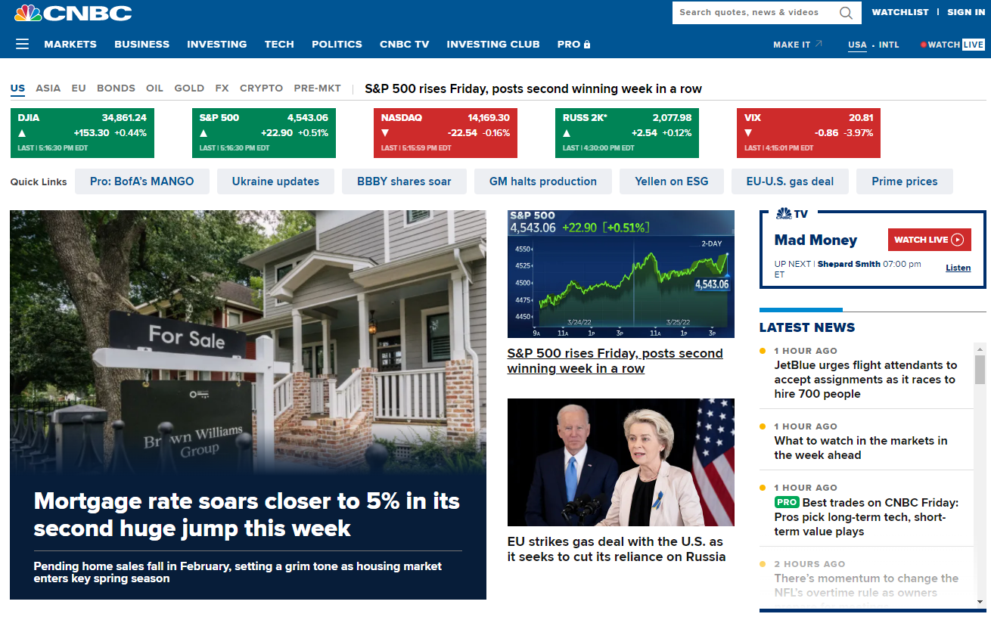

Investorplace\s(https://investorplace.com/)

This is a new one with a lot of useful information. Another site you should check on a regular basis is



There are various options at the exhibition, and you may choose from a variety of tickers and specialties. For instance, consider the following 7 Chinese equities to purchase despite Pandemic volatility and other factors. It's a type of one-stop shop for finding various stocks. Obviously, you don't just buy anything because someone tells you to. The goal is to locate unique tickers that we wouldn't have discovered otherwise.

Other websites which are also useful

[www.cnn.com](http://www.cnn.com)

[www.twitter.com](http://www.twitter.com)

[www.benzinga.com](http://www.benzinga.com)

Important Points to Remember

There are several methods for obtaining news, some of which are included here.

Google News (https://news.google.com/) is a service provided by Google.

Seeking Alpha (https://seekingalpha.com/) is a website that helps people find answers to their questions.

CNBC (https://www.cnbc.com/) is a business news network.

CNN Business (https://edition.cnn.com/business) and Investorplace (https://investorplace.com/)

Twitter (https://twitter.com/) is a popular social media platform.

Use just for news stories and avoid looking into people's personal thoughts or analyses.

Benzinga (https://www.benzinga.com/) is a financial news website.

**What Are Stock Splits and What Should You Do With Them?**

For a variety of causes, a company's stock price may be divided. This simply implies that they are raising or lowering the number of shares held by each shareholder. Splitting of Stocks Split 1 for 2 In a 1-2 split, each share you own is divided into two. Example: If you previously owned one $100 share of $XYZ, you now own two $50 shares.

**Split 1 for 4**

Each share you own will be divided into four shares in a 1-4 split.

For example, if you had one $100 share of $XYZ, you now have four $25 shares. This is relatively self-explanatory, and the overall value of your stocks will remain unchanged following the split. The splits don't have to be restricted to "2-1 and 4-1," but may also be 10-1, 50-1, and so on. However, investors may withdraw or enter the market, creating price fluctuations. In general, such splits are seen positively by shareholders since they now have more shares and so perceive more possibility for future growth. This is frequently reflected in a beneficial impact on the stock price

Stock Split in the Reverse

A corporation might potentially opt for a reverse stock split. This suggests they're attempting to reduce the number of publicly traded shares by sifting them. This is almost always a bad sign because it indicates that companies are trying to raise the price of their individual shares (at least numerically). Split ten for one In a 10-1 split, your ten shares will be combined into one. For instance, if you had ten shares of $XYZ valued $100 each, you now have one share worth $100. Splits 100 for 1 Your 100 shares will be divided into one share in a 100-1 split. For example, if you previously owned 100 shares of $XYZ for $100, you now own one share worth $100.

Why would a business want to do anything like this?

Because many exchanges (NASDAQ, NYSE, and others) have minimum per-share criteria in order to be listed. As a result, a firm that is quickly losing market value will most likely consider dividing its stock price to avoid delisting. What occurs most of the time? The reverse stock split usually just serves to postpone the inevitable. As you can see, a firm that is fast losing value is still losing value overall, and altering the cost per share just delays this. As a result, if you witness a reverse stock split, know that it will most likely continue to fall following the split. However, on a few occasions, the reverse stock split will provide the firm with enough time to turn things around. We don't advocate waiting to find out, though.

Important Reminder Keep in mind that most brokers will charge you a fee if you hold your shares during a stock split of any kind. If you opt to hold, make sure to check with your broker to see how much your charge will be.

Important Points to Remember

Here are a few key points to remember.

Splits allow a corporation to raise or lower its share price. Normal splits are typically good news for shareholders since they now have more shares and more potential for future growth. Reverse stock splits are virtually always a bad indicator. This signifies that a corporation wants to raise its share price in order to meet listing criteria.

Reverse stock splits can sometimes help a firm turn around, but they usually merely postpone the inevitable. Some brokers may impose a fee for holding such stocks, so double-check.

**What Should You Do If Your SEC Halts?**

SEC halts are one of the most aggravating things we have to deal with as traders (AKA Trading Halts). This is when the SEC effectively suspends trading for a certain securities for a set length of time. These can occur at any time of day and for any cause. This implies that if you are currently in a position, you will be unable to exit it until the market resumes trading. What Causes This to Happen? Before any substantial news is disclosed, the SEC will put a stock on hold. This might be a result of an FDA approval, earnings release, CEO departing, or a lawsuit, among other things. This manner, the stock price isn't changed until the news is out.

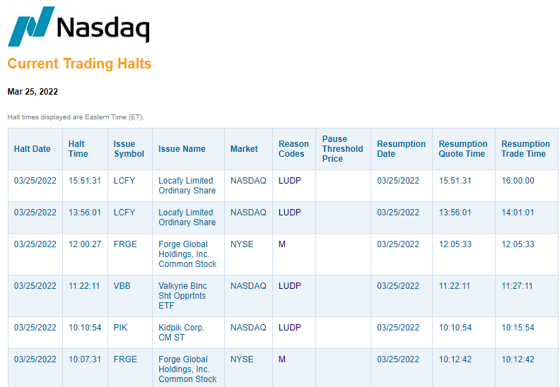

Putting an End to Reason Codes

This graph will show you if your stock has been suspended or not. It'll also show you why a halt is necessary, under the heading "codes of justification

"Here are the most important ones to be aware of:

Trading has been paused in T1 pending the revelation of relevant news.

Trading has been paused in T2 as a result of recent news.

T5 Halt: This is when trade is halted owing to a price movement of 10% or more in a five-minute period.

T12 Halt: Trading has been suspended awaiting the exchange's receipt of new information.

**How long do they last before they need to be replaced?**

SEC Halts based on News are meant to last 10 minutes (5 minutes before the announcement, 5 minutes after), but they can extend much longer in practise. An SEC halt might last for hours if "further information is sought." The longer the SEC waits to un-pause a stock, the more attention it will receive when it opens. As a result, there will most likely be increased volatility when the market opens.

**What is the best way to trade them?**

Because SEC Halts come in a variety of forms and sizes, it's crucial to know how to tell them apart. An SEC halt before a major news announcement is unavoidable, therefore planning ahead is the best strategy to trade this one. This implies deciding if you are willing to remain stuck in a situation if it is interrupted. This is dangerous because if the position is halted and unfavourable news emerges, you will have a difficult time executing out once the SEC reopens the stock. So, before you go, ask yourself this question.

Being stuck in a situation while "awaiting more information" can be devastating. The longer it takes, the more probable price activity will be severely influenced when the market opens. The easiest approach to play this is to take advantage of overreaction lows following the announcement.

**Important Points to Remember**

Here are a few key points to remember.

Several factors might cause a stock to be paused during a trading session.

Before any substantial news is disclosed, the SEC will put a stock on hold. This might include things like FDA approval, earnings release, CEO departing, and a lawsuit, among other things. You can exit a position if there is a trading halt. T1 and T2 halts are the most prevalent, and they are caused by imminent or just disclosed news. These halts normally last 10 minutes, although they can sometimes continue longer.

In general, the longer the SEC takes to un-pause, the more attention a stock will receive when it reopens, i.e. higher trading volume. Volatility SEC halts may be harmful if you are locked in a position due to bad news. Being stuck in a position due to "waiting for more information" can be devastating. You should normally avoid holding a stock during a trade stoppage (if known beforehand)

**Be Aware of These Share Offerings!**

These two sorts of offers, which are effectively the issue of fresh shares, will be seen often by traders. The context of these products, on the other hand, is crucial.

**Initial Public Offering (IPO)**

(Initial Public Offering) This is when a corporation decides to become publicly listed for the first time (and the first time we can trade it). Companies set an IPO price for their stock to be introduced to the market (which is generally far higher than it merits). However, IPOs are generally surrounded by a lot of buzz since people rush to purchase in within the initial few days after they go public (and often expect to get a good deal as an early buyer). This may, and frequently does, result in massive volatility and possibilities for hype. However, because we don't have any historical price action with which to judge the stock's history, risk management becomes incredibly tough.

Wait a few weeks before trading recent IPOs so you may assess how the stock moves and its association with providing us with high probability setups.

Don't Believe the Hype During $LMND initial public offering (IPO) in March 2020, it attracted a lot of attention as a major social media network, and everyone wanted to be a part of it. That's despite the fact that experts (to be fair, they're monkeys) had previously predicted that Snapchat would be overpriced during its first public offering. However, enthusiasm propelled it up in the early periods (as you can see from the chart), and IPO investors were left in tears when SNAP proceeded to drop off in high-volatility sessions. Be careful that initial public offerings (IPOs) are extremely tough to assess!

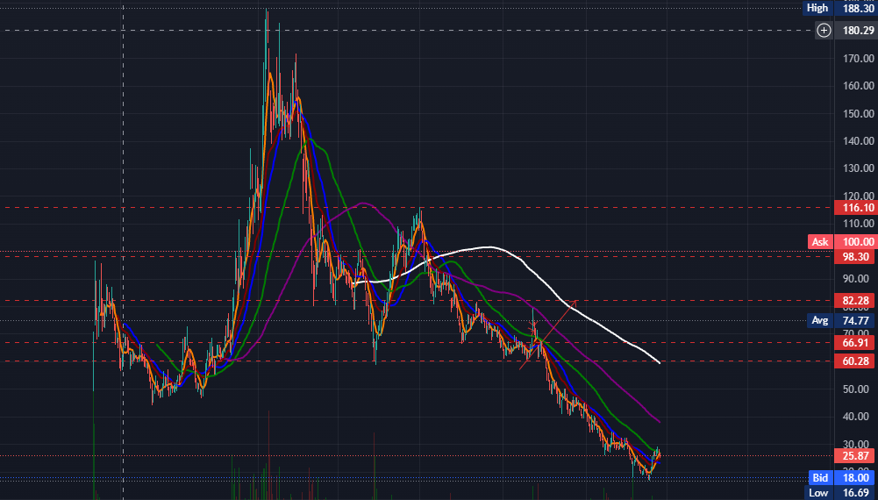

Offerings Made Directly This occurs when a company that is already publicly traded decides to issue more shares (usually to raise more money). This is often not a positive thing for existing shareholders because the issue of new shares implies that there are more shares available, diluting the value of the existing shares.

**Example $HTZ**

Companies in bankruptcy, on the other hand, will take advantage of their hype manoeuvres. HTZ soared in value after declaring bankruptcy in May 2020, as investors overlooked risk and concluded that the danger of bankruptcy didn't matter to them (we did propose buying HTZ at the time, but just for trading fluctuations, not for long-term keeping!). It soared, and HTZ decided to take advantage of the situation by increasing the number of shares available. Although the authorities eventually rejected this, it is a good example of how firms would issue new shares even if it is at the expense of present owners.

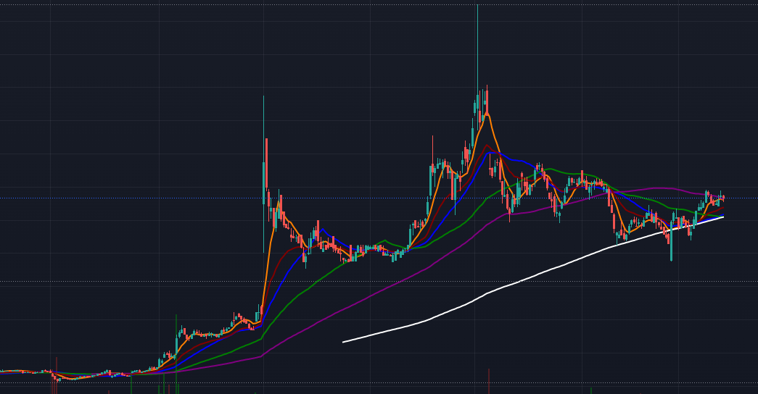

Important Points to Remember

Here are a few key points to remember.

Companies decide on an IPO price to introduce their stock to the market, i.e. This is when a company first decides to go through the process of becoming publicly traded.

IPOs frequently result in huge fluctuations and hype opportunities.

Don't fall for the IPO hype; it is strongly recommended to wait a few weeks to trade recent IPOs

In the near term, direct offerings of this sort are normally a depreciating factor;

nonetheless, direct offerings can assist firms raise funds. It might be advantageous in the long term if they can use it effectively.

When a stock rises dramatically (usually due to pure hype), companies like to do direct offerings to sell their shares at the higher price while the stock is still trading high.

Anytime a stock rises dramatically (especially in the biotech world, where companies need a lot of money), expect a direct offering announcement..

**SEC Filings**:

**How to Read Them**

We'll go through how to read and identify the five most critical elements of SEC filings in this section. SEC filings are essentially a cheat sheet for determining whether or not a stock is worth trading. We can spot hype, false information, future triggers, and even approaching calamity ahead of time. We can take advantage of this chance to make a trade-off. Using SEC filings can provide us with a picture of what is going on under the surface, allowing us to benefit in the near term.

Years ago, for example, there was a certain biotech stock that was all the rage in the trading world. They engaged a public relations agency to propagate reports that they had discovered a cure for a particular form of cancer. This was a public relations agency that was well-known for inflating stock values. A simple glance at SEC filings, on the other hand, would have shown that not only was their firm headquartered in a run-down mall, but they also had no assets on hand, no factory property, and no method to produce or distribute the medicine. For years, it had been deceiving its stock price in order to fund the few activities it had completed.

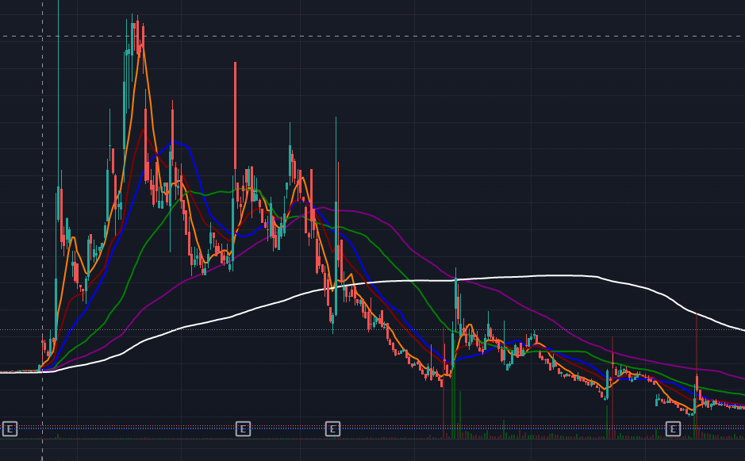

Thousands of investors placed their money into it, and then, as you can see from the chart above, they were brutally beaten down. If you had looked at the SEC filings before investing, though, you would have seen this coming. The importance of SEC filings can plainly be seen. They provide us with a clear picture of what is happening under the surface.

**Form 10-K**

The most current 10-K is the first form to examine. The 10-K is essentially the yearly financial report that contains all of the information we require to get started. We check for five easy items on this 10-K form.

1. The Headquarter's Address

2.Risk Factors Statement

3.Operatingexpenses

4.Money on Hand

5.Chance of Dilution, i.e., the possibility that the corporation will issue new shares, eroding our present holding.

**Example $CLOV**

**To study SEC filings, you must first understand how to locate them. Let's use "$CLOV" as an example of a random ticker. As you can see here, they've risen dramatically as a result of positive publicity.**

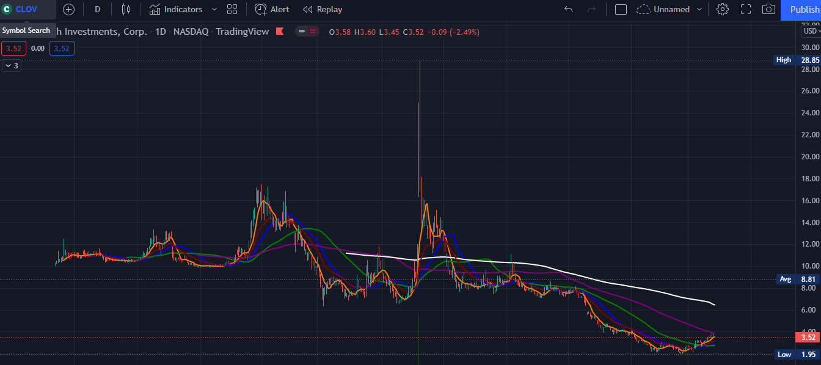

We can now go at the SEC filings to discover what's going on behind the surface. To obtain the SEC filings, simply google the ticker symbol, such as "$CLOV SEC filings." Because many websites do not include all of the SEC filings, the simplest method is to simply google it.

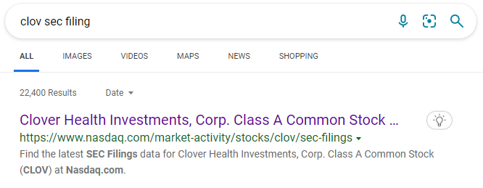

Now we may pick the best result from the list.

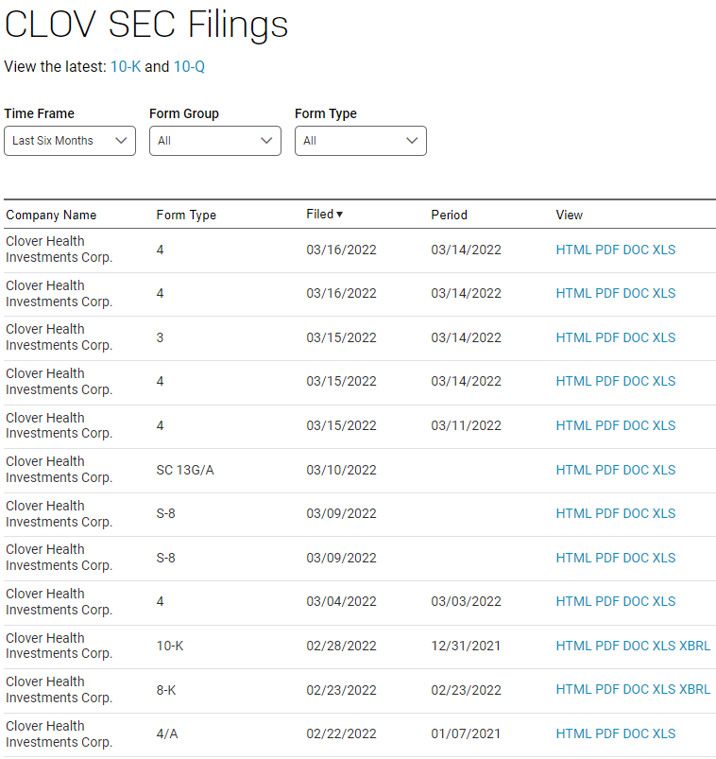

The headquarters' address is

The 10-K is now open for the first phase. This should be somewhere around the start; you may copy the address and put it into Google Street View. This step is quite simple and may seem foolish, but it is incredibly significant because many firms in this category will make big announcements and PR.

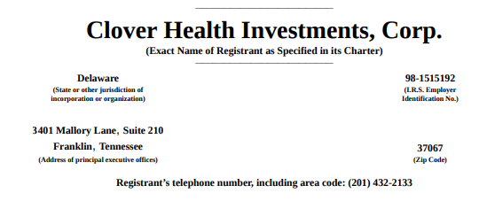

Address test: 3401 Mallory Lane, suite 210, Franklin, Tennessee





Risk Factors Statement This is where firms inform their investors about the most significant risks or hazards they face. This is a fantastic feature of SEC Filings that saves us a lot of time.

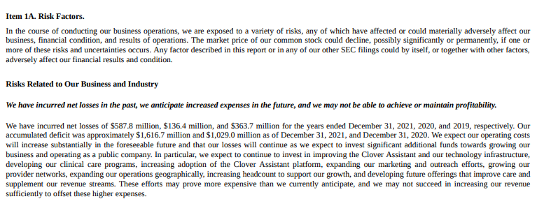

They claim we have a limited operational history, have lost money in the past, and will continue to lose money in the future. They further claim that we have never made money from product sales and that we may never be profitable. All of these financials are a waste of time.

**Expenses of Operations**

Operating expenditures are critical because they determine how much cash a firm need to operate. We may then utilise this information to see if this firm will be able to stay afloat in the near future. If you can't discover it on your own, you may use Chrome's search feature to look for "Operating expenditures."

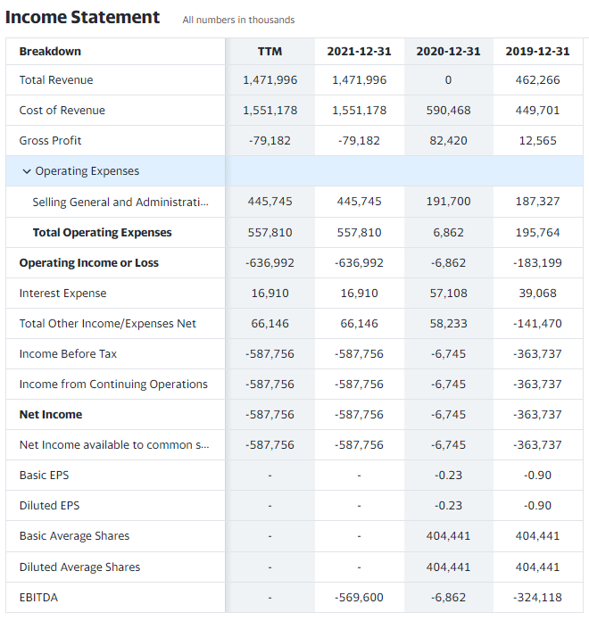

Money in the Bank

We'll now check to determine if they have enough cash on hand to cover these losses. The first piece of information may be found in the form above. We can zoom in to get a better look.

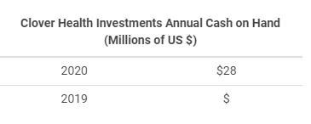

In 2020 $CLOV had $28 million cash on hand but as you can see that their expense aer much higher making this company a risky trade.

**Dilution Possibility**

If they aren't profitable and don't have much cash on hand, where are they receiving this money from? Investors and finance are how they receive their money. Issuing additional shares and diluting the share price are two examples.

As a result, this is a corporation that relies heavily on funding and investment flows to keep afloat. Investor inflow is, of course, the component that counts to us. We want to make sure they aren't diluting the stock price excessively to cover their costs. This might have an impact on our short-term position because if we get into a position and then they offer dilution, it's a significant deterrent.

**Conclusion from the 10-k form**

We've just finished reading $CLOV's files, and we now fully understand that $CLOV is spending more than it earns, that they have no clue when they'll be profitable, and that their future is entirely dependent on the success of their health-care services. We may look at the chart and conclude that any news about $CLOV teaming with significant corporations is likely to generate a huge reaction in the share price based on this information.

**Important Points to Remember**

SEC filings can help us quickly look for different fundamentals of a company.

You can find these filings by simply searching for the ticker symbol in Google.

You can look in the 10-K form for multiple things like Address, Risk factors, Operating expenses, cash on hand, and chances of dilution.

This can help us give a picture of the company and what is going on beneath the surface.

**What to Do If You're Delisted**

When a stock is liable to being delisted from an exchange, it is referred to as delisting. This can happen for a variety of reasons, but the most typical is when the stock price drops below a specific level (for example, when it goes below $1 per share). This is nearly usually a bad thing since stocks that are delisted from an exchange are prone to being beaten down. What are your options for avoiding this? Search for stocks that have been suspended or delisted. NASDAQ, for example, has this list.

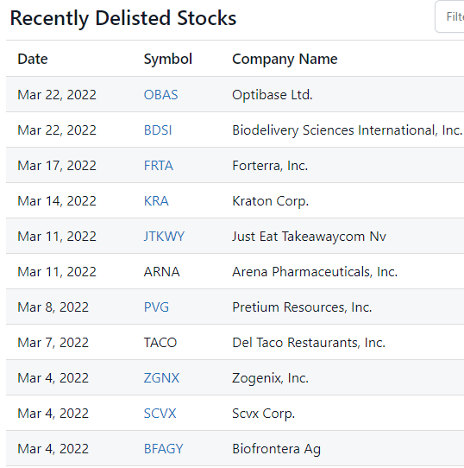

Also, keep an eye out for stocks that are on the verge of being delisted. To avoid being delisted, the corporation may be tempted to take dramatic steps to boost its share price. A reverse stock split, a merger, or a shady pumping news announcement might all be possibilities.

**5 Steps to Investing in Downtrends**

The market may react swiftly to news, such as tweets.

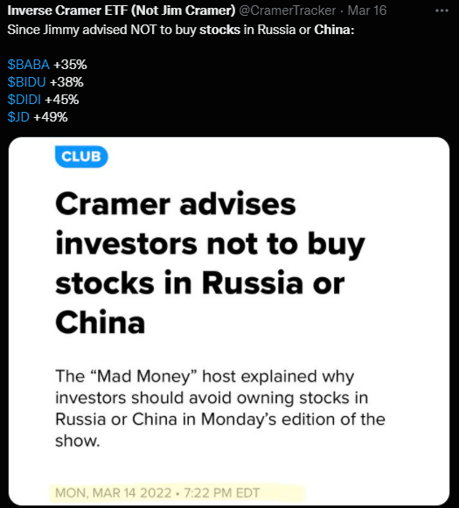

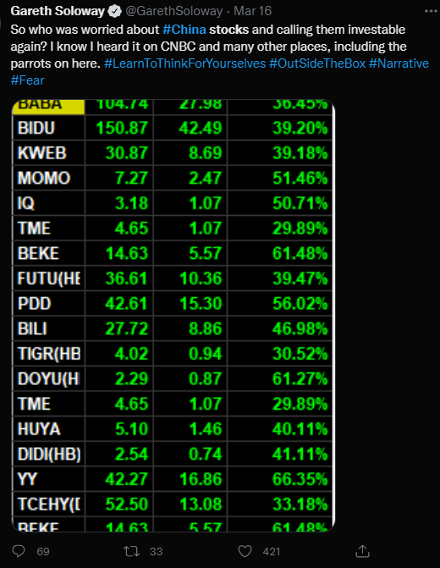

**Example $DIDI**

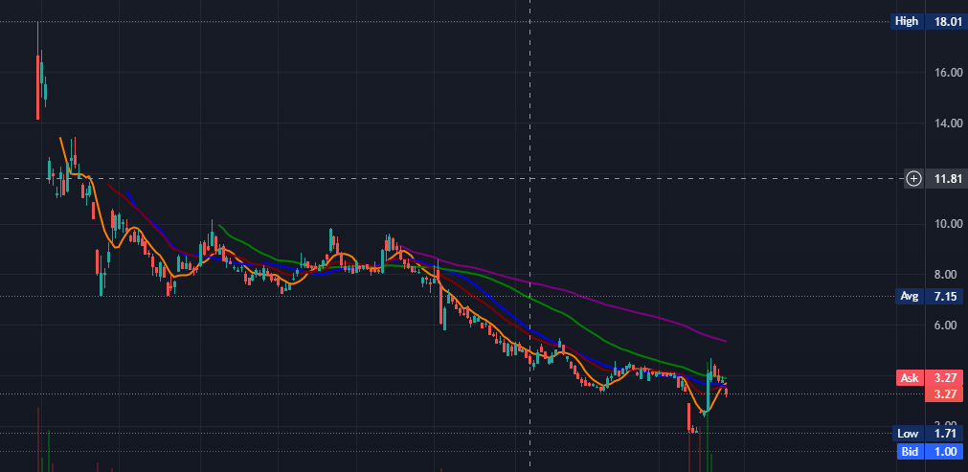

Because we focus on fluctuations as traders, it is up to us to figure out how to trade them off. During this time, you should take the following steps.

**Forming a Hypothesis is the first step**.

You should determine if the market is downtrending or not. Of course, there's no way to know for sure because you never know if things will pick up later in the day. Forming a hypothesis, which you will subsequently validate with price movement, is the first stage. This might be triggered by a catalyst or by price movement. You are not need to be correct. All you have to do now is make a prediction on whether the market will rise or fall. We are now formulating a hypothesis based on the Catalyst we have that Volatility will skyrocket.

**Equities Checklist**

Step 2 is to get your list of ETFs that do well on large move red days out of the way. TVIX, JNUG, and UVXY, for example, are some of Charlie's favourite charts.

Trading the Day in an ineffective manner You pull out the list and immediately begin going from one Stock/ETF to the next in the sequence listed below, skipping over the other items in the list. When there is potentially unsettling news, such as a trade war, you should turn to TVIXTVIX. This is because it is a volatility-driven index, which implies that the more the volatility, the greater the possibility to benefit. Based on our previous hypothesis, we may conclude that if this occurs, volatility would rise. Now that we have a hypothesis, we want to see if it can be confirmed by price movement. As soon as we get a Confirmation, our Hypothesis is verified, and we may now follow the price movement until we obtain a confirmation.

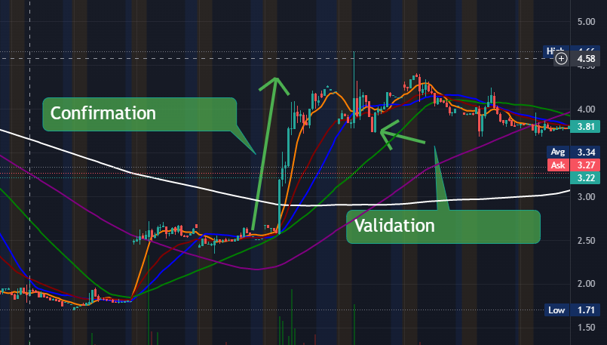

**UVXY**

We're now on our way to UVXY. UVXY is our bearish leveraged fund. We're seeking for technical proof of our hypothesis once more. UVXY will rise if the market continues to fall.

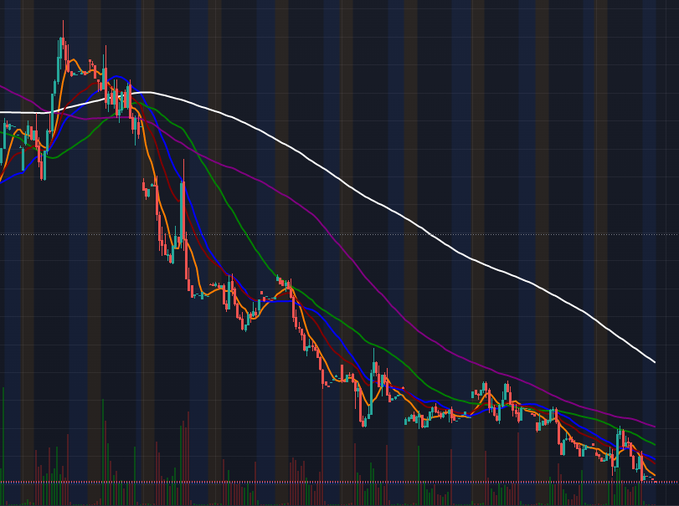

We're now waiting for confirmation of our estimate. Now we have confirmation, but it is shaky because the RSI is nearly overbought.

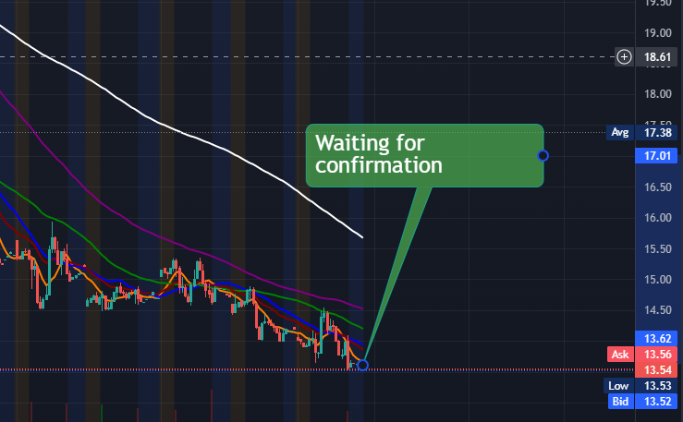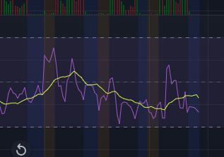

RSI is in nearing the oversold territory meaning that a reverse in the market is possible. If UVXY goes down the market is trending up. if UVXY is trending up overall markets should be heading lower.

Regardless, we take the position since we have a lot of upward directional strength (Above the long-term SMA line). As a result, we invest at Confirmation and then ride the price movement until Validation.

You may feel a little uneasy in the meantime as we go below the Short-term SMA line and get overbought, but you set your exit point to a typical Validation with a medium risk tolerance. Then, at Validation, we sell out.

However, we are not yet finished. Now we have another confirmation and take a new position, but this one is less lucrative, and you will be verified out shortly. Depending on your entry, you may have made a tiny profit or a slight loss.

**Conclusion**

So far, we've had three successful deals out of four. The one that didn't go so well was also the one where we were on the verge of breaking even. This time it worked, but would it work 90 times out of 100? Probably not, since we made a mistake. Our trade was inefficient and short-sighted to a considerable extent. The first step was completed successfully, but the remainder of the day was a disaster. We must now organise this.

**Step 3**:

In each stock/ETF from Step 2, create price alerts. Instead of bouncing from trade to trade like we did previously, we may execute each deal at the same time when it makes sense. This manner, we may profit from each position's upside while also diversifying the sorts of positions we own. In step 3, we create price alerts in each Stock/ETF.

Now, as indicated below, we've set our Alerts for two points. 1.Alert 1: Directional Change 2.Confirmation Alert 2

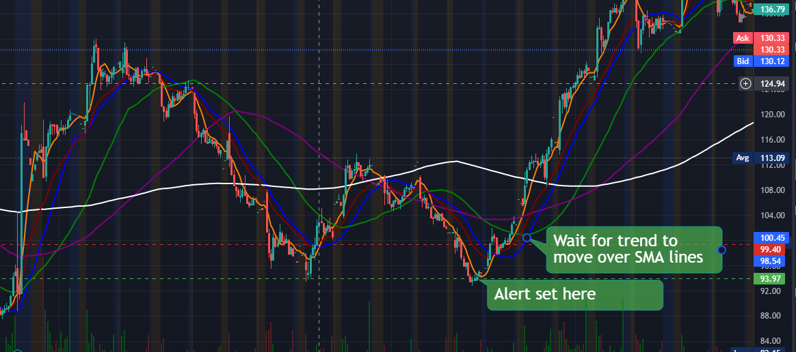

Then, once we've been notified, we may go back and assess our situation. This implies that instead of going through each alert one at a time as stated above, you may execute on many alarms at once.

**Step 4:**

Assess the Alerts You can then select whether or not to take a position. This is significant since it is here that you will determine whether or not to vote for Confirmation. Confirmations aren't meant to be used as a blind entrance point. Never take a position on anything on the spur of the moment. Confirmations are simply places where we check to determine if we have more elevating variables than deprecating aspects. Then we'll be able to decide whether or not to take a stand. Let's pretend we're dealing with the Volatile Hypothesis. We may have created a market open alert for TVIX for confirmation.

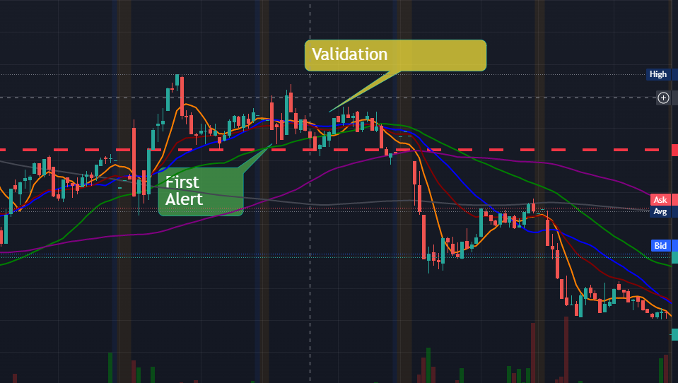

One issue was that our hypothesis was incorrect. Our prediction that the market will be volatile proved to be inaccurate. As you can see, TVX has continued to drop off as a result of this. Confirmation and Validation might have helped you make a tiny profit even if your hypothesis was incorrect. This is why Validation and Confirmation are so critical.

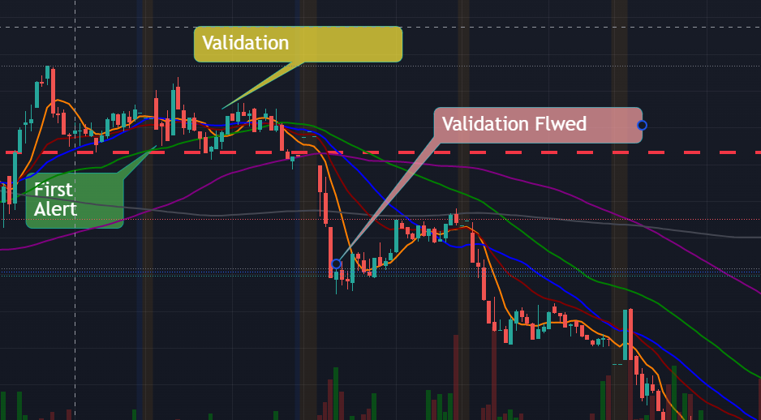

**Step 5:**

Put the Plan into Action If the position makes logical based on the preceding phases, you execute it here. Making a strategy and sticking to it is essential. Trading is a probabilistic game, therefore you can win in the long term if you use these settings.

**Takeaways to Consider**

Some key takeaways are listed below.

When it comes to trading on a red day, there are five essential procedures to follow.

1.Develop a hypotheses (Is the market trending down or up.)

2.List of Stocks to Buy and Sell ( Here discussed TVIX, UVXY & JNUG)

3.Evaluate Alerts after setting price alerts in each Sock/ETF in Step 24. (Most important step as here you decide based on different factors if it makes sense to take a position or not)

5.Finish the TradeThere will always be some losses in trading, but you should focus on sticking to the strategy. You'll win in the long term if you do it this way.

**Value Dipping (Section 8) (Multi-Day, Multi-Week, Multi-Month)**

What is Value Dipping, and how does it work?

Value dipping is the process of identifying stocks with high intrinsic value and purchasing them at low prices. This isn't the same as the tactics we've been studying so far in the course. This is because when you go into a firm, you examine it, look at how it is trading, and then forecast where the price objective will be.

These are the greatest sorts of trades for anyone searching for low-maintenance opportunities. It is now ideal for customers who want to trade Multi-Day, Multi-Week, or even Multi-Month without having to worry about day-to-day price fluctuation due of its flexibility. The problem with them is that they need a lot of work upfront compared to your normal job, but once you're in it and have completed the task right, you won't have to think about it for a long time. The key to value dipping is to look for equities that have fallen in value.

**Example $TSLA**

Tesla is undoubtedly one of the most well-known and well-known value dip trades. Many individuals have a long-term perspective on Tesla, so any drops in the price represent excellent purchasing opportunities.

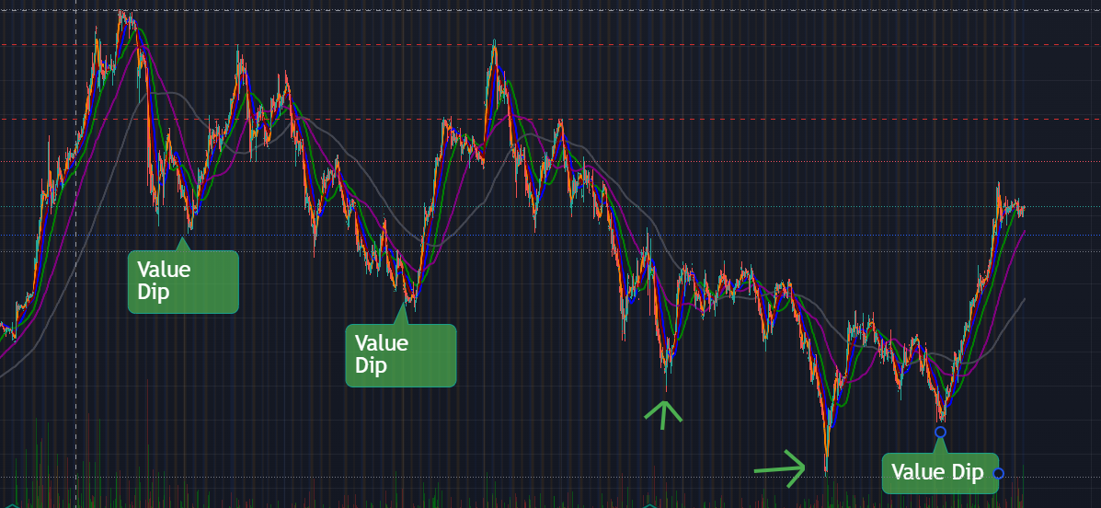

The value sinking method, on the other hand, argues, "OK, we know $TSLA is undervalued at current price, but I'm not sure how much further undervalued it can go." So you purchase in at a low price and then accept the possibility of suffering some short-term losses. If you had invested in as stated below, this would have happened.

**Advantages and disadvantages**

The advantage of these sorts of moves is that they don't need you to cope with very aggressive departure points. This means that if you do things right, you may take fewer trades, put in less effort, and achieve identical outcomes. The disadvantage is that if your analysis is incorrect, you expose yourself to a lot of danger. This is because, in most cases, you will be utilising Validation as an exit strategy to protect yourself against future decreases because you will not be holding through them.

When value dips, on the other hand, you cling on to the dips because you feel there is intrinsic value and that the price will not fall further.

So, in value dipping, you must put in a lot of effort up front to ensure that you are buying value, but in the opposite direction, you must put in a lot of work all the time, but you have a medium risk management and the positions are faster. When it comes to a company's intrinsic worth, it might take months to recognise the apparent value. People who enjoy identifying firms, forecasting what they will do, and researching the market will enjoy value dipping. You must also ensure that they are inexpensive and a decent value. Short-term investment is similar to value dipping. You've decided to invest in a firm because you believe in its intrinsic worth.

**three main topics to discuss 4**

In order to perform Value dip bets, we need to talk about three important points.

1.You must understand how to value stocks, that is, how to set price goals.

2. You must be able to recognise when you are mistaken. You will make mistakes from time to time, and you must know when to cut your losses.

3. You must also know when to cut winners. You may either let it run or collect gains at the price objective. In the next sections, we'll go through these themes in more detail.

**Important Points to Remember**

Here are some key takeaways:

Value dipping is when you see an inherent value in a company and buy it on a dip.

You can buy it at this lower price and hold it through any volatility until it reaches fair value.

Value dipping differs from regular trading in that Exit points are more relaxed and it is necessary to buy companies that are of value.

This assists you in determining the stock's intrinsic worth. Once you've established your position, value dipping takes little upkeep.

It is perfect for persons who enjoy identifying firms, forecasting their future actions, and researching the industry.

You must first ensure that the position you are adopting is a good one.

The disadvantage of this method is that if your analysis is incorrect, you are exposing yourself to a great deal of danger.

You may think of value dipping as a type of short-term investing. You should also know how to set price objectives, trim losses, and grab winnings.

**How to Decide on a Price Target**

To correctly assess a drop, you must be able to set a price target based on what the stock's future worth is. What direction do you think this stock will go in the next six months? The main point is to make a prediction and then manage our risk if the prediction is incorrect. Setting price objectives is done in a variety of ways. Setting price targets is more of an art than a science, but there is some science involved.

It doesn't matter how precise your price predictions are as long as you're accurately anticipating the stock's trajectory. For example, if your stock is trading at $10 at the end of the day and your price objective is $20, but it finishes up at $18, it doesn't really matter because you still made money. This is due to the fact that you correctly identified the direction. However, if it dropped from $10 to $5, it shows your strategy was incorrect and you made a mistake.

**Setting Price Targets:**

A Step-by-Step Guide Setting Price Targets consists of three steps:

1. Determine the Median Price

2.Determine a Growth Path (This necessitates an understanding of the Company's performance and how it connects to the stock price.) We need to look at recent Firm earnings, earnings estimates, how the company is performing compared to its rivals, how large the company's market potential is, and new services/new initiatives that might bring in additional cash. You put all of information together to forecast a growth path.)

3.Assign a price target (This is where we take the data that we took in Step 1 and 2 and we place a price target on the Chart)

**Example $INTC**,

Because it is a discounted play, it is simple to complete. Stocks that have been battered to all-time lows are simpler to appraise since they have already moved considerably higher and we have evidence on why they traded much higher.

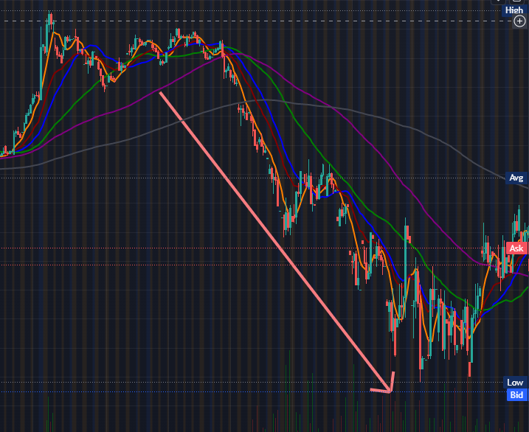

Of course, there are other equities with high momentum, such as Tesla and Amazon. It's a little more difficult to define what these stocks need to do to keep hitting higher highs because they're routinely making higher highs. However, we will go into these kind of prospects in this part as well. Now we'll go over the stages for this stock one by one, as described above.

For the whole year, the stock had been trading in the indicated channel. This includes, as shown above, the major Pandemic slump of 2020, when everything plainly plummeted. That must be included since it is a significant occurrence. To get the whole picture, we need to include everything on the pricing chart for that year. Now we'll look at this chart and try to figure out where the chart's rough midpoint is. Roughly $50 for the rough midway. As a result, we may put the median at $50. Essentially, this means that, despite all of the previous year's changes, it had a median of around $50. In this year's setting, $50 was a reasonable price, i.e. exactly in the centre.

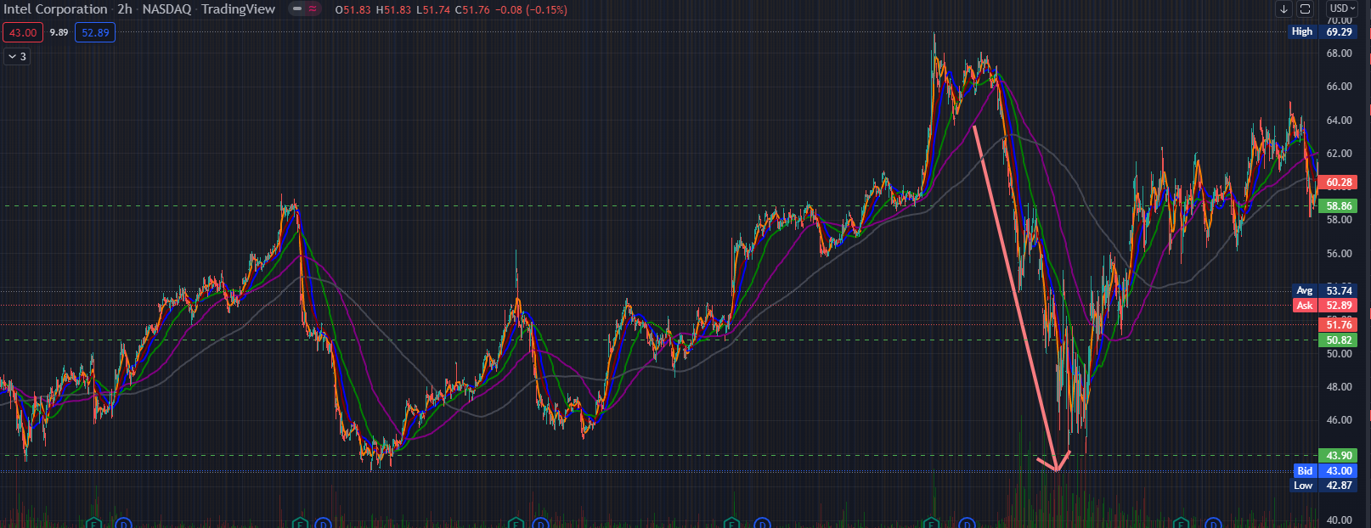

Calculate a Growth Path Since $INTC is at all-time lows, the issue we must address is whether the value that was there throughout the year (in the aforementioned range with a median of $50) is still extant or has changed permanently.

This is because, assuming the Value remains, it was unjust for $INTC to be beaten down so severely, and we still have a lot of upside potential. Now we search for "$INTC Investor Relations" on Google and open the quarterly reports.

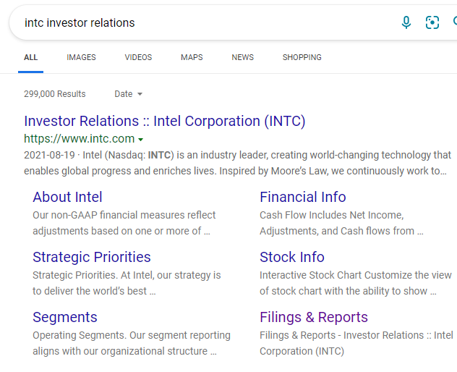

Click on Filings & Reports

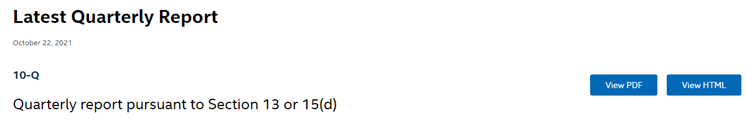

Now, depending on the firm you're searching for, you may need to delve a little more because every publicly listed company is different. Every publicly traded company, on the other hand, is required by law to publish a quarterly report.

As a result, if it isn't as simple as digging a little deeper, you may need to go to the real investor website and then access it. The essential idea is that if you look hard enough, you'll find it. Now we're going to look at the headlines.

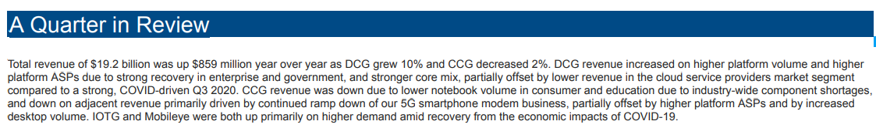

A Quarter in Review Total revenue of $19.2 billion was up $859 million year over year as DCG grew 10% and CCG decreased 2%. DCG revenue increased on higher platform volume and higher platform ASPs due to strong recovery in enterprise and government, and stronger core mix, partially offset by lower revenue in the cloud service providers market segment compared to a strong, COVID-driven Q3 2020. CCG revenue was down due to lower notebook volume in consumer and education due to industry-wide component shortages, and down on adjacent revenue primarily driven by continued ramp down of our 5G smartphone modem business, partially offset by higher platform ASPs and by increased desktop volume. IOTG and Mobileye were both up primarily on higher demand amid recovery from the economic impacts of COVID-19.

As you can read the revenue was up by $859 Million year over year.

This quarter's stats are all higher than the previous quarter's. This indicates that they are growing. But we can also see that the future outlook shows a slowdown in the economy. Meaning that the future quarter results might not be as strong as this quarter. but ideally $INTC is a growing company.

Now we'll go on to the following section, which is guidance. The projection for the upcoming quarter is known as guidance. When it comes to forecasting in a downtrodden company like $INTC, the most important thing to look for is anything NEGATIVE. In this scenario, the most important factor is that Adjusted Net (Loss) Income per share is generally negative.

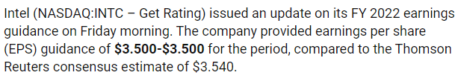

This largely negative range indicates that the corporation expects profits per share to decline. This signifies a drop in profits, which is unfavourable. However, unless you've been following a firm for a long time, these quarterly results and predictions won't provide you with the complete picture.. We walk over to the analyst reports for the prior quarter's earnings to see what they have to say. The more you read, the clearer it will become as to why this Earnings report was good or terrible. (By looking at these earnings reports, you will eventually have an understanding of what to look for with these firms.

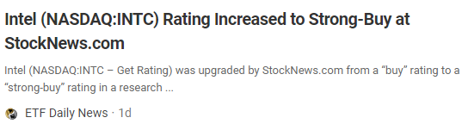

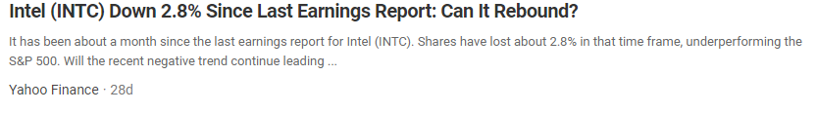

When you open this article, the analyst goes through all of the positive and negative aspects of the earnings report. He also discusses the company's strengths, weaknesses, and potential opportunities/challenges that it may face in the future. Although you should not depend your own view on that of an analyst, these studies might bring out items that you may have overlooked. Then read a few more of these Analyst reports to get a sense of what this Earnings report meant in the context of the company's history. This is quite beneficial since it is similar to receiving the viewpoints of many different individuals. When you're creating price objectives, try to read as many of these as you can.

**Another excellent resource is Investor Presentation.**

**Companies showcase their new company expansion efforts as well as look back on statistics from the previous quarter. One thing to keep in mind regarding investor presentations is that they are intended to sell something. Keep in mind that they are attempting to sell their firm. They certainly make some good points, thus reviewing some previous Investor presentations is beneficial. These presentations may be found in the Investor Relations section of any publicly listed corporation. In any case, it is at this time that you must create a POSITIVE or NEGATIVE projection for the company's growth.**

"Is the Company (Not the Stock) I'm examining on a road of growth and will their business continue to expand?" you must ask yourself. This is a stage that is more akin to an art than a science. You must take into account their current earnings report, future forecasts, market niche, and how well their competitors have performed in comparison to them. You must conduct due diligence on a large amount of facts before coming to a judgement. There is no concrete way to make this selection, as you can see. This isn't a one-size-fits-all solution. However, the more searches you conduct like this, the better you will be able to forecast the direction of growth.

**Make a price target chart**

Returning to the Chart, we have our Median price shown here, and our Current price plotted at the bottom, as indicated in the image below.

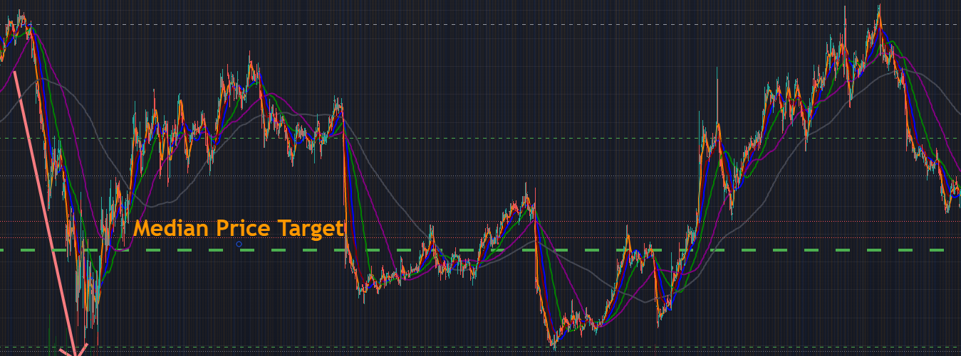

Because our growth trajectory is strong, we expect $INTC will continue to rise and eventually surpass the value it provided to the market during this time. Now, because it traded on the median as an average throughout this time period, it will be valued more and the median will rise. As a result, we observe $INTC climb not only up to the current median, but much higher above it.

If we assume that $INTC's intrinsic value will rise, we can observe that every time the stock reaches this median, it then rises to these two levels of resistance, as illustrated below. As a result, we'll put our price objective somewhere between this lower barrier and the upper resistance.

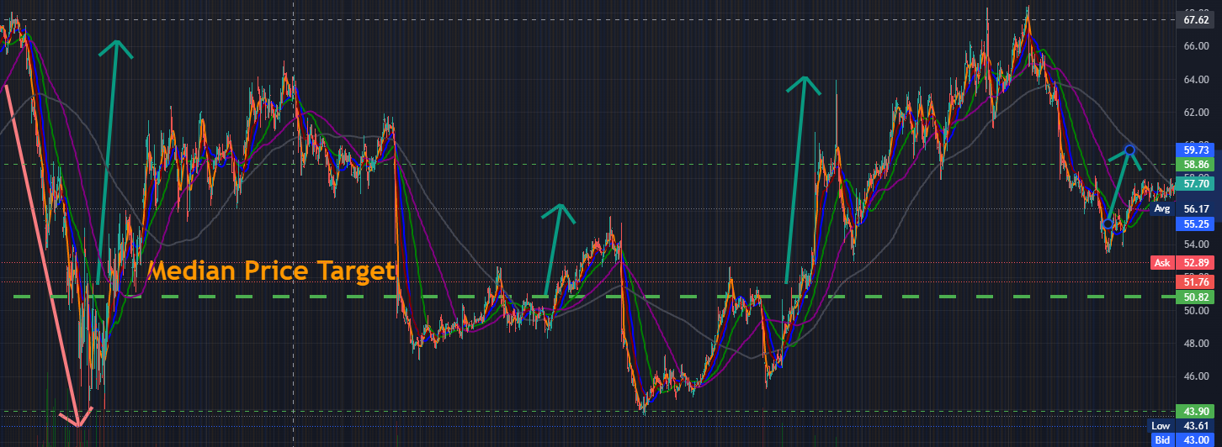

As a result, we put the price objective at $50, which is approximately in the centre of the Resistance levels.

So far, we've set the price objective for $INTC at $50, and it's now trading at roughly $43. As a result, a $50 price target suggests a significant amount of upside potential.

**A Crucial Point**

However, there is one problem that has to be addressed.

What happen if $INTC growth slows?

If the figures fall in the coming quarter and there are signals of bad occurrences, you'll need to revise your price goal.

Price objectives must be subjected to change at all times, so don't be afraid to adjust them if you're wrong.

Every analyst firm adjusts their price predictions on a yearly basis.

Don't beat yourself up if you make a mistake.

The most important thing is to cast an exact direction on the stock. After a while,You obtain a sense of how to evaluate these firms and where your analysis went wrong as a result of your experience (If wrong). As a novice, all you need to worry about is getting the heading right.

Important Points to Remember

Here are a few key points to remember.

To estimate a Target price, there are three primary processes.

1. Determine the median price.

2.Determine a development path

3.Plot a price target

Estimating a growth direction is the most important step in this process.

As a beginner, focus on getting the growth direction right first.

With practise, you will get better at estimating price targets.

For researching a company, go to the Investor relations page and see different data like quarterly reports and investor presentations.

Price objectives are only estimations, so you might be wrong at any time.

If you're mistaken about a pricing objective, don't be scared to revise it.

**When to Get Rid of Losers**

Even if we have more flexible exit points and risk management in value sinking, we are still going to be incorrect occasionally. When you're mistaken, we'll talk about when to cut loser. There are three possible explanations for your error.

1.You–Your analysis was incorrect, and as a result, the stock failed to meet its price goal.

2.Sector-Perhaps your analysis was sound, but the sector was incorrect.

The stock had intrinsic value, but as the sector as a whole cooled, the price dropped as well. Buying Amazon during the Dot Com boom is an illustration of this. During the bubble, everything went down, but Amazon's intrinsic worth remained the same. So, if you believed in Amazon, you had the option of cutting out and waiting for it to rebound, or simply waiting through the downturn.

3.When you buy something valuable, but the whole market drops (due to the Corona virus, for example), your stock drops as well. It does not imply that the underlying value has vanished; rather, it indicates that the market as a whole is going through a period of transition that must be waited out. You may either hold through the decline or sell out and wait for the market to rebound to find a better entry position.

Have a specific point at which you will sell out regardless of what occurs. You can't argue yourself out of the clutching and hoping method if this isn't a solid level. This risk-management departure point should be a prior level of support. For example, if you're buying MU at the position below, you should set your exit at the prior support level. If it falls below that prior level of support, you should sell.

When it comes to risk management, the idea is to have a level below which you will sell the stock and cut losses. This is just to ensure that you are not stuck holding positions in which you made a mistake or in which you purchased at the peak of a sector before it cooled off, or in which you purchased at the peak of the market before it cooled down. That is OK if you are willing to keep these holdings until the market or industry recovers. That, however, was not your intention when you accepted the post. From the standpoint of capital efficiency, this is clear.

Even if you bought exactly at the high before the Covid downturn, it would have been better if you sold out at the top and then repurchased at much lower prices rather than holding out for the full year. It all boils down to market efficiency and finding a decent offer. You can always buy back in if you sell at a lower price when support breaks.

Important Points to Remember

Here are some key takeaways:

There are three basic reasons why you may need to cut losers on occasion.

1.You made a mistake when calculating the price objective.

2.For whatever reason, the industry has calmed off.

3.The market has corrected or crashed for some reason. It is critical to have a concrete exit point below which you will always sell. This exit point should ideally be placed at a previous support level. If you are extremely bullish on a stock, you can choose this point two support levels below. You can always re-analyze and buy the stock back at a lower price after selling it off.

**What is the best way to cutwinners?**

Let's imagine you established a price objective and were correct, but the price continued to rise after you hit your target. When do you plan to sell? For this, we may return to the $TSLA example. Assume you set a price objective of $127 for $TSLA, but the stock is currently trading above $130.

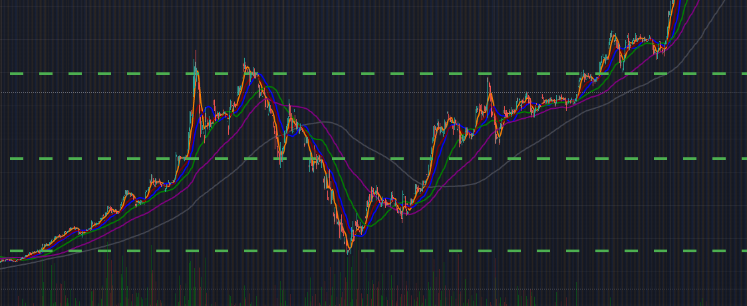

If your price goal is $127, anything over that is overvalued, but there's no need to sell if the stock continues to rise. In this instance, a trailing stop loss might be used to follow the price. For example, if you hit your price objective of 130 dollars, you can set a trailing stop loss for if your stock drops more than 5%.

A trailing stop loss is a stop loss that moves with the price of the stock. For example, if the stock goes from $1 to $2, the stop loss moves with it. In the event that your stock drops more than 5%, you establish a trailing stop loss. This means that if the stock drops more than 5%, your stop loss will trigger and sell you out. This is because you want to safeguard your gains because your stock has already reached its full potential when it reaches your price objective. This is why, rather than putting your risk management at the absolute bottom of support (Stop loss at Support), which would erase all of your winnings, you set a trailing stop loss, which cuts you out at a higher level.

Set a trailing stop loss instead of closing out the position only because it has hit the price goal. If your broker doesn't offer trailing stop loss, the next best thing is to establish a manual stop loss at a higher level of support. Set your stop loss at 15$ if it goes over the 15$ range, for example. Set your stop loss once again when it drops a few of bucks. If you don't have trailing stop losses, be conservative with them.

Important Points to Remember Here are some key takeaways: If a stock meets your price objective and continues to rise, you don't have to sell it right once. The best option is to establish a 5-percent trailing stop loss. If your broker does not offer a trailing stop loss, you can manually adjust the stop loss based on market conditions.

Bringing the Average Down Let's pretend you're in a value dip trade with a price goal of $100. You bought in at a low of 45 dollars and kept on while it rose, but now it has broken back down to roughly 40 dollars, as seen below.

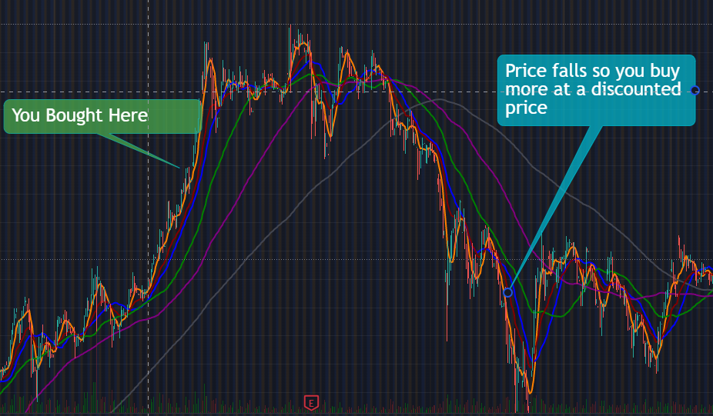

Your research still says it's undervalued and will ultimately reach $100, but it's now even less expensive than the original entry. You now have the option to buy more at a lower price and profit even more when the stock reaches your $100 goal price. If you opt to buy more here, it is known as averaging down, because you are purchasing more at a cheaper price.

So, how can you know if averaging down is a good idea? You must use extreme caution here, since many traders place trades based on wishful thinking rather than sound analysis. They now average down instead of admitting they were incorrect when it starts to go down. They're essentially doubling back on a mistake.

As a result, if we're going to average down, we'll need some quality controls. 1.If you're going to average down, you'll double-check your price objective first. Consider averaging down as if we were taking a whole fresh position and evaluating the stock from the ground up. Rerun all of the procedures from the Price Targets lesson to check if anything has changed, if any new catalysts have emerged, or if anything else has emerged that might cause you to adjust your price objective. This is because if the price objective is the same, averaging down is acceptable.

If the price objective is now lower than it was previously, you must make a new judgement. Determine the new price objective and whether it alters your opinion on the stock. Did your stock tumble along with the rest of the sector's stocks? Is there a specific negative trigger for your stock, or is this a result of market-wide selling? You must determine why this stock has cooled.

In this case, assuming the Price Target hasn't altered, this decline is a fantastic purchasing opportunity since it enhances your upside potential.

**Averaging UP**

Averaging up is when you find a bet that is gaining traction and decide to invest more cash in it, as seen below. Basically, when the stock rises, you want to add to your investment.

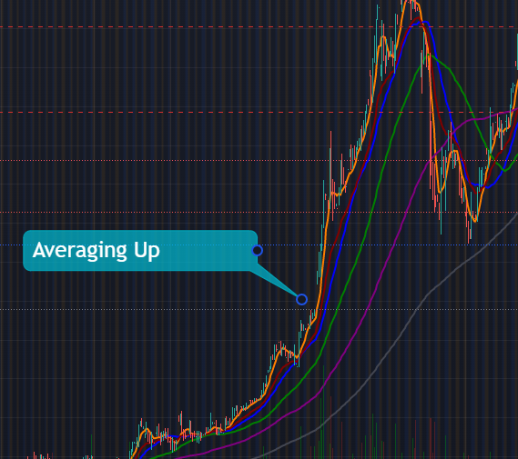

There is now a razor-thin border between averaging up on a winning position and averaging up on a winning position too late, which might result in a losing position. Many individuals make the mistake of averaging up too late and turning a winning position into a losing one. The point is, the more and faster something runs up, the more probable it is to have an intensive cool down time.

I**mportant Points to Remember**

Here are a few key points to remember.

Price goals are critical for both averaging up and down on a stock.

Averaging down occurs when you buy something and it drops more, requiring you to buy more to bring your average down.

If the stock falls, you must re-evaluate your price target before averaging down.

Don't be scared to acknowledge when you're incorrect and the new price goal is lower than the old one.

You'll need to figure out why the price dropped in the first place to determine if it makes sense to average down or not.

When a stock is rising in value, you want to acquire more to enhance your upside.

Many individuals arrive late, which can change a winning position into a losing one.

Taking the Average

Assume you purchased a stake in $SPCE for $15, as indicated below. According to your research, $SPCE has been momentarily beaten down, and your price goal is approximately $20.

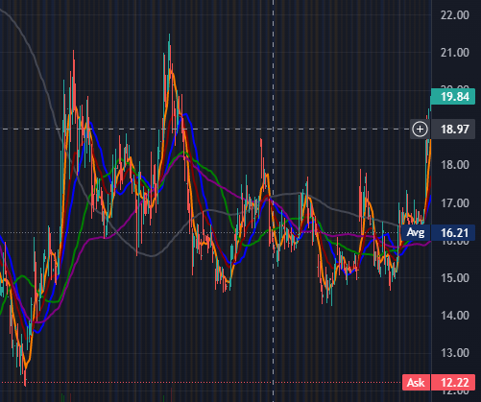

You are aware, though, that the journey will be long and difficult. Then there's this rapid run-up, similar to the one depicted before, but considerably quicker. Your $15 entry position is now at $20, which isn't high enough to achieve your price objective, but because it happened so quickly, you're concerned that it won't make it to your 25$ price target on this run, which may take a few days. Your goal was for a few days, but it soared, and now you're worried that if it sells, it'll take a few months to get back to $25.

As we explained in the last section, this is where averaging down comes into play. You can sell a portion of your stake now to lock in some profits, and then hold the balance until your price objective is reached. However, unlike averaging up or down, there is no requirement to average out. Averaging out is a highly important technique that may help you better manage your account's money. When averaging out, how much of your stake should you sell? This is based on your assessment of how dangerous the current scenario is to the earnings you've already made and may need to lock in.

For example, we still have Positive strength over the short-term SMA line in this case, indicating that the strength is continuing and that there is no imminent risk of missing the price objective. You may average out by selling 25 or 50 percent of your position if you want to lock in your winnings and take some money off the table. Let's imagine you decide to sell half of your stock here and keep the other half. Now that you still have a position in the market, you're not just letting it go; you're putting a stop loss in place at 5% below your average out price.

This manner, you've profited on half of your position while the other half is free to ride to your price objective, and if they fail and fall, you'll be selling them at a 5% loss when the stop loss kicks in.

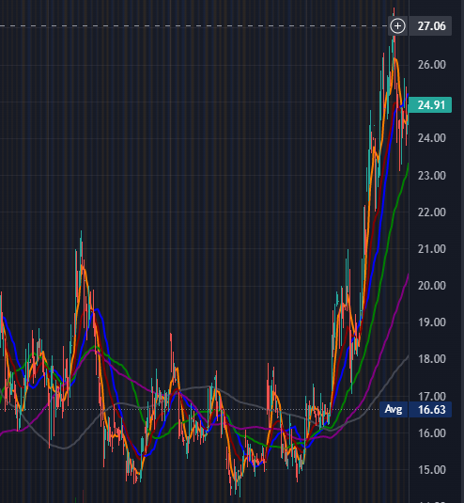

What if you didn't average out at this point since the position was strong and had all of the chart's elevating characteristics, and later on you received a massive red candle that broke the short-term SMA line as seen below?

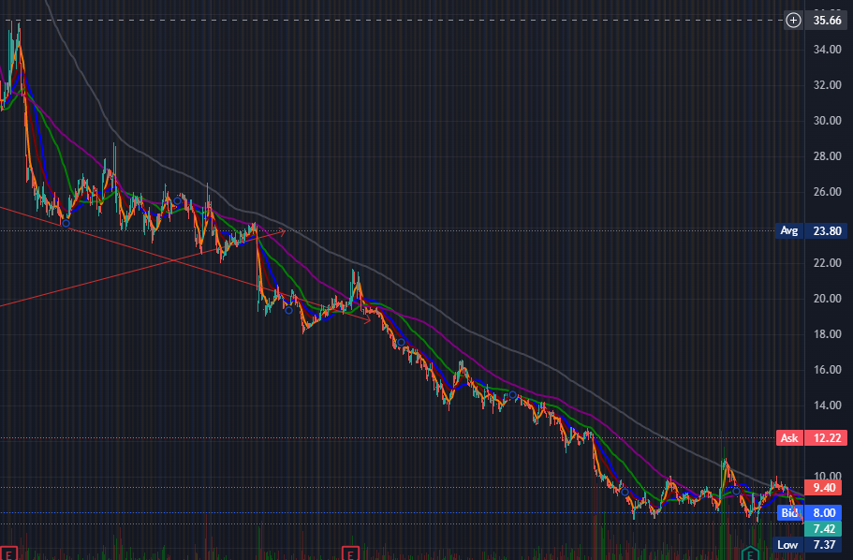

This indicates that our position is now under jeopardy, since a downturn has been confirmed. After a run-up, we know that the first candle that closes below the Short-term SMA line is our confirmation. Since we broke into the rising trend at the bottom, this is the first significant danger of a downturn. It suggests that we are now less likely to achieve our price goal in the foreseeable future.

This is where the concept of averaging out comes into play. You may average out here even more aggressively than we did before if you are in a dangerous position while still being near to your price goal. For example, you can sell 75 percent of your position and lock in gains, then set a stop loss for the remaining 25 percent, as we did before.

This manner, the remaining 25% can rise back to the price objective, and if it's the beginning of a total slump, you can sell at the stop loss.

Effect of Personality There are, nevertheless, some precautions must be taken. Averaging out is also influenced by your personality as a trader. 8.6.1.1Extremely Wary Individual This tool will be more of a problem for you if you are typically more conservative and have considered averaging out at just a quarter of your price objective. At the end of the day, averaging out is a strategy for locking in gains rather than preventing you from realising the majority of them. When averaging out, the idea is to ask oneself, "Is this going to lock-in or prevent profit?"

This is because if it keeps you from taking a significant portion of your profit till the price goal, then having the price objective in the first place is pointless.

Person Who Is Excessively Aggressive On the other side, if you are the sort of person who is too aggressive and can't seem to sell winning positions, it's a good idea to take some money off the table. That way, you reduce the danger of not being able to lock in your earnings later.

In conclusion, This is how we may sum up the Averaging out. As we saw in the example, the amount of profit you take out is determined by how dangerous your position is at the moment (Elevating vs deprecating factors) In conclusion, you should only utilise averaging out when absolutely necessary. The purpose of averaging out is to ensure that successful positions are maintained. For example, if your price objective is $250 and you're trading around $240 (plus you think it won't reach it for a while), it's a good idea to average out.

**Important Points to Remember**

Here are a few key points to remember. Averaging out is used to protect and lock in profits on profitable investments.

You do this by selling a portion of your profitable position to lock in profits and setting a stop loss for the rest

.How much of your position you should sell depends on how much threat you have to your position.

This threat comes from various elevating vs depreciating factors as we discussed in the course.

Don't confuse averaging out with changing a price target on a stock for any reason.

**Toolkit for Biotechnology**

Step-by-Step Biotech Worksheet We'll go through every aspect of constructing a successful trading plan for Biotech Catalysts, including FDA Approvals, Phase Data Releases, and Presentations, in this section.

Step 1: Look for and evaluate biotech investments. To trade Biotech stocks, you'll need to first figure out when catalysts will occur. There are a few methods to achieve this, but our favourites are the websites listed below.

Resources

1.https://www.biopharmcatalyst.com/

2.<https://www.fdatracker.com/fda-calendar/>

3.<https://www.rttnews.com/corpinfo/fdacalendar.aspx>

4.<http://tradebiotechstocks.com/fda-calendar/>

These websites may or may not provide premium services, but the free ones will provide you with all you want. We do not encourage paying money to locate public dates and do not recommend using any premium biotech catalyst services.

FDA Approval Stages Once you've identified Biotech dates, you'll need to sort through them to locate the ones that are significant. FDA dates are divided into numerous categories. This is due to the fact that medications go through several phases in the FDA approval procedure. A-PDUFA - Catalysts' "Holy Grail" (FDA Approval) The FDA finally decides whether or not a medicine is worth putting on the market at this point. (It's worth noting that once a medicine reaches PDUFA, it has an approval rate of around 80%.) $MRNA PDUFA in 2020 is an example.

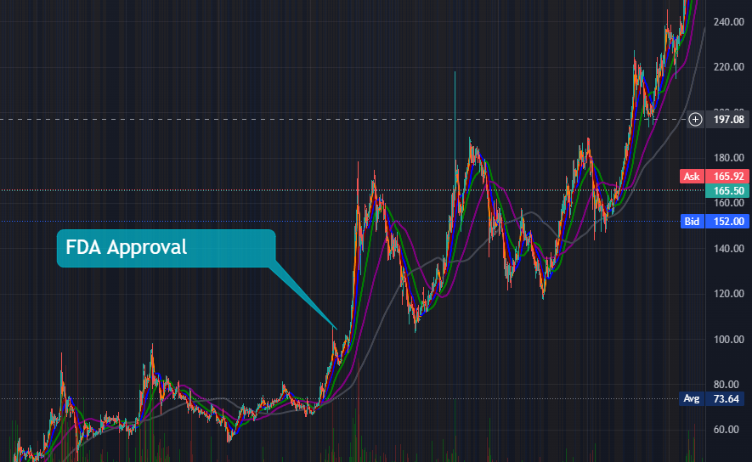

Data Releases for Phases 1-3 Before reaching the PDUFA stage, all medications must go through a series of "phase trials." Phase 1: In this phase, the drug product is tested in a limited number of individuals, all of whom are healthy, to assess preliminary safety and tolerated dose ranges. Phase 2: They perform trials on a small number of patients to assess the drug's efficacy. Phase 3: Additional Clinical Safety Testing

Presentations of the Phases This is the time when firms present their Phase Trial data. It allows businesses to boost their stock price, attract investors, and, on occasion, create media buzz. This isn't always a significant trigger, but it does help to generate investor interest and consequently volume.

Step 2: Make a list of the dates. Make a list of relevant Biotech Plays for the following month on a calendar. This will allow you to keep a close check on them in the week leading up to the catalyst and throughout it. This is vital to keep track of since a lot of Biotech possibilities start attracting investor interest as early as 2-3 weeks before a catalyst.

Step 3: Do some research on the company and look for previous trends. Once you've located several tickers, do your homework and research the company's history. Concentrate on the following: Insider Activity in the Recent Past You should concentrate on determining what and when insiders are trading stocks. Reactions to Similar News Events in the Past If you're trying to trade an FDA approval, for example, look at how your ticker has responded to past FDA approvals. Who Are the Institutional Owners of the Assets? Keep an eye out for big-name institutional investors. Certain institutional investors, like as Blackrock, have a good track record of selecting winners (on average) What Is The State Of The Fundamentals? What significance does this medication announcement have for their business? A lot of these tiny biotech bets are based entirely on the success of a single medicine.

Price Targets of Analysts What are the price goals set by analysts? Are they higher or lower than the current market price? 9.1.4 Step 4: Come up with a hypothesis Proceed to Step 4 and make a hypothesis about whether or not you believe the medicine will be passed based on your study. A hypothesis is simply an informed prediction as to whether something will be accepted or not. An incorrect theory does not harm you, but an accurate hypothesis does. Most of your theories will be incorrect at first, but they will help you trade these moves and comprehend what's going on. (Inaccurate hypotheses aren't a problem because you only act on a hypothesis once it's CONFIRMED, as in Step 6)

Step 5: Recognize Early Warning Symptoms 9.1.5.1 Run-up to the Announcement This has the potential to be both a benefit and a burden. It may be a gift if you took the job in anticipation of a news trigger. Prices that rise too rapidly before an announcement, on the other hand, may PRE-FACTOR an approval into the share price. If this occurs, the actual announcement is unlikely to gain traction, and it may even receive unfavourable feedback.

Breakdown of the Pre-Announcement This is a warning indicator, and it indicates that you should probably wait until after the announcement to see if there is any price activity to trade off of. There was no response. Alternatively, you could notice that there is no response at all. If the stock price remains unchanged in the days leading up to an announcement, it might indicate that the news is either immaterial to most investors or that the stock isn't receiving much media attention. Both of these things are problematic since you won't be able to trade off their price action if they can't garner media attention. As a result, make sure you're seeing some signals of higher volume in the days leading up to an announcement. If not, it's most likely because you're not paying attention.

Step 6: Enter When It Is Appropriate Price Action Elevating Factors A-Confirms Your Hypothesis orB-Makes Sense This might signify a variety of things. APRICE STRENGTHconfirmation for pre-anticipation run-up/breakdown B-Waiting for a Price-Strengthening Opportunity AFTER the run-up/breakdow for the post-announcement

Step 7: Don't hold your breath and hope. A-Anyone may buy a stock at confirmation, but you must also know when to sell. Don't be such a sentimental knucklehead. Holding and hoping will turn you into a TERRIBLE trader and will wipe out your account. B-Exit as soon as you realise your theory is incorrect (price strength reverses, elevating factors turn into deprecating ones) 9.1.8 Step 8: Evaluate What Went Well and What Went Wrong.